**ĐẠI HỌC QUỐC GIA THÀNH PHỐ HỒ CHÍ MINH**

**TRƯỜNG ĐẠI HỌC CÔNG NGHỆ THÔNG TIN**

**KHOA HỆ THỐNG THÔNG TIN**

**BÁO CÁO CUỐI KỲ**

**MÔN MẠNG XÃ HỘI**

**DÙNG CÁC THUẬT TOÁN PHÂN CỤM ĐỂ PHÂN CỤM CHO DATASET DANH SÁCH TUYỂN DỤNG VIỆC LÀM**

**TẠI CÁC QUẬN CỦA BANG CALIFORNIA**

**Lớp:** IS353.O11.HTCL

**GVHD:** ThS. Nguyễn Thị Kim Phụng

**Sinh viên thực hiện:**

Bùi Đức Duy - 20521228

Bùi Duy Thiện - 20520772

**THÀNH PHỐ HỒ CHÍ MINH, THÁNG 12 NĂM 2023**

# NHẬN XÉT CỦA GIẢNG VIÊN

…………………………………………………………………………………………

…………………………………………………………………………………………

…………………………………………………………………………………………

…………………………………………………………………………………………

…………………………………………………………………………………………

…………………………………………………………………………………………

…………………………………………………………………………………………

…………………………………………………………………………………………

…………………………………………………………………………………………

…………………………………………………………………………………………

…………………………………………………………………………………………

…………………………………………………………………………………………

…………………………………………………………………………………………

…………………………………………………………………………………………

…………………………………………………………………………………………

…………………………………………………………………………………………

…………………………………………………………………………………………

…………………………………………………………………………………………

…………………………………………………………………………………………

…………………………………………………………………………………………

…………………………………………………………………………………………

…………………………………………………………………………………………

…………………………………………………………………………………………

# MỤC LỤC

NHẬN XÉT CỦA GIẢNG VIÊN 2

MỤC LỤC 3

1. GIỚI THIỆU 5

2. XÁC ĐỊNH BÀI TOÁN 5

3. MÔ TẢ BỘ DỮ LIỆU 5

3.1. Nguồn dữ liệu 5

3.2. Bảng mô tả 5

3.3. Tiền xử lý dữ liệu 6

3.3.1. Làm sạch dữ liệu 6

3.3.2. Đồ thị 2 phía 7

3.3.3. Đồ thị 1 phía 9

Đồ thị 1 phía trên gephi: 11

4. CÁC ĐỘ ĐO 11

4.1 Closeness centrality 11

4.2 Betweenness centrality 12

4.3 PageRank 13

4.4 Eigenvector centrality 14

5. THUẬT TOÁN PHÂN CỤM CỘNG ĐỒNG 15

5.1 Thuật toán Louvain 15

Cụm 1: 16

Cụm 2: 22

Cụm 3: 28

Cụm 4: 31

Trực quan hóa trên Gephi: 34

5.2 Thuật toán Spinglass 35

Cụm 1: 36

Cụm 2: 43

Cụm 3: 50

Cụm 4: 52

5.3 Thuật toán Agglomerative Clustering 52

Cụm 1: 55

Cụm 2: 66

5.4 Thuật toán Spectral Clustering 71

Cụm 1: 73

Cụm 2: 79

Cụm 3: 81

Cụm 4: 94

5.5 Thuật toán Random Forest 98

5.6 Thuật toán Decision Tree 103

BẢNG PHÂN CÔNG CÔNG VIỆC 111

THAM KHẢO 112

# GIỚI THIỆU

Trong thời đại công nghệ ngày nay, việc sử dụng thuật toán phân cụm (clustering) trở thành một công cụ mạnh mẽ để khám phá và tổ chức thông tin từ các tập dữ liệu lớn. Trong ngữ cảnh tìm kiếm việc làm, việc hiểu rõ về xu hướng tuyển dụng trong các quận của bang California không chỉ giúp ứng viên tìm kiếm cơ hội nghề nghiệp mà còn hỗ trợ doanh nghiệp và chính phủ trong việc lập kế hoạch chiến lược cho thị trường lao động.

Đối với bài toán này, nhóm em sẽ áp dụng từ môn học mạng xã hội các thuật toán về độ đo (dựa trên đường đi, phổ, khoảng cách,...), khai thác dữ liệu trên mạng này (gom cụm) và các thuật toán phân cụm để phân tích gom cụm các công việc được tuyển dụng tại các quận khác nhau của California. Việc này giúp chúng ta có cái nhìn toàn diện về sự phân bố của ngành nghề, loại công việc trong mỗi khu vực. Bằng cách này, cả ứng viên và nhà tuyển dụng có thể tối ưu hóa quá trình tìm kiếm và cung ứng việc làm.

# XÁC ĐỊNH BÀI TOÁN

**Input:** Tập dữ liệu ban đầu trên nguồn dữ liệu Kaggle đã qua tiền xử lý dữ liệu.

**Output:** Đưa ra độ đo, đưa ra cộng đồng phục vụ cho việc phân tích mạng xã hội của dataset *‘California State Jobs’.*

# MÔ TẢ BỘ DỮ LIỆU

## Nguồn dữ liệu

**Link dataset:** [California State Jobs (kaggle.com)](https://www.kaggle.com/datasets/datasciencedonut/california-state-jobs)

**Dataset:** CalCareersData.csv gồm 5766 dòng với 10 cột. Sử dụng cột *Job_Listing* và *Location*.

## Bảng mô tả

|  |  |  |  |
| --- | --- | --- | --- |
| **STT** | **Tên trường dữ liệu** | **Mô tả** | **Kiểu dữ liệu** |
| **1** | Job_Listing | Tên các công việc được tuyển dụng | String |
| **2** | Location | Tên quận | String |

## Tiền xử lý dữ liệu

### Làm sạch dữ liệu

Import các thư viện cần thiết.

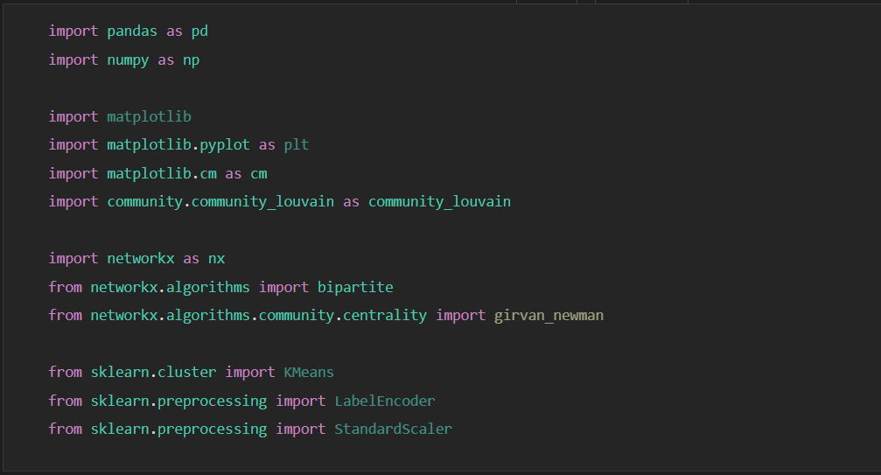

Mở và đọc dataset ban đầu.

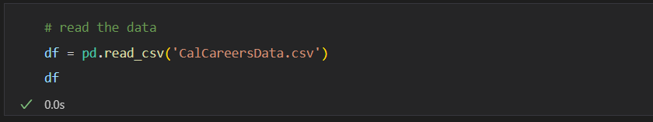

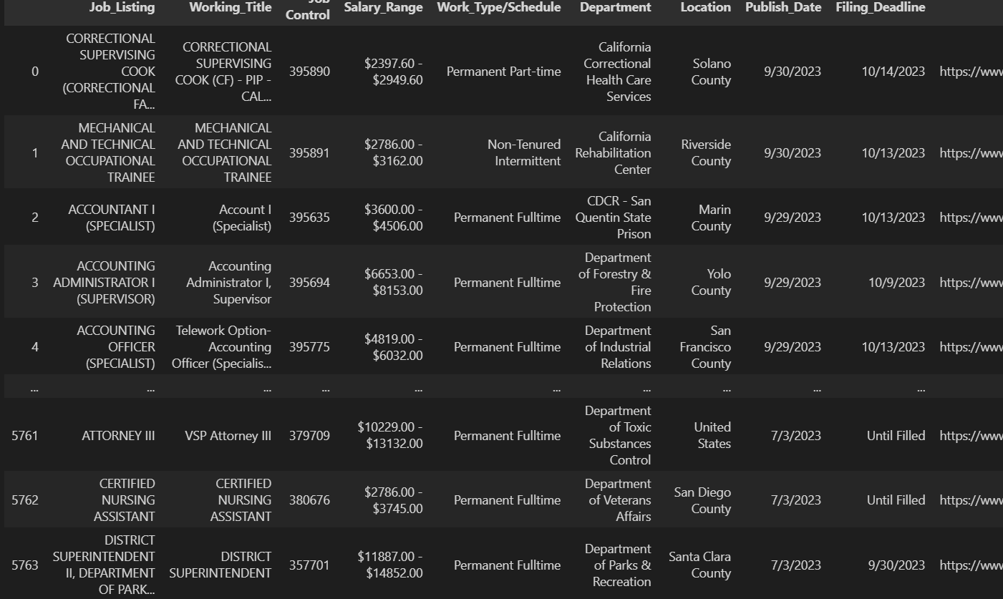

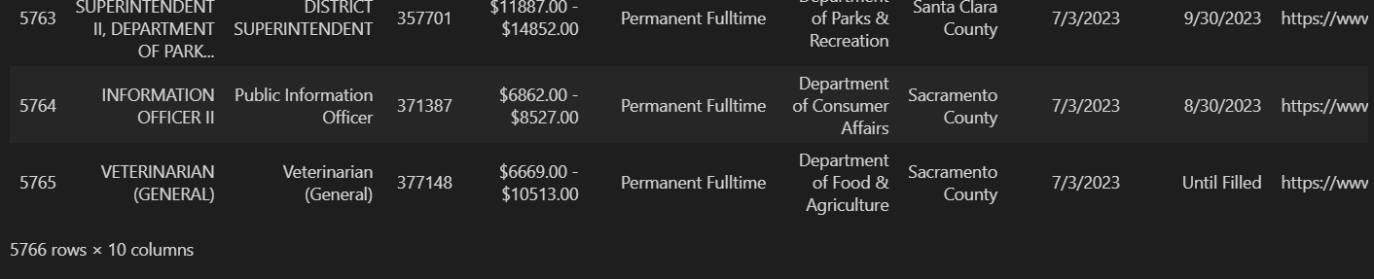

Lấy ra 2 cột cần tính là *Job_Listing* và *Location* sau đó xóa dòng null và dòng trùng.

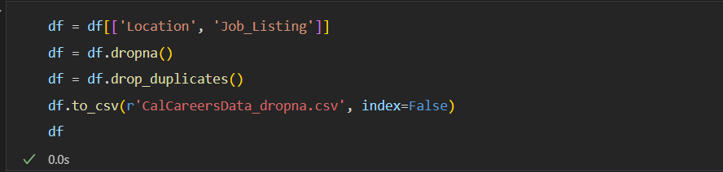

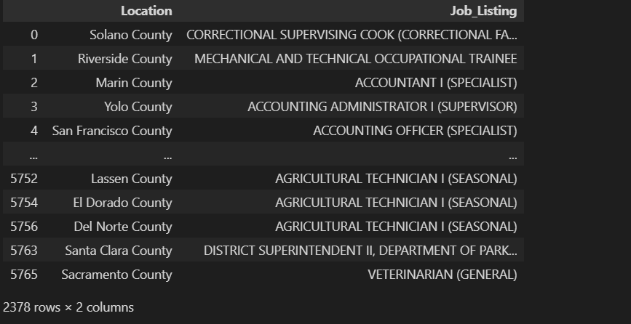

Dữ liệu sau khi làm sạch gồm 2378 dòng và 2 cột.

### Đồ thị 2 phía

***Node:*** là tên quận (location) và tên công việc (job) mà quận đó tuyển dụng.

***Edge:*** là mối quan hệ giữa việc 2 cộng việc đó có được tuyển dụng tại cùng một quận.

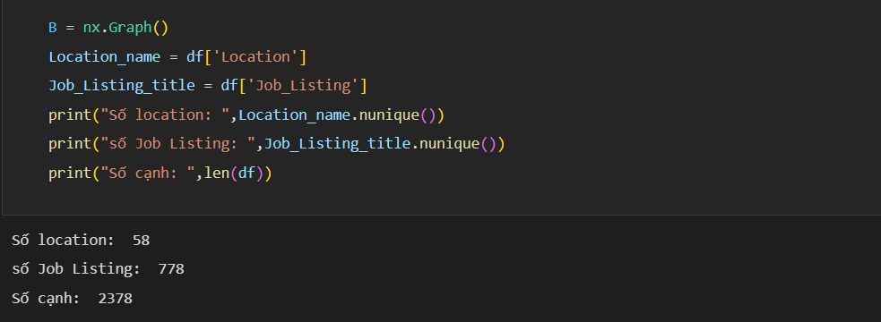

Số quốc gia thi đấu là 154.

Số bộ môn thi đấu là 86.

Số cạnh là 1731.

***Tạo đồ thị***



***Vẽ đồ thị 2 phía***

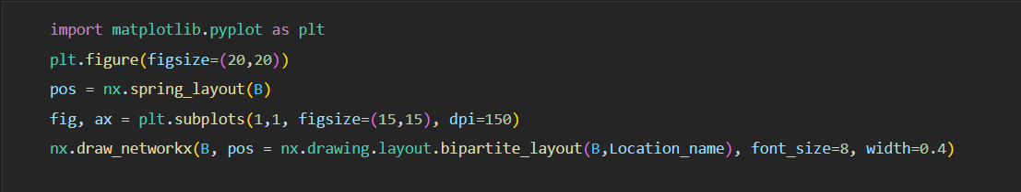

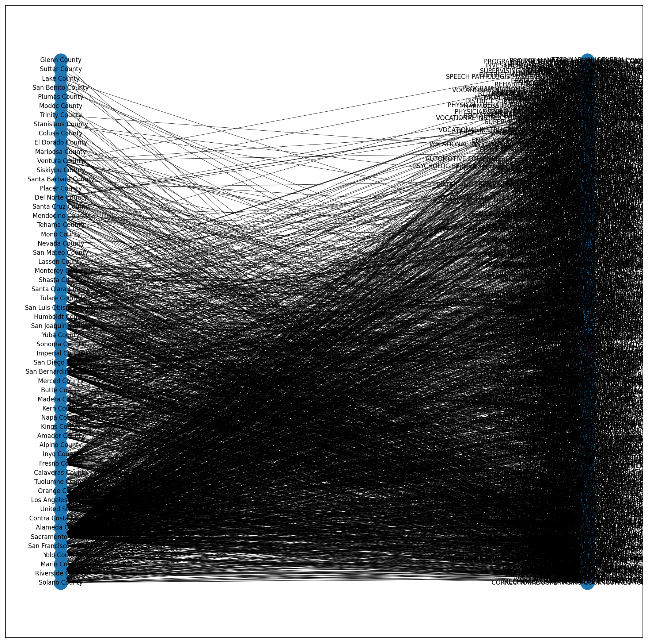

Nhìn vào đồ thị có thể thấy một khu vực sẽ tuyển dụng nhiều công việc. Và ngược lại, một công việc khi được tuyển dụng sẽ có tại nhiều khu vực.

### Đồ thị 1 phía

***Node:*** là tên một công việc.

***Edge:*** hai công việc được tuyển dụng cùng một khu vực sẽ được nối với nhau để tạo thành cạnh.

***Weight:*** trọng số là số khu vực trùng nhau mà hai công việc được tuyển dụng cùng một khu vực.

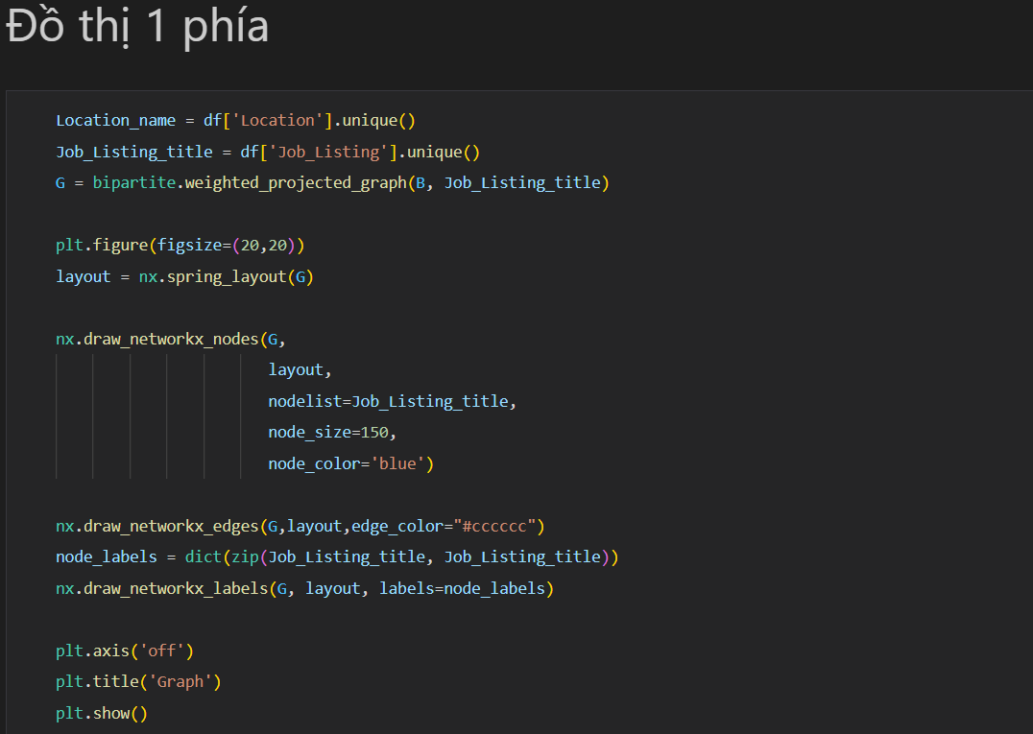

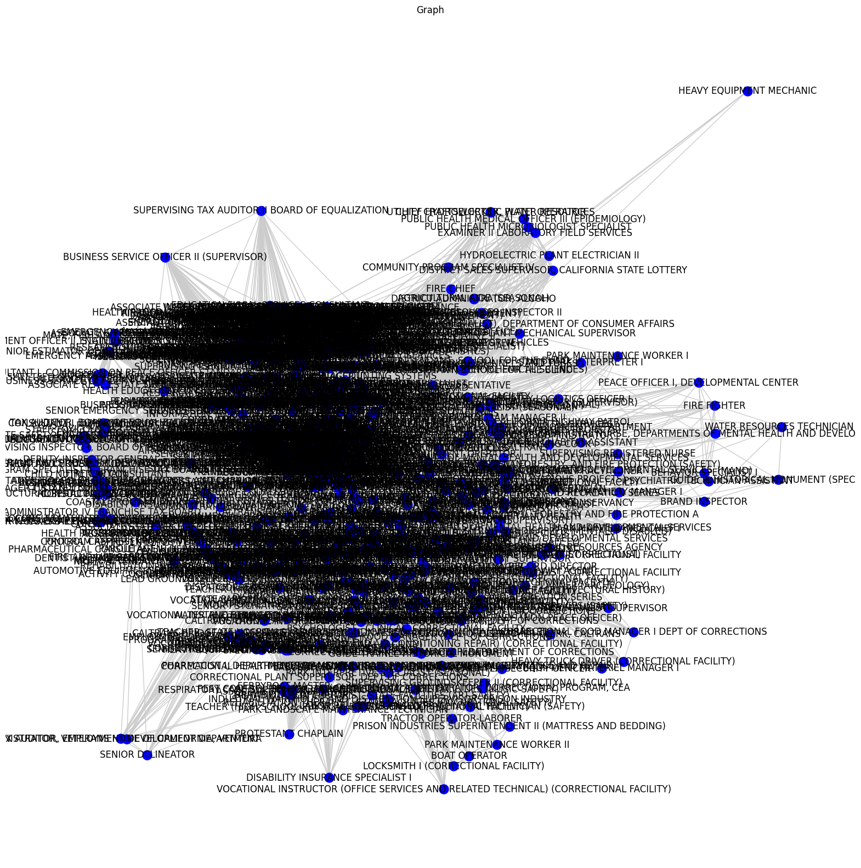

### Đồ thị 1 phía trên gephi:

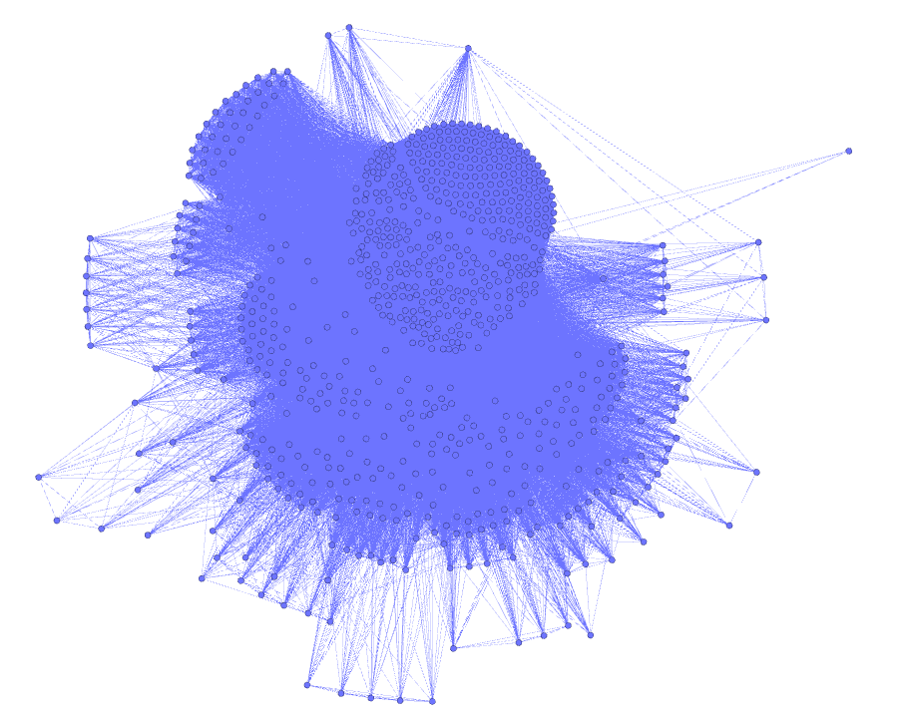

# CÁC ĐỘ ĐO

## Closeness centrality

Kết quả của closeness centrality thể hiển top độ gần các node đến tất cả các node trong mạng. Nó cũng đồng nghĩa với việc top các công việc được tuyển dụng cao nhất.



Kết quả Python top 10 công việc

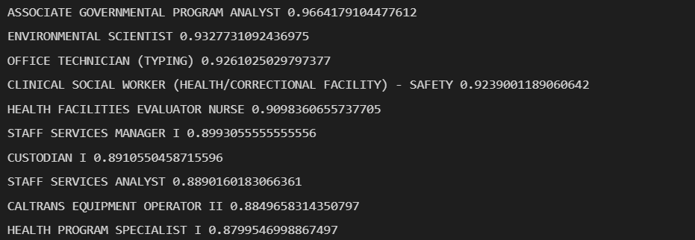

Kết quả Gephi python top 10 công việc

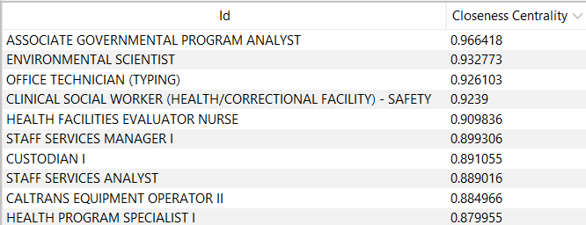

Cả 2 kết quả đều giống nhau.

## Betweenness centrality

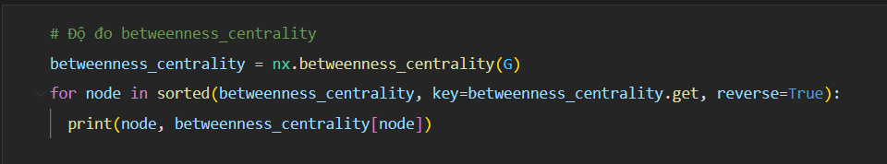

Kết quả Python top 10 công việc

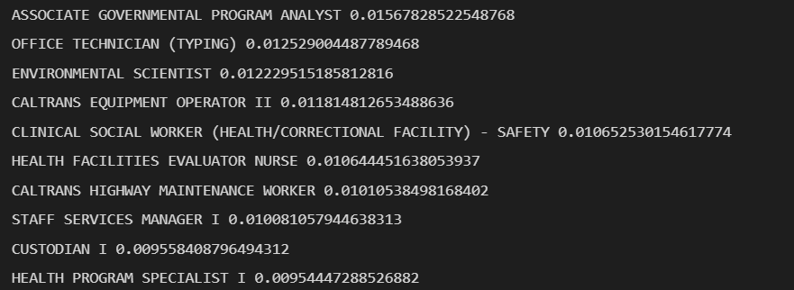

Kết quả Gephi top 10 công việc

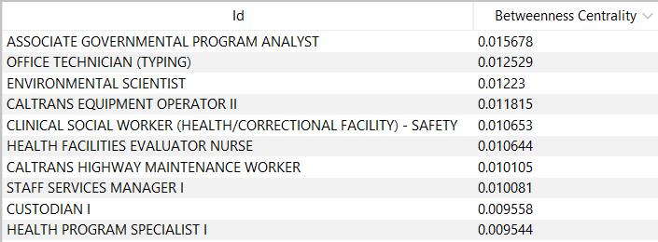

Cả 2 kết quả đều giống nhau.

## PageRank



Kết quả trên Python top 10 công việc

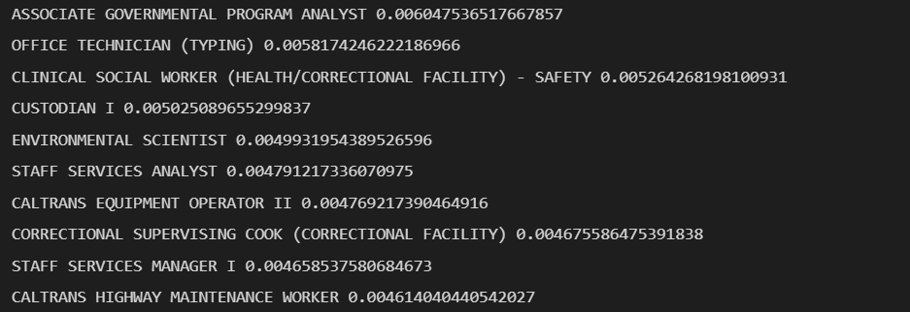

Kết quả Gephi top 10 công việc

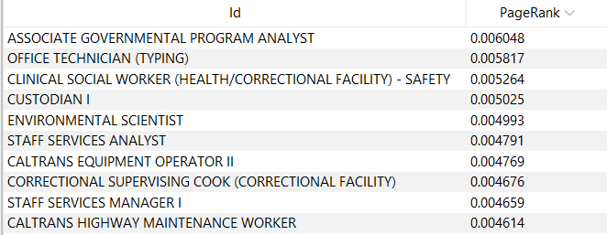

Cả 2 kết quả đều giống nhau.

## Eigenvector centrality



Kết quả Python top 10 công việc

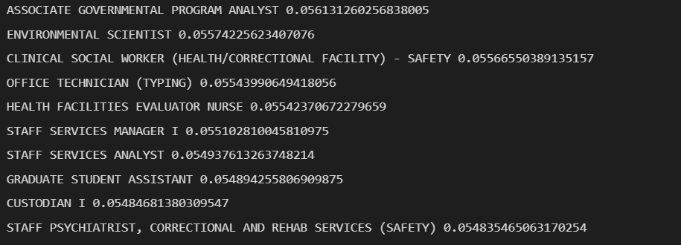

Kết quả Gephi top 10 công việc

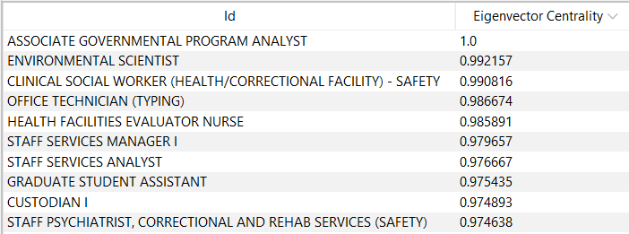

Tuy có sai khác về tính toán nhưng kết quả xếp hạng các công việc vẫn giống nhau.

# THUẬT TOÁN PHÂN CỤM CỘNG ĐỒNG

## Thuật toán Louvain

Vẽ đồ thị [1]

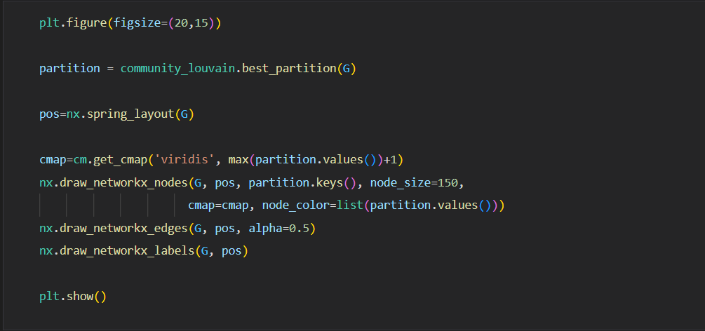

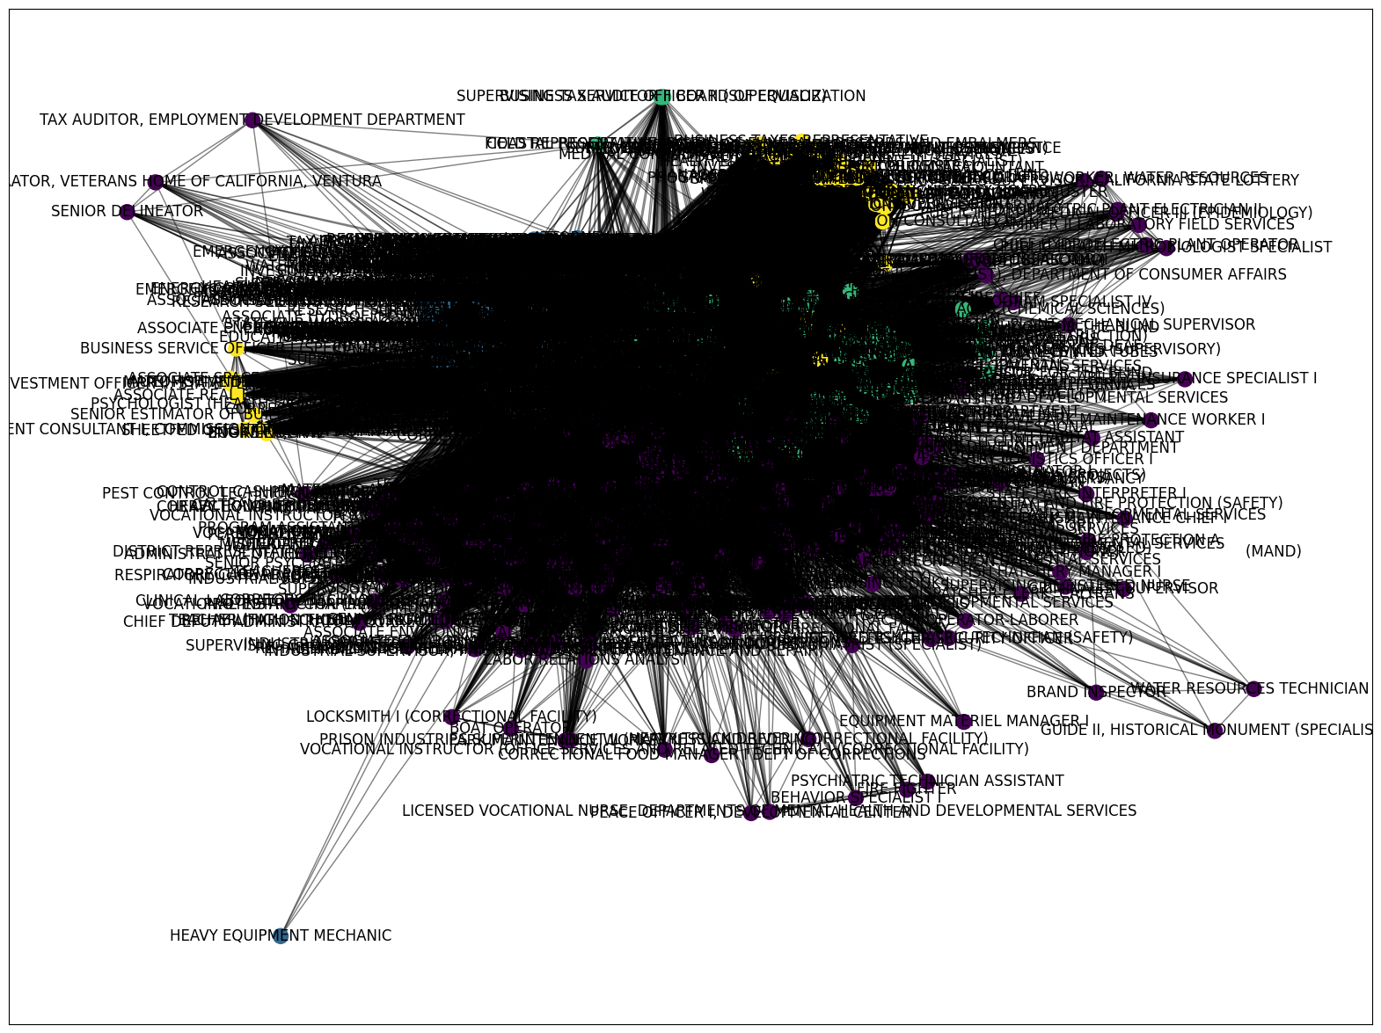



**Danh sách các cụm:**

### Cụm 1:

|  |
| --- |
| CORRECTIONAL SUPERVISING COOK (CORRECTIONAL FACILITY),  MECHANICAL AND TECHNICAL OCCUPATIONAL TRAINEE,ACCOUNTANT I (SPECIALIST),ASSOCIATE GOVERNMENTAL PROGRAM ANALYST,  ASSOCIATE PERSONNEL ANALYST,AUTOMOBILE MECHANIC (CORRECTIONAL FACILITIES),CALTRANS EQUIPMENT OPERATOR II,CALTRANS HIGHWAY MAINTENANCE LEADWORKER,CALTRANS HIGHWAY MAINTENANCE WORKER,CALTRANS LANDSCAPE MAINTENANCE LEADWORKER,CAPTAIN, ADULT INSTITUTION,  CERTIFIED NURSING ASSISTANT,CHIEF PHYSICIAN AND SURGEON, CORRECTIONAL FACILITY,CHIEF PSYCHOLOGIST, CORRECTIONAL FACILITY,CONSERVATIONIST I,COOK SPECIALIST I,CUSTODIAN I,CUSTODIAN II,DENTAL ASSISTANT, CORRECTIONAL FACILITY,  EMPLOYMENT PROGRAM REPRESENTATIVE,ENVIRONMENTAL SCIENTIST,FORESTRY TECHNICIAN,GROUNDSKEEPER,HEALTH PROGRAM MANAGER III,HEALTH RECORD TECHNICIAN I,  HEALTH SERVICES SPECIALIST (SAFETY),HEAVY EQUIPMENT MECHANIC (CORRECTIONAL FACILITY),HEAVY EQUIPMENT MECHANIC APPRENTICE, CALTRANS,REGISTERED NURSE (SAFETY),  STAFF SERVICES ANALYST,STAFF SERVICES MANAGER I,  AGRICULTURAL TECHNICIAN I (SEASONAL), CALTRANS ELECTRICIAN I,CALTRANS EQUIPMENT OPERATOR I,CALTRANS LANDSCAPE SPECIALIST,CALTRANS MAINTENANCE SUPERVISOR,  CARPENTER I,CARPENTER II (CORRECTIONAL FACILITY),CASE RECORDS TECHNICIAN,COMMERCIAL VEHICLE INSPECTION SPECIALIST, CORRECTIONAL OFFICER,CORRECTIONAL SERGEANT, DISPATCH-CLERK SUPERVISOR, CALTRANS,FOOD ADMINISTRATOR I (CORRECTIONAL FACILITY), HEALTH PROGRAM SPECIALIST I, INDUSTRIAL SUPERVISOR, PRISON INDUSTRIES (MAINTENANCE AND REPAIR), JEWISH CHAPLAIN, OFFICE TECHNICIAN (TYPING), ADMINISTRATIVE ASSISTANT I,AUTOMOTIVE EQUIPMENT OPERATOR I(MAND), BEHAVIOR SPECIALIST II,CALTRANS LANDSCAPE, MAINTENANCE WORKER,CHIEF, FIREFIGHTER/SECURITY OFFICER, CORRECTIONAL PLANT SUPERVISOR, DEPT OF CORRECTIONS, FISH AND WILDLIFE SCIENTIFIC AID,FISH AND WILDLIFE TECHNICIAN, FOOD SERVICE TECHNICIAN I, FORESTRY LOGISTICS OFFICER I,HYDROELECTRIC PLANT MECHANICAL SUPERVISOR,  NATIVE AMERICAN SPIRITUAL LEADER, SENIOR PSYCHIATRIST (SPECIALIST), STUDENT ASSISTANT, CHIEF PSYCHIATRIST, CORRECTIONAL AND REHAB SERVICES (SAFETY),CLINICAL SOCIAL WORKER (HEALTH/CORRECTIONAL FACILITY) – SAFETY, CORRECTIONAL CASE RECORDS MANAGER,CORRECTIONAL CASE RECORDS SUPERVISOR,CORRECTIONAL COUNSELOR I,ENVIRONMENTAL SERVICES INTERN,SUPERVISING REGISTERED NURSE (SAFETY),WATER RESOURCES TECHNICIAN I,ELECTRICIAN II (CORRECTIONAL FACILITY),PAINTER II (CORRECTIONAL FACILITY),SUPERVISING CORRECTIONAL COOK DEPT OF CORRECTIONS,MATERIALS AND STORES SUPERVISOR I (CORRECTIONAL FACILITY),COMMUNITY RESOURCES MANAGER, DEPARTMENT OF CORRECTIONS,COOK SPECIALIST II,CRIMINALIST SUPERVISOR,FIRE PREVENTION SPECIALIST I,FIRE PREVENTION SPECIALIST II,PLUMBER II (CORRECTIONAL FACILITY), CALTRANS ELECTRICAL SUPERVISOR,CALTRANS ELECTRICIAN II, CARPENTER III (CORRECTIONAL FACILITY), CONSERVATIONIST SUPERVISOR, CORRECTIONAL PLANT MANAGER II, DEPT OF CORRECTIONS,CLINICAL LABORATORY TECHNOLOGIST, CORRECTIONAL FACILITY, FISH HABITAT ASSISTANT, HEAVY FIRE EQUIPMENT OPERATOR, HOSPITAL POLICE LIEUTENANT, CHIEF DEPUTY ADMINISTRATOR, CORRECTIONAL PROGRAM, CEA, CONSERVATIONIST II,PSYCHIATRIC TECHNICIAN (SAFETY),  CORRECTIONAL COUNSELOR II (SUPERVISOR),ELECTRONICS TECHNICIAN (CORRECTIONAL FACILITY),FORESTRY AND FIRE PROTECTION A,HEARING REPORTER,INDUSTRIAL SUPERVISOR, PRISON INDUSTRIES (LAUNDRY),LICENSED VOCATIONAL NURSE, CALIFORNIA DEPARTMENT OF CORRECTIONS AND REHABILITATION, ELECTRICAL ENGINEERING TECHNICIAN I, FORESTER II (SUPERVISORY), HEALTH FACILITIES EVALUATOR NURSE, MEDICAL ASSISTANT, ADMINISTRATOR, VETERANS HOME OF CALIFORNIA, VENTURA,BOAT OPERATOR, CONTROL CASHIER I (MOTOR VEHICLE SERVICES), DEPARTMENT OF MOTOR VEHICLES  TELEVISION SPECIALIST,APPRENTICESHIP CONSULTANT, CALTRANS MAINTENANCE AREA SUPERINTENDENT,MUSLIM CHAPLAIN, ASSISTANT CORRECTIONAL FOOD MANAGER (DEPT OF CORRECTIONS), ASSISTANT SAFETY ENGINEER, DISPATCHER-CLERK, CALTRANS, OFFICE ASSISTANT (TYPING), PARK MAINTENANCE WORKER I, RECREATION THERAPIST, CORRECTIONAL FACILITY, TEACHER (HIGH SCHOOL-GENERAL EDUCATION) (CORRECTIONAL FACILITY),CORRECTIONAL BUSINESS MANAGER I, DEPARTMENT OF CORRECTIONS,SENIOR VOCATIONAL REHABILITATION COUNSELOR, QUALIFIED REHABILITIATION PROFESSIONAL,CHIEF ENGINEER I, (CORRECTIONAL FACILITY), DISABILITY INSURANCE SPECIALIST I, GRADUATE STUDENT ASSISTANT,PROGRAM DIRECTOR (MENTAL DISABILITIES-SAFETY), CHIEF HYDROELECTRIC PLANT OPERATOR, CORRECTIONAL FOOD MANAGER I DEPT OF CORRECTIONS, EXAMINER II LABORATORY FIELD SERVICES, REGISTERED NURSE, CORRECTIONAL FACILITY, TEACHING ASSISTANT (CORRECTIONAL FACILITY), CALTRANS BRIDGE MAINTENANCE SUPERVISOR, DISABILITY INSURANCE PROGRAM MANAGER II, SPECIAL AGENT-IN-CHARGE, CORRECTIONAL HEALTH SERVICES ADMINISTRATOR II, CORRECTIONAL FACILITY,FORESTRY ASSISTANT II, LICENSED VOCATIONAL NURSE (MAND), GUIDE II, HISTORICAL MONUMENT (SPECIALIST), PHARMACY TECHNICIAN,SENIOR MOTOR VEHICLE TECHNICIAN, DISTRICT REPRESENTATIVE II, DIV CDS& STNDS (NON-PEACE OFFICER), DISTRICT SALES SUPERVISOR, CALIFORNIA STATE LOTTERY,ARCHEOLOGICAL PROJECT LEADER (SEASONAL), ARCHEOLOGICAL SPECIALIST (SEASONAL), ASSOCIATE MENTAL HEALTH SPECIALIST, ASSOCIATE SAFETY ENGINEER, FIRE CAPTAIN CORRECTION INSTITUTION, LABORATORY ASSISTANT, CORRECTIONAL FACILITY, LIBRARIAN (CORRECTIONAL FACILITY), LIBRARY TECHNICAL ASSISTANT (SAFETY),MAINTENANCE MECHANIC, MAINTENANCE MECHANIC (CORRECTIONAL FACILITY), MAINTENANCE WORKER, DEPARTMENT OF THE CALIF. HIGHWAY PATROL, OIL SPILL PREVENTION SPECIALIST, OPTOMETRIST, CORRECTIONAL FACILITY, PERSONNEL SPECIALIST, PHYSICAL THERAPIST I, CORRECTIONAL FACILITY, PROGRAM ASSISTANT (MENTAL DISABILITIES-SAFETY), RADIOLOGIC TECHNOLOGIST, CORRECTIONAL FACILITY, REGISTERED NURSE(MAND), RESPIRATORY CARE SUPERVISOR, CORRECTIONAL FACILITY, ROUTE SALES REPRESENTATIVE, SENIOR PARK AIDE (SEASONAL),SENIOR PSYCHIATRIST (SUPERVISOR), CORRECTIONAL AND REHABILITATIVE SERVICES (SAFETY), SPECIAL INVESTIGATOR, STATE PARK PEACE OFFICER SUPERVISOR (RANGER),SUPERVISING CLINICAL LABORATORY TECHNOLOGIST, CORRECTIONAL FACILTY, SUPERVISING COOK I, SUPERVISING PSYCHIATRIC SOCIAL WORKER I, CORRECTIONAL FACILTY, SUPERVISING REGISTERED NURSE II, CORRECTIONAL FACILITY, TEACHER (HIGH SCHOOL-PHYSICAL EDUCATION) (CORRECTIONAL FACILITY), TRANSPORTATION ENGINEERING TECHNICIAN,UNIT SUPERVISOR (SAFETY), UTILITY CRAFTSWORKER, WATER RESOURCES, VOCATIONAL INSTRUCTOR (BUILDING MAINTENANCE) (CORRECTIONAL FACILITY), COUNSELOR, SCHOOL FOR THE DEAF, HEALTH RECORD TECHNICIAN II (SUPERVISOR), HYDROELECTRIC PLANT ELECTRICIAN II,LICENSING PROGRAM MANAGER II, OFFICE SERVICES SUPERVISOR II,PARK MAINTENANCE CHIEF I, PHARMACIST I (MAND), PROTESTANT CHAPLAIN, PUBLIC HEALTH MICROBIOLOGIST SPECIALIST, REHABILITATION THERAPIST, STATE FACILITIES (RECREATION-SAFETY), STAFF PSYCHIATRIST(MAND),STOCK CLERK, TAX ADMINISTRATOR I, EMPLOYMENT DEVELOPMENT DEPARTMENT,TAX AUDITOR, EMPLOYMENT DEVELOPMENT DEPARTMENT, VOCATIONAL INSTRUCTOR (CARPENTRY)(CORRECTIONAL FACILITY), VOCATIONAL INSTRUCTOR (WELDING) (CORRECTIONAL FACILITY), VOCATIONAL INSTRUCTOR, AUTO MECHANICS (CORRECTIONAL FACILITY), WILDLIFE HABITAT ASSISTANT, INDUSTRIAL WAREHOUSE AND DISTRIBUTION, SUPERVISOR, PRISON INDUSTRY, MOTOR CARRIER SPECIALIST I, CALIFORNIA HIGHWAY PATROL,NURSE PRACTITIONER (SAFETY),PARK LANDSCAPE MAINTENANCE TECHNICIAN, PARK MAINTENANCE ASSISTANT, PRISON INDUSTRIES SUPERINTENDENT II (MATTRESS AND BEDDING), PSYCHIATRIC TECHNICIAN ASSISTANT (SAFETY),PSYCHOLOGIST - CLINICAL, CORRECTIONAL FACILITY, PUBLIC HEALTH MEDICAL OFFICER III (EPIDEMIOLOGY), PUBLIC HEALTH NURSE II, CORRECTIONAL FACILITY, PUBLIC SAFETY DISPATCH SUPERVISOR I CALIFORNIA HIGHWAY PATROL, SENIOR PSYCHOLOGIST, CORRECTIONAL FACILITY (SPECIALIST), SENIOR PSYCHOLOGIST, CORRECTIONAL FACILITY (SUPERVISOR), SENIOR TRANSPORTATION SURVEYOR (CALTRANS), SUPERVISOR OF BUILDING TRADES (CORRECTIONAL FACILITY), BEHAVIOR SPECIALIST I, DISTRICT SUPERINTENDENT II, DEPARTMENT OF PARKS AND RECREATION SERIES, LABOR RELATIONS ANALYST, LOCKSMITH I (CORRECTIONAL FACILITY), MATERIALS AND STORES SUPERVISOR II (CORRECTIONAL FACILITY), MEDICAL RECORD DIRECTOR, PARK MAINTENANCE SUPERVISOR, PHARMACIST II,PRE-LICENSED PSYCHIATRIC TECHNICIAN, REGIONAL DENTAL DIRECTOR, CEA REGISTERED DIETITIAN, CORRECTIONAL FACILITY, RESPIRATORY CARE PRACTITIONER, CORRECTIONAL FACILITY, SENIOR RADIOLOGIC TECHNOLOGIST, CORRECTIONAL FACILITY (SPECIALIST), FISH HATCHERY MANAGER I, FORESTER I (NONSUPERVISORY),LICENSED VOCATIONAL NURSE, DEPARTMENTS OF MENTAL HEALTH AND DEVELOPMENTAL SERVICES, MATERIALS AND STORES SPECIALIST,NURSE PRACTITIONER, CORRECTIONAL FACILITY, OCCUPATIONAL THERAPIST, DEPARTMENTS OF MENTAL HEALTH AND DEVELOPMENTAL SERVICES, PSYCHIATRIC TECHNICIAN ASSISTANT, REGISTERED DIETITIAN (SAFETY), REGISTERED DIETITIAN, SERVICE ASSISTANT (MAINTENANCE), CALTRANS, STATE PARK INTERPRETER I, SUPERVISING CASE RECORDS TECHNICIAN, WATER AND SEWAGE PLANT OPERATOR, DEPARTMENT FORESTRY AND FIRE PROTECTION (SAFETY), ASSOCIATE STEEL INSPECTOR, DISABILITY EVALUATION SERVICES ADMINISTRATOR I,SECURITY GUARD, SUPERVISING REHABILITATION THERAPIST, WATER RESOURCE CONTROL ENGINEER, EXECUTIVE OFFICER, SAN JOAQUIN RIVER CONSERVANCY, HEAVY TRUCK DRIVER (CORRECTIONAL FACILITY), LICENSED VOCATIONAL NURSE (SAFETY), PARK MAINTENANCE WORKER II, PRE-LICENSED PSYCHIATRIC TECHNICIAN (SAFETY), RESPIRATORY CARE PRACTITIONER (MAND), STATE PARK EQUIPMENT OPERATOR, TEACHER, STATE HOSPITALS(LRNG HANDICAPPED, MENTALLY DISABLED), EMPLOYMENT DEVELOPMENT ADMINISTRATOR, EMPLOYMENT PROGRAM MANAGER II, GUIDE TRAINEE HISTORICAL MONUMENT, PEACE OFFICER I, DEVELOPMENTAL CENTER,PEST CONTROL TECHNICIAN (CORRECTIONAL FACILITY), RESIDENT CARE SPECIALIST, STAFF PSYCHIATRIST, CORRECTIONAL AND REHAB SERVICES (SAFETY), SUPERVISING GROUNDSKEEPER II (CORRECTIONAL FACILITY), VOCATIONAL INSTRUCTOR (ELECTRICAL WORK) (CORRECTIONAL FACILITY), VOCATIONAL INSTRUCTOR (REFRIGERATION AND AIR CONDITIONING REPAIR) (CORRECTIONAL FACILITY), CORRECTIONAL FOOD MANAGER II DEPT OF CORRECTIONS, FOOD SERVICE TECHNICIAN II, PERSONNEL TECHNICIAN II (SPECIALIST), PEST PREVENTION ASSISTANT I (VARIOUS PROJECTS), SENIOR TRANSPORTATION ELECTRICAL ENGINEER (SUPERVISOR), TEACHER, STATE HOSPITALS (SEVERELY HANDICAPPED, DEVELOPMENTALLY DISABLED), TELECOMMUNICATIONS FACILITIES TECHNICIAN II, CHP, VOCATIONAL INSTRUCTOR (COMPUTER AND RELATED TECHNOLOGIES) (CORRECTIONAL FACILITY), CRIME ANALYST III, FIRE FIGHTER, NURSE INSTRUCTOR, CORRECTIONAL FACILITY, PEST PREVENTION ASSISTANT II (VARIOUS PROJECTS), RIGHT OF WAY AGENT, VOCATIONAL INSTRUCTOR (OFFICE SERVICES AND RELATED TECHNICAL) (CORRECTIONAL FACILITY), DIETETICS ASSISTANT DIRECTOR, PODIATRIST, DEPARTMENTS OF MENTAL HEALTH AND DEVELOPMENTAL SERVICES, ASSOCIATE ENVIRONMENTAL PLANNER (ARCHEOLOGY), ASSOCIATE ENVIRONMENTAL PLANNER (ARCHITECTURAL HISTORY), CATHOLIC CHAPLAIN, PHYSICAL THERAPY ASSISTANT,PHYSICIAN AND SURGEON, CORRECTIONAL FACILITY (INTERNAL MED/FAMILY PRACTICE), PHARMACIST I, DEPARTMENTS OF MENTAL HEALTH AND DEVELOPMENTAL SERVICES, PHYSICAL THERAPIST I, DEPARTMENTS OF MENTAL HEALTH AND DEVELOPMENTAL SERVICES, SUPERVISING REGISTERED NURSE, SENIOR RIGHT OF WAY AGENT, DISTRICT SUPERINTENDENT I, DEPARTMENT OF PARKS AND RECREATION SERIES, PARK INTERPRETIVE SPECIALIST (SEASONAL), WATER AND SEWAGE PLANT SUPERVISOR (CORRECTIONAL FACILITY), CHIEF PHYSICIAN AND SURGEON, REHABILITATION THERAPIST, STATE FACILITIES (ART-SAFETY), REHABILITATION THERAPIST, STATE FACILITIES (MUSIC-SAFETY), REHABILITATION THERAPIST, STATE FACILITIES (OCCUPATIONAL-SAFETY), SOCIAL WORK ASSOCIATE (SAFETY),VOCATIONAL INSTRUCTOR (AUTO BODY AND FENDER REPAIR) (CORRECTIONAL FACILITY), VOCATIONAL INSTRUCTOR, PLUMBING (CORRECTIONAL FACILITY), FERRYBOAT MASTER,SENIOR PSYCHIATRIC TECHNICIAN, DRAWBRIDGE OPERATOR  PHYSICIAN AND SURGEON (SAFETY), SENIOR MAINTENANCE AIDE (SEASONAL), TRACTOR OPERATOR-LABORER, BRAND INSPECTOR, EQUIPMENT MATERIEL MANAGER I,SPEECH PATHOLOGIST I, DEPARTMENTS OF MENTAL HEALTH AND DEVELOPMENTAL SERVICES,  DISTRICT MANAGER, DIVISION OF OCCUPATIONAL SAFETY AND HEALTH,ADMINISTRATIVE OFFICER II, RESOURCES AGENCY, LABORATORY TECHNICIAN CHEMICAL ANALYSIS, PLANT QUARANTINE INSPECTOR, SUPERVISING SPECIAL INVESTIGATOR I, SUPERVISING SPECIAL INVESTIGATOR II, CARPENTER II, SENIOR DELINEATOR |

**Ý nghĩa cụm 1:**

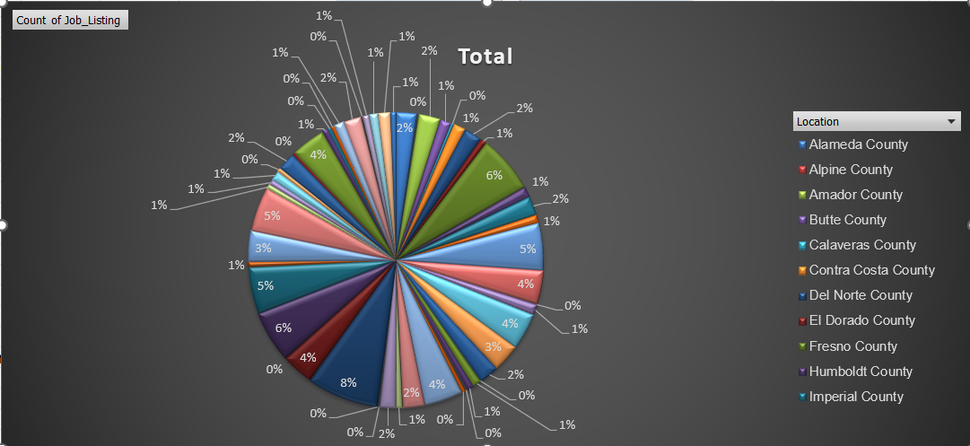

Nhóm các công việc được tuyển dụng trải đều ở tất cả các khu vực.

### Cụm 2:

|  |
| --- |
| ACCOUNTING ADMINISTRATOR I (SUPERVISOR), ACCOUNTING OFFICER (SPECIALIST), COMMUNICATIONS SUPERVISOR, COMMUNITY PROGRAM SPECIALIST III, CORRECTIONAL COUNSELOR II (SPECIALIST), CRIME ANALYST II, EMERGENCY MANAGEMENT COORDINATOR/INSTRUCTOR I, OFFICE OF EMERGENCY SERVICES, EMERGENCY MANAGEMENT COORDINATOR/INSTRUCTOR II, OFFICE OF EMERGENCY SERVICES, EMERGENCY SERVICES COORDINATOR, OFFICE OF EMERGENCY SERVICES, EXECUTIVE ASSISTANT, FINANCIAL ACCOUNTANT I, FISH AND WILDLIFE SEASONAL AID, HEALTH FACILITIES EVALUATOR II (SUPERVISOR), SENIOR ENGINEER WATER RESOURCES, SUPERVISING ENGINEER WATER RESOURCES, ACCOUNTANT TRAINEE, ASSOCIATE ACCOUNTING ANALYST, ASSOCIATE ENERGY SPECIALIST (TECHNOLOGY EVALUATION AND DEVELOPMENT), ASSOCIATE OPERATIONS SPECIALIST, FRANCHISE TAX BOARD, CRIME ANALYST I, EDUCATION FISCAL SERVICES CONSULTANT, INFORMATION OFFICER I (SPECIALIST), ASSOCIATE PROPERTY APPRAISER (BOARD OF EQUALIZATION), SENIOR ACCOUNTING OFFICER (SPECIALIST), ADMINISTRATOR III FRANCHISE TAX BOARD, ASSOCIATE BUSINESS MANAGEMENT ANALYST, ASSOCIATE MECHANICAL ENGINEER, ASSOCIATE TRANSPORTATION PLANNER, CUSTOMER SERVICE SUPERVISOR, FRANCHISE TAX BOARD, GRAPHIC DESIGNER III, HEALTH PROGRAM MANAGER II, OFFICE ASSISTANT (GENERAL), ACCOUNTING ANALYST, ASSOCIATE INVESTMENT MANAGER,PUBLIC EMPLOYEES` RETIREMENT SYSTEM, BATTALION CHIEF, CHILD DEVELOPMENT CONSULTANT, CLAIM AUDITOR, CORPORATION EXAMINER, CORRECTIONAL CASE RECORDS ANALYST, EXECUTIVE SECRETARY I, JUNIOR ENGINEERING TECHNICIAN, TAX TECHNICIAN II, BOARD OF EQUALIZATION, CORRECTIONAL COUNSELOR III, LEGAL ANALYST, PROGRAM MANAGER, PUBLIC UTILITIES COMMISSION, RESEARCH DATA SUPERVISOR II, ACCOUNTING ADMINISTRATOR II, ASSOCIATE ADMINISTRATIVE ANALYST ACCOUNTING SYSTEMS, ASSOCIATE RIGHT OF WAY AGENT, BUSINESS TAXES ADMINISTRATOR I, BOARD OF EQUALIZATION, CORRECTIONAL HEALTH SERVICES ADMINISTRATOR I, CORRECTIONAL FACILITY, ELECTRONICS TECHNICIAN, FINANCIAL ACCOUNTANT II, INFORMATION TECHNOLOGY TECHNICIAN, TAX TECHNICIAN I, BOARD OF EQUALIZATION, ASSOCIATE TELECOMMUNICATIONS ENGINEER, CORRECTIONAL ADMINISTRATOR, DEPARTMENT OF CORRECTIONS, CUSTODIAN SUPERVISOR II, DISASTER ASSISTANCE PROGRAM SPECIALIST I, SENIOR SPECIALIST PROPERTY APPRAISER (BOE), ADMINISTRATIVE ASSISTANT II, ADMINISTRATOR I, FRANCHISE TAX BOARD, ASSOCIATE BUDGET ANALYST, ENERGY COMMISSION SPECIALIST II (TECH EVALUATION AND DEVELOPMENT), ENVIRONMENTAL PROGRAM MANAGER II, INFORMATION TECHNOLOGY MANAGER II, STAFF MANAGEMENT AUDITOR (SPECIALIST) STATE CONTROLLER'S OFFICE, ASSISTANT BUREAU CHIEF, NON-PEACE OFFICER, ASSOCIATE HAZARDOUS MATERIALS SPECIALIST, ASSISTANT INDUSTRIAL HYGIENIST, AUDITOR I, DIGITAL PRINT OPERATOR II, EDUCATION PROGRAMS CONSULTANT, FINANCIAL ACCOUNTANT III, GROUNDSKEEPER (CORRECTIONAL FACILITY), HOUSING AND COMMUNITY DEVELOPMENT REPRESENTATIVE I, LEGAL SUPPORT SUPERVISOR I, MECHANICAL ENGINEER, SENIOR PERSONNEL SPECIALIST, YOUTH AID, ELECTRICIAN III (CORRECTIONAL FACILITY), OFFICE SERVICES SUPERVISOR I (TYPING), ATTORNEY II, FIELD REPRESENTATIVE, DEPARTMENT OF JUSTICE, MANAGEMENT SERVICES TECHNICIAN, PAINTER I, STUDENT ASSISTANT -ENGINEERING AND ARCHITECTURAL SCIENCES-, AGRICULTURE PROGRAM SUPERVISOR I, ASSOCIATE INSURANCE COMPLIANCE OFFICER, DEPARTMENT OF INSURANCE, ASSOCIATE PARK AND RECREATION SPECIALIST, CRIME ANALYST SUPERVISOR, CHIEF EXECUTIVE OFFICER, HEALTH CARE (SAFETY), Communications Editor, EDUCATION RESEARCH AND EVALUATION ADMINISTRATOR I, EDUCATION RESEARCH AND EVALUATION CONSULTANT, ELECTRIC GENERATION SYSTEM SPECIALIST III, HEAVY EQUIPMENT MECHANIC, MAILING MACHINES OPERATOR I, TRANSPORTATION SURVEYOR (CALTRANS), ADMINISTRATIVE OFFICER I, RESOURCES AGENCY, AIR QUALITY ENGINEER I, DEPARTMENT OF CONSUMER AFFAIRS, ASSOCIATE ENVIRONMENTAL PLANNER, BUSINESS SERVICE ASSISTANT (SPECIALIST), Assistant Secretary, Public and Employee Communications, ACCOUNT CLERK II, SENIOR PAYROLL SPECIALIST, ASSOCIATE INDUSTRIAL HYGIENIST, Hydroelectric Plant Technician II, PROGRAM MANAGER II, CALIFORNIA BAY DELTA AUTHORITY, PROGRAM MANAGER I, OFFICE OF EMERGENCY SERVICES, ASSISTANT TELECOMMUNICATIONS ENGINEER, CALTRANS HIGHWAY MECHANIC SUPERVISOR, COMMUNITY PROGRAM SPECIALIST II, DIRECT CONSTRUCTION SUPERVISOR II, ELECTRIC GENERATION SYSTEM SPECIALIST I, EMPLOYMENT PROGRAM MANAGER I, MANAGER I, DEPARTMENT OF MOTOR VEHICLES, ASSOCIATE PRINTING PLANT SUPERINTENDENT, ELECTRICIAN II, ENERGY ANALYST, HEALTH FACILITIES EVALUATOR MANAGER II, INFORMATION TECHNOLOGY SPECIALIST III, LEGAL ASSISTANT, CONTROL CASHIER II (VEHICLE REGISTRATION), DEPARTMENT OF MOTOR VEHICLES, HEALTH PROGRAM AUDIT MANAGER I, DEPARTMENT OF HEALTH SERVICES, SENIOR ENGINEERING GEOLOGIST, ASSISTANT PROPERTY AUDITOR APPRAISER (BOARD OF EQUALIZATION), ASSOCIATE ANALYST, ASSOCIATE PROGRAM AUDITOR, CalPERS, BUSINESS MANAGER I, ENERGY RESOURCES SPECIALIST III MANAGERIAL, ASSOCIATE PROPERTY AUDITOR APPRAISER (BOARD OF EQUALIZATION), HOUSING AND COMMUNITY DEVELOPMENT REPRESENTATIVE II, HOUSING AND COMMUNITY DEVELOPMENT SPECIALIST II, LICENSING REPRESENTATIVE II, ABC, PARK AIDE (SEASONAL), PERSONNEL PROGRAM ADVISOR, PROGRAM MANAGER II, OFFICE OF EMERGENCY SERVICES, RESEARCH DATA SUPERVISOR I, RESEARCH SCIENTIST II (EPIDEMIOLOGY/BIOSTATISTICS), SENIOR ACCOUNTING OFFICER (SUPERVISOR), SENIOR COMPLIANCE REPRESENTATIVE, FRANCHISE TAX BOARD, STAFF SERVICES MANAGER II (MANAGERIAL), SUPERVISING MANAGEMENT AUDITOR, TAX TECHNICIAN, FRANCHISE TAX BOARD, UTILITIES ENGINEER, WAREHOUSE WORKER, ASSOCIATE HEALTH PROGRAM ADVISER, ASSOCIATE HYDROELECTRIC POWER UTILITY ENGINEER, COMPLIANCE REPRESENTATIVE, FRANCHISE TAX BOARD, NURSE CONSULTANT III (SUPERVISOR), PUBLIC UTILITIES REGULATORY ANALYST I, SENIOR BRIDGE ENGINEER, SENIOR WORKERS' COMPENSATION INSURANCE REPRESENTATIVE, SPECIAL AGENT, SUPERVISING PROGRAM TECHNICIAN II, SUPERVISING SPECIAL INVESTIGATOR I (NON-PEACE OFFICER) , ASSOCIATE CONTROL ENGINEER, CORRECTIONAL LIEUTENANT, CUSTOMER SERVICE SPECIALIST, FRANCHISE TAX BOARD, DEPUTY ATTORNEY GENERAL SUPERVISOR, DIGITAL COMPOSITION SPECIALIST II, FINANCIAL ACCOUNTANT IV, FINANCIAL AND PERFORMANCE EVALUATOR II, DEPT OF FINANCE, GENERAL AUDITOR III, INVESTMENT MANAGER, PUBLIC EMPLOYEES' RETIREMENT SYSTEM, MANAGER II, DEPARTMENT OF MOTOR VEHICLES, PERSONNEL SUPERVISOR II, PHYSICIAN AND SURGEON, CORRECTIONAL FACILITY, PUBLIC HEALTH MEDICAL ADMINISTRATOR I, RESEARCH DATA ANALYST II, RESEARCH DATA SPECIALIST III , RESEARCH SCIENTIST III (SOCIAL BEHAVIORAL SCIENCES), RESEARCH SCIENTIST SUPERVISOR II (EPIDEMIOLOGY/BIOSTATISTICS), SENIOR TRANSPORTATION PLANNER, SUPERVISING PROGRAM TECHNICIAN III, TAX PROGRAM SUPERVISOR, FRANCHISE TAX BOARD, TRAINING OFFICER I, MATERIALS AND RESEARCH ENGINEERING ASSOCIATE (SPECIALIST), PHARMACY SERVICES MANAGER, PROGRAM TECHNICIAN III, RESEARCH SCIENTIST I (EPIDEMIOLOGY/BIOSTATISTICS), SENIOR AUDITOR EVALUATOR I, SENIOR AUDITOR EVALUATOR II, SENIOR AUDITOR EVALUATOR III, SENIOR MARKETING SPECIALIST, CALIFORNIA STATE LOTTERY, STATE PARK INTERPRETER II, SUPERVISING TRANSPORTATION ENGINEER, CALTRANS, TAX PROGRAM TECHNICIAN I, FRANCHISE TAX BOARD, WATER RESOURCES ENGINEERING ASSOCIATE (SPECIALIST), WORKERS' COMPENSATION ASSISTANT, AIR RESOURCES TECHNICIAN II, CALTRANS MAINTENANCE MANAGER I, FINANCIAL AND PERFORMANCE EVALUATOR I, DEPARTMENT OF FINANCE, LANDSCAPE ASSOCIATE, CALTRANS, OFFSET PRESS ASSISTANT, PUBLIC SAFETY OPERATOR, CALIFORNIA HIGHWAY PATROL, RECEIVER'S MEDICAL EXECUTIVE (SAFETY), SENIOR WATER RESOURCE CONTROL ENGINEER, TAX ADMINISTRATOR II, EMPLOYMENT DEVELOPMENT DEPARTMENT, CONSTRUCTION SUPERVISOR III (CORRECTIONAL FACILITY), DENTIST, CORRECTIONAL FACILITY, ELECTRIC GENERATION SYSTEM PROGRAM SPECIALIST I, MAILING MACHINES SUPERVISOR II, SENIOR ENVIRONMENTAL PLANNER, CODES AND STANDARDS ADMINISTRATOR I (NON-PEACE OFFICER), ENVIRONMENTAL PLANNER, PSYCHOLOGIST (HEALTH FACILITY - CLINICAL), DEPARTMENTS OF MENTAL HEALTH AND DEVELOPMENTAL SERVICES, SENIOR HAZARDOUS SUBSTANCES ENGINEER, ASSISTANT HEALTH PHYSICIST, AVIATION OFFICER II (FLIGHT OPERATIONS), FISCAL ANALYST, PERSONNEL SUPERVISOR I, SENIOR CLINICAL LABORATORY TECHNOLOGIST, CORRECTIONAL FACILITY, SENIOR TAX COMPLIANCE REPRESENTATIVE (SPECIALIST), AIR RESOURCES SUPERVISOR II, AUTOMOTIVE POOL ATTENDANT I, COMMUNITY COLLEGE PROGRAM ASSISTANT , ENERGY COMMISSION SPECIALIST I (TECH EVALUATION AND DEVELOPMENT), GRADUATE LEGAL ASSISTANT, PRINTING TRADES SPECIALIST TRAINEE (GENERAL), SENIOR MECHANICAL ENGINEER, VETERINARIAN SPECIALIST (GENERAL), FISCAL SUPERVISOR, Supervising Analyst, SUPERVISING HAZARDOUS SUBSTANCES ENGINEER I, SUPERVISING PSYCHIATRIC SOCIAL WORKER I, SUPERVISING TRANSPORTATION PLANNER, SUPPORT SERVICES ASSISTANT (INTERPRETER), RESEARCH SCIENTIST SUPERVISOR I (EPIDEMIOLOGY/BIOSTATISTICS), SENIOR MANAGEMENT AUDITOR, TAX PROGRAM TECHNICIAN II, FRANCHISE TAX BOARD, AGRICULTURAL BIOLOGICAL TECHNICIAN, COMMUNITY COLLEGE ADMINISTRATOR I, PRINCIPAL TRANSPORTATION ENGINEER, CALTRANS, STATE FAIR WORKER, CASUAL EMPLOYMENT (VARIOUS), PRINCIPAL HYDROELECTRIC POWER UTILITY ENGINEER, ASSISTANT AGRICULTURAL ECONOMIST, RESEARCH SCIENTIST II (SOCIAL/BEHAVIORAL SCIENCES), RESEARCH SCIENTIST IV (EPIDEMIOLOGY/BIOSTATISTICS), STAFF PROGRAM AUDITOR, CALPERS, SUPERVISING VETERINARIAN (GENERAL), TELECOMMUNICATIONS SYSTEMS TECHNICIAN II, FIELD REPRESENTATIVE, BOARD OF CORRECTIONS, WELFARE FRAUD PREVENTION COORDINATOR, SENIOR STATE ARCHEOLOGIST, ASSOCIATE TOXICOLOGIST, AGRICULTURE PROGRAM SUPERVISOR IV, SUPERVISING PSYCHIATRIC SOCIAL WORKER II, CORRECTIONAL FACLTY, NURSE CONSULTANT III (SPECIALIST), INVESTMENT OFFICER II, PUBLIC EMPLOYEES' RETIREMENT SYSTEM, FOUNDATION DRILLER, PRIVATE POSTSECONDARY EDUCATION SPECIALIST, PROJECT MANAGER I, LITTLE HOOVER COMMISSION, VETERINARIAN (GENERAL) |

**Ý nghĩa cụm 2:**

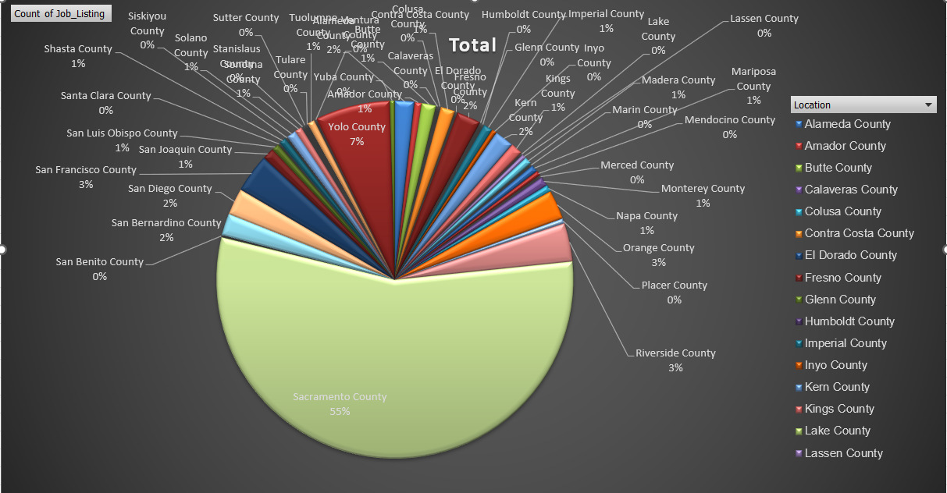

Nhóm các công việc được tuyển dụng chủ yếu tại khu vực *Sacramento County.*

### Cụm 3:

|  |
| --- |
| ADOPTIONS SPECIALIST, ASSOCIATE MANAGEMENT AUDITOR, ATTORNEY, ATTORNEY III, ATTORNEY IV, C. E. A., DEPUTY ATTORNEY GENERAL IV, DISABILITY INSURANCE PROGRAM REPRESENTATIVE, ENVIRONMENTAL PROGRAM MANAGER I (SUPERVISORY), INFORMATION TECHNOLOGY SPECIALIST I, INFORMATION TECHNOLOGY SPECIALIST II, STAFF SERVICES MANAGER II (SUPERVISORY), ATTORNEY, ASSISTANT CHIEF COUNSEL, DEPUTY ATTORNEY GENERAL, DEPUTY ATTORNEY GENERAL III, DISTRICT ADMINISTRATOR, ALCOHO, HEALTH PROGRAM SPECIALIST II, AIR RESOURCES ENGINEER (MAND), FINANCIAL INSTITUTIONS EXAMINER, TAX TECHNICIAN III, BOARD OF EQUALIZATION, AIR POLLUTION SPECIALIST, BUSINESS TAXES REPRESENTATIVE, ACCOUNTING ADMINISTRATOR I (SPECIALIST), ENGINEER,CIVIL, RESEARCH DATA SPECIALIST I, ADMINISTRATIVE LAW JUDGE, BOOKBINDER IV, BUSINESS TAXES COMPLIANCE SPECIALIST, ENVIRONMENTAL PROGRAM MANAGER I (MANAGERIAL), BUSINESS TAXES SPECIALIST I, BOARD OF EQUALIZATION, FORESTRY AIDE, INFORMATION TECHNOLOGY ASSOCIATE, INFORMATION TECHNOLOGY MANAGER I, ATTORNEY V, FIRE CAPTAIN, FIRE FIGHTER II (PARAMEDIC), HEALTH EDUCATION CONSULTANT II, INFORMATION TECHNOLOGY SUPERVISOR II, ASSOCIATE ARCHITECT, ASSOCIATE STATE ARCHAEOLOGIST, ATTORNEY SUPERVISOR, SENIOR ENVIRONMENTAL SCIENTIST (SPECIALIST), ASSISTANT CHIEF, AGRICULTURAL AIDE (SEASONAL), BUSINESS TAXES SPECIALIST III, BOARD OF EQUALIZATION, COMMUNITY PROGRAM SPECIALIST IV, SENIOR WORKERS' COMPENSATION CLAIMS ADJUSTER, AIR RESOURCES SUPERVISOR I, BUSINESS TAXES SPECIALIST II, BOARD OF EQUALIZATION, TRANSPORTATION ENGINEER (CIVIL), COASTAL PROGRAM ANALYST III, FAIR EMPLOYMENT AND HOUSING CONSULTANT III (SPECIALIST), FISH AND WILDLIFE INTERPRETER II, ASSOCIATE SPACE PLANNER, RESEARCH DATA SPECIALIST II, ASSOCIATE SAFETY ENGINEER (PRESSURE VESSELS), CHILD NUTRITION CONSULTANT, MATE, FISH AND GAME VESSEL, SENIOR ENVIRONMENTAL SCIENTIST (SUPERVISORY), DEPUTY LABOR COMMISSIONER I, CONSULTING PSYCHOLOGIST, INSPECTOR, BOARD OF PHARMACY, LEGAL SECRETARY, FIRE CHIEF, NURSE EVALUATOR II, HEALTH SERVICES, PROGRAM SPECIALIST III, FRANCHISE TAX BOARD, RESEARCH SCIENTIST III (EPIDEMIOLOGY/BIOSTATISTICS), SENIOR PARK AND RECREATION SPECIALIST, STAFF SERVICES MANAGER III, ASSOCIATE REAL ESTATE OFFICER, HEAVY TRUCK DRIVER, PUBLIC UTILITIES REGULATORY ANALYST V, SENIOR ESTIMATOR OF BUILDING CONSTRUCTION, STAFF AIR POLLUTION SPECIALIST, STAFF MANAGEMENT AUDITOR, STATIONARY ENGINEER, SUPERVISING INSPECTOR, BOARD OF PHARMACY, INVESTMENT OFFICER II, STATE TEACHERS' RETIREMENT SYSTEM, TEACHING ASSISTANT, SCHOOL FOR THE BLIND, WORKERS' COMPENSATION INSURANCE TECHNICIAN, COASTAL PROGRAM MANAGER, DISABILITY INSURANCE PROGRAM MANAGER III, FIELD REPRESENTATIVE, BOARD OF FUNERAL DIRECTORS AND EMBALMERS, LAW ENFORCEMENT CONSULTANT I, COMMISSION ON PEACE OFFICER STANDARDS AND TRAINING, MAINTENANCE WORKER, TUNNELS AND TUBES, SENIOR EMERGENCY SERVICES COORDINATOR, OFFICE OF EMERGENCY SERVICES, SENIOR PSYCHOLOGIST (HEALTH FACILITY) (SUPERVISOR), BUSINESS SERVICE OFFICER I (SPECIALIST), HEALTH EDUCATION CONSULTANT III (SPECIALIST), HEALTH PROGRAM MANAGER I, INFORMATION OFFICER II, MINERAL RESOURCES INSPECTOR II, SHEETFED OFFSET PRESS OPERATOR II, DEPUTY INSPECTOR GENERAL, MANAGER I, STATE COMPENSATION INSURANCE FUND, MEDICAL CONSULTANT I, DEPARTMENT OF HEALTH SERVICES, RESEARCH DATA ANALYST I, RESEARCH DATA MANAGER, ADMINISTRATOR IV FRANCHISE TAX BOARD, AUTOMOTIVE TECHNICIAN I, MOTOR VEHICLE REPRESENTATIVE, SPECIAL ASSISTANT INSPECTOR GENERAL, STAFF TOXICOLOGIST (SPECIALIST), INVESTIGATIVE CERTIFIED PUBLIC ACCOUNTANT, NIGHT ATTENDANT, SCHOOL FOR THE DEAF, ASSOCIATE TAX AUDITOR, BOARD OF EQUALIZATION, SUPERVISING FRAUD INVESTIGATOR I, DEPARTMENT OF INSURANCE, TAX AUDITOR, BOARD OF EQUALIZATION, WORKERS' COMPENSATION CLAIMS ADJUSTER, MEDICAL CONSULTANT II, DEPARTMENT OF HEALTH SERVICES, PROGRAM SPECIALIST II, FRANCHISE TAX BOARD, PUBLIC HEALTH MEDICAL OFFICER II, STRUCTURAL PEST CONTROL BOARD SPECIALIST, PROGRAM REPRESENTATIVE II (SPECIALIST), DEPARTMENT OF CONSUMER AFFAIRS, HOSPITAL POLICE OFFICER, CHILD NUTRITION SUPERVISOR I, SENIOR TOXICOLOGIST, AGENT, ALCOHOLIC BEVERAGE CONT, NIGHT ATTENDANT, SCHOOL FOR THE BLIND, RESEARCH SCIENTIST MANAGER (CHEMICAL SCIENCES), NUTRITION EDUCATION CONSULTANT |

**Ý nghĩa cụm 3:**

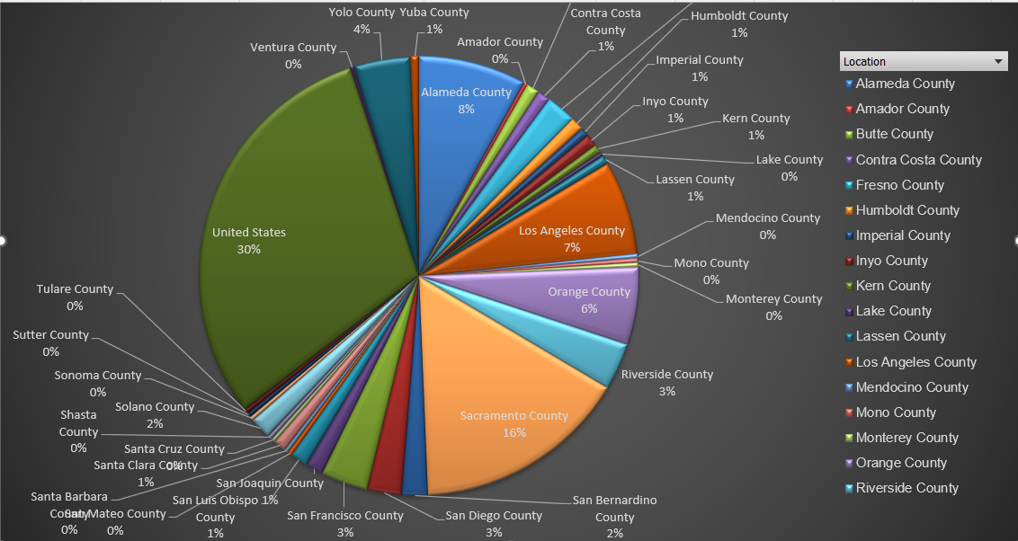

Nhóm các công việc được tuyển dụng chủ yếu tại khu vực *United States và Sacramento* *County.*

### Cụm 4:

|  |
| --- |
| BUSINESS SERVICE OFFICER I (SUPERVISOR), DIRECT CONSTRUCTION SUPERVISOR I, ENGINEER, WATER RESOURCES, PROGRAM TECHNICIAN II, AUTOMOTIVE TECHNICIAN II, DISTRICT SALES REPRESENTATIVE, CA STATE LOTTERY, HEALTH FACILITIES EVALUATOR MANAGER I, ASSISTANT COORDINATOR OF NURSING SERVICES, ASSOCIATE TAX AUDITOR , EMPLOYMENT DEVELOPMENT DEPARTMENT, CALTRANS HEAVY EQUIPMENT MECHANIC, HAZARDOUS SUBSTANCES ENGINEER, ADMINISTRATOR II, FRANCHISE TAX BOARD, AREA ADMINISTRATOR, DIVISION OF APPRENTICESHIP STANDARDS, ENGINEERING GEOLOGIST, CHIEF ENGINEER II, CLINICAL SOCIAL WORKER (HEALTH FACILITY), DENTIST, DEPARTMENTS OF MENTAL HEALTH AND DEVELOPMENTAL SERVICES, ELECTRICAL ENGINEER, STAFF SERVICES MANAGEMENT AUDITOR, CUSTODIAN SUPERVISOR I, DRIVER SAFETY HEARING OFFICER, DRIVER SAFETY MANAGER I, ASSOCIATE CONSTRUCTION ANALYST, COMMUNICATIONS OPERATOR, AGRICULTURAL TECHNICIAN II (SEASONAL), ASSOCIATE OIL AND GAS ENGINEER, CHIEF ENGINEER I, STATIONARY ENGINEER (CORRECTIONAL FACILITY), ACTIVITY COORDINATOR, VETERANS HOME AND MEDICAL CENTER, CONSERVANCY PROJECT DEVELOPMENT ANALYST II, ELECTRICIAN I, SEASONAL CLERK, STAFF PSYCHIATRIST (SAFETY), COASTAL PROGRAM ANALYST I, FIRE AND LIFE SAFETY OFFICER II (HEALTH FACILITIES CONSTRUCTION), BUILDING MAINTENANCE WORKER, ACCOUNTING TECHNICIAN, CHIEF OF PLANT OPERATION I, HEALTH PROGRAM AUDITOR IV, DEPARTMENT OF HEALTH SERVICES, LABORER, OFFICE TECHNICIAN (GENERAL), FOOD SERVICE SUPERVISOR II, LICENSING-REGISTRATION EXAMINER, DEPARTMENT OF MOTOR VEHICLES, PAROLE AGENT II, ADULT PAROLE SUPERVISOR, PROGRAM AND PROJECT SUPERVISOR, PUBLIC UTILITIES COMMISSION, PROGRAM TECHNICIAN, SENIOR LEGAL ANALYST, SENIOR TELECOMMUNICATIONS ENGINEER, STAFF PARK AND RECREATION SPECIALIST, LICENSING PROGRAM ANALYST, PUBLIC SAFETY DISPATCHER, CALIFORNIA HIGHWAY PATROL, SCIENTIFIC AID, SENIOR UTILITIES ENGINEER (SPECIALIST), TRANSPORTATION SURVEYOR PARTY CHIEF (CALTRANS), WORKERS' COMPENSATION CONSULTANT, HYDROELECTRIC PLANT TECHNICIAN I, PUBLIC UTILITIES REGULATORY ANALYST IV, SENIOR TRANSPORTATION ENGINEER, CALTRANS, WAREHOUSE MANAGER II, TRANSPORTATION ENGINEER (ELECTRICAL), WATER SERVICES SUPERVISOR, DISABILITY INSURANCE PROGRAM MANAGER I, INVESTIGATOR, PAROLE SERVICE ASSOCIATE, PUBLIC UTILITIES REGULATORY ANALYST II, SENIOR HYDROELECTRIC PLANT OPERATOR, SENIOR PSYCHOLOGIST (HEALTH FACILITY) (SPECIALIST), SPECIAL AGENT, DEPARTMENT OF JUSTICE, SUPERVISING REGISTERED NURSE III, CORRECTIONAL FACILITY, INVESTIGATIVE AUDITOR III, DEPARTMENT OF JUSTICE, MAINTENANCE AIDE (SEASONAL), NURSE INSTRUCTOR, PROPERTY CONTROLLER II (CORRECTIONAL FACILITY), PSYCHIATRIC TECHNICIAN INSTRUCTOR, SENIOR PSYCHIATRIC TECHNICIAN (SAFETY), PHARMACEUTICAL CONSULTANT II, DEPARTMENT OF HEALTH SERVICES (SUPERVISORY), PUBLIC UTILITIES REGULATORY ANALYST III, SENIOR LEGAL TYPIST, AUTOMOTIVE EQUIPMENT OPERATOR I, DEPARTMENT OF MENTAL HEALTH AND DEVELOPMENTAL SERVICES, PAROLE AGENT III, ADULT PAROLE, SENIOR STRUCTURAL ENGINEER, SUPPORT SERVICES ASSISTANT (GENERAL), BUSINESS SERVICE OFFICER II (SUPERVISOR), FINANCIAL INSTITUTIONS MANAGER, SUPERVISING TAX AUDITOR II BOARD OF EQUALIZATION, LEAD GROUNDSKEEPER I (CORRECTIONAL FACILITY), PETROLEUM DRILLING ENGINEER, SENIOR LANDSCAPE ARCHITECT, CALTRANS, PHYSICIAN ASSISTANT, CORRECTIONAL FACILITY, WORKERS COMPENSATION COMPLIANCE OFFICER, PSYCHOLOGIST (HEALTH FACILITY - CLINICAL - SAFETY), MEDICAL CONSULTANT (ENFORCEMENT), MEDICAL BOARD OF CALIFORNIA, CHIEF, RESTORATIVE CARE SERVICE, REHABILITATION THERAPIST, STATE FACILITIES (RECREATION), LEAD GROUNDSKEEPER, LABORATORY ASSISTANT, PROGRAM REPRESENTATIVE I, DEPARTMENT OF CONSUMER AFFAIRS |

**Ý nghĩa cụm 4:**

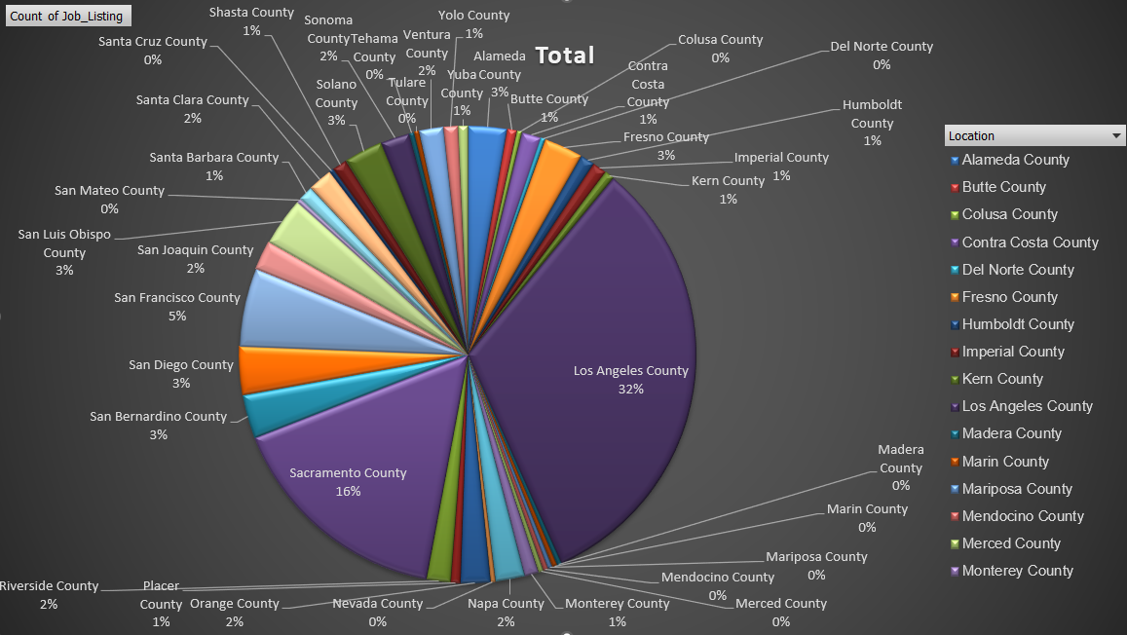

Nhóm các công việc được tuyển dụng chủ yếu tại khu vực *Los Angeles County và Sacramento* *County..*

### Trực quan hóa trên Gephi:

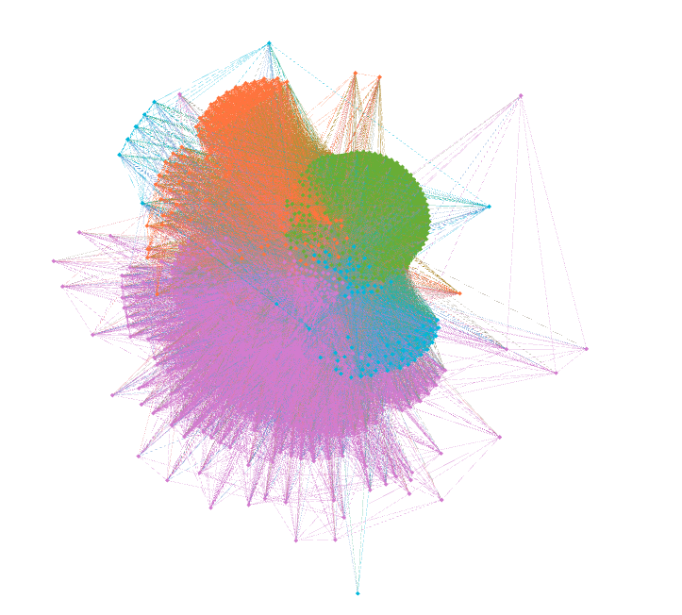

## Thuật toán Spinglass

Import thư viện và vẽ graph [2]

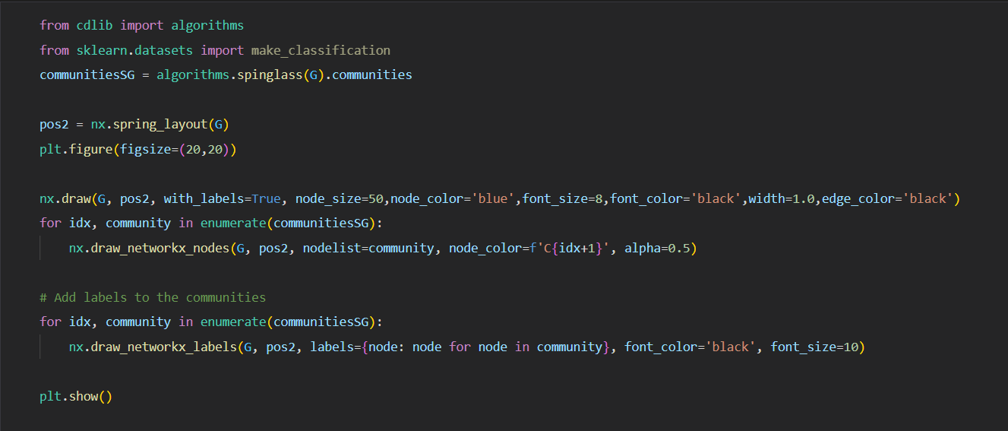

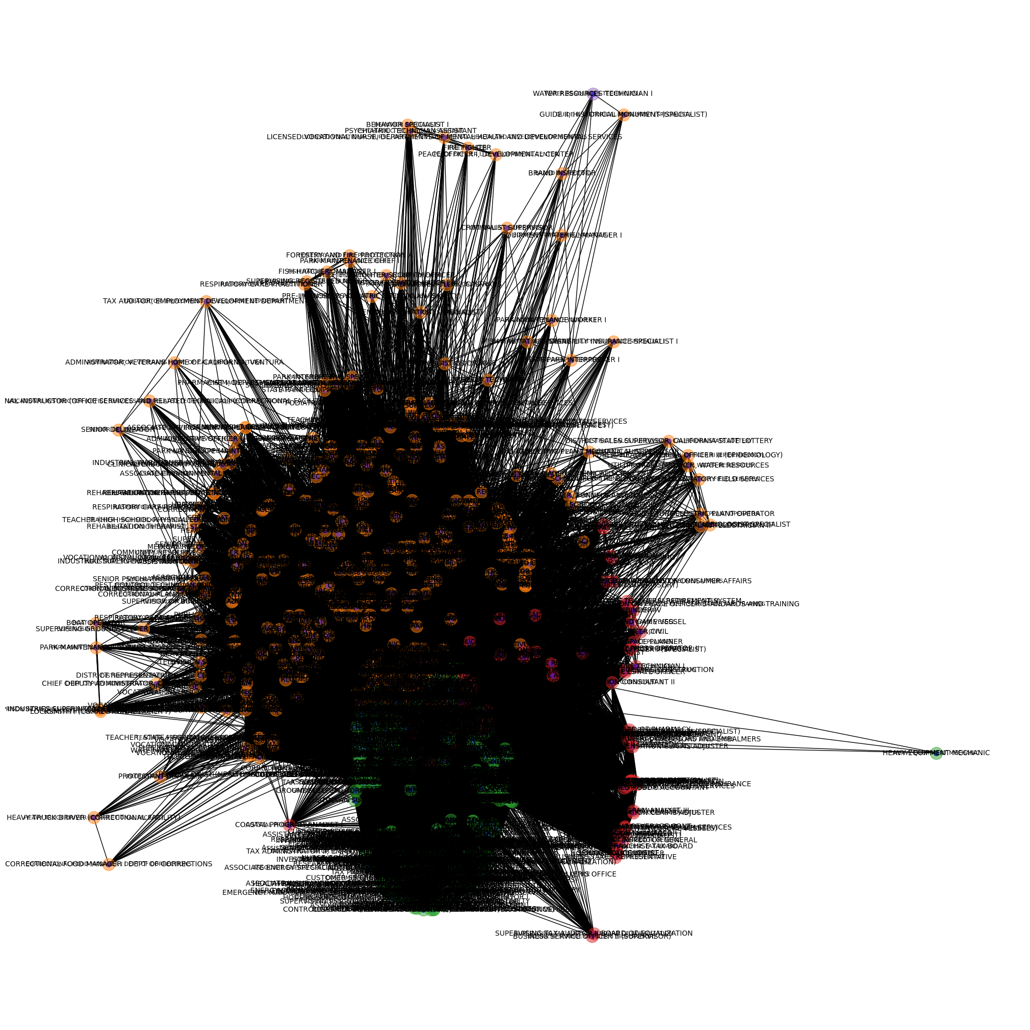

### Cụm 1:

|  |
| --- |
| CORRECTIONAL SUPERVISING COOK (CORRECTIONAL FACILITY), MECHANICAL AND TECHNICAL OCCUPATIONAL TRAINEE, ACCOUNTANT I (SPECIALIST), ADOPTIONS SPECIALIST, ASSOCIATE GOVERNMENTAL PROGRAM ANALYST, ASSOCIATE PERSONNEL ANALYST, AUTOMOBILE MECHANIC (CORRECTIONAL FACILITIES), BUSINESS SERVICE OFFICER I (SUPERVISOR), CALTRANS EQUIPMENT OPERATOR II, CALTRANS HIGHWAY MAINTENANCE LEADWORKER, CALTRANS HIGHWAY MAINTENANCE WORKER, CALTRANS LANDSCAPE MAINTENANCE LEADWORKER, CAPTAIN, ADULT INSTITUTION, CERTIFIED NURSING ASSISTANT, CHIEF PHYSICIAN AND SURGEON, CORRECTIONAL FACILITY, CONSERVATIONIST I, COOK SPECIALIST I, CUSTODIAN I, CUSTODIAN II, DENTAL ASSISTANT, CORRECTIONAL FACILITY, DIRECT CONSTRUCTION SUPERVISOR I, EMPLOYMENT PROGRAM REPRESENTATIVE, ENVIRONMENTAL SCIENTIST, FORESTRY TECHNICIAN, GROUNDSKEEPER, HEALTH PROGRAM MANAGER III, HEALTH RECORD TECHNICIAN I, HEALTH SERVICES SPECIALIST (SAFETY), HEAVY EQUIPMENT MECHANIC (CORRECTIONAL FACILITY), HEAVY EQUIPMENT MECHANIC APPRENTICE, CALTRANS, INFORMATION TECHNOLOGY SPECIALIST I, REGISTERED NURSE (SAFETY), STAFF SERVICES ANALYST, STAFF SERVICES MANAGER I, AGRICULTURAL TECHNICIAN I (SEASONAL), AUTOMOTIVE TECHNICIAN II, CALTRANS ELECTRICIAN I, CALTRANS EQUIPMENT OPERATOR I, CALTRANS LANDSCAPE SPECIALIST, CALTRANS MAINTENANCE SUPERVISOR, CARPENTER I, CARPENTER II (CORRECTIONAL FACILITY), CASE RECORDS TECHNICIAN, COMMERCIAL VEHICLE INSPECTION SPECIALIST, CORRECTIONAL OFFICER, CORRECTIONAL SERGEANT, DISPATCH-CLERK SUPERVISOR, CALTRANS, FOOD ADMINISTRATOR I (CORRECTIONAL FACILITY), HEALTH PROGRAM SPECIALIST I, INDUSTRIAL SUPERVISOR, PRISON INDUSTRIES (MAINTENANCE AND REPAIR), JEWISH CHAPLAIN, OFFICE TECHNICIAN (TYPING), ADMINISTRATIVE ASSISTANT I, ASSISTANT COORDINATOR OF NURSING SERVICES, ASSOCIATE TAX AUDITOR , EMPLOYMENT DEVELOPMENT DEPARTMENT, AUTOMOTIVE EQUIPMENT OPERATOR I (MAND), BEHAVIOR SPECIALIST II, CALTRANS HEAVY EQUIPMENT MECHANIC, CALTRANS LANDSCAPE MAINTENANCE WORKER, CHIEF, FIREFIGHTER/SECURITY OFFICER, CORRECTIONAL PLANT SUPERVISOR, DEPT OF CORRECTIONS, FISH AND WILDLIFE SCIENTIFIC AID, FISH AND WILDLIFE TECHNICIAN, FOOD SERVICE TECHNICIAN I, FORESTRY LOGISTICS OFFICER I, HYDROELECTRIC PLANT MECHANICAL SUPERVISOR, NATIVE AMERICAN SPIRITUAL LEADER, SENIOR PSYCHIATRIST (SPECIALIST), STUDENT ASSISTANT, AREA ADMINISTRATOR, DIVISION OF APPRENTICESHIP STANDARDS, CHIEF PSYCHIATRIST, CORRECTIONAL AND REHAB SERVICES (SAFETY), CLINICAL SOCIAL WORKER (HEALTH/CORRECTIONAL FACILITY) - SAFETY, CORRECTIONAL CASE RECORDS MANAGER, CORRECTIONAL CASE RECORDS SUPERVISOR, CORRECTIONAL COUNSELOR I, ENGINEERING GEOLOGIST, ENVIRONMENTAL SERVICES INTERN, SUPERVISING REGISTERED NURSE (SAFETY), ELECTRICIAN II (CORRECTIONAL FACILITY), PAINTER II (CORRECTIONAL FACILITY), SUPERVISING CORRECTIONAL COOK DEPT OF CORRECTIONS, CHIEF ENGINEER II, CLINICAL SOCIAL WORKER (HEALTH FACILITY), COMMUNITY RESOURCES MANAGER, DEPARTMENT OF CORRECTIONS, COOK SPECIALIST II, CRIMINALIST SUPERVISOR, DENTIST, DEPARTMENTS OF MENTAL HEALTH AND DEVELOPMENTAL SERVICES, FIRE PREVENTION SPECIALIST I, FIRE PREVENTION SPECIALIST II, PLUMBER II (CORRECTIONAL FACILITY), ADMINISTRATIVE LAW JUDGE, BUSINESS TAXES COMPLIANCE SPECIALIST, CALTRANS ELECTRICAL SUPERVISOR, CALTRANS ELECTRICIAN II, CARPENTER III (CORRECTIONAL FACILITY), CONSERVATIONIST SUPERVISOR, CORRECTIONAL PLANT MANAGER II, DEPT OF CORRECTIONS, CUSTODIAN SUPERVISOR I, DRIVER SAFETY HEARING OFFICER, DRIVER SAFETY MANAGER I, CLINICAL LABORATORY TECHNOLOGIST, CORRECTIONAL FACILITY, COMMUNICATIONS OPERATOR, FISH HABITAT ASSISTANT, HEAVY FIRE EQUIPMENT OPERATOR, HOSPITAL POLICE LIEUTENANT, CHIEF DEPUTY ADMINISTRATOR, CORRECTIONAL PROGRAM, CEA, CONSERVATIONIST II, PSYCHIATRIC TECHNICIAN (SAFETY), CORRECTIONAL COUNSELOR II (SUPERVISOR), ELECTRONICS TECHNICIAN (CORRECTIONAL FACILITY), FORESTRY AND FIRE PROTECTION A, HEARING REPORTER, INDUSTRIAL SUPERVISOR, PRISON INDUSTRIES (LAUNDRY), LICENSED VOCATIONAL NURSE, CALIFORNIA DEPARTMENT OF CORRECTIONS AND REHABILITATION, STATIONARY ENGINEER (CORRECTIONAL FACILITY), ACTIVITY COORDINATOR, VETERANS HOME AND MEDICAL CENTER, CONSERVANCY PROJECT DEVELOPMENT ANALYST II, ELECTRICAL ENGINEERING TECHNICIAN I, FORESTER II (SUPERVISORY), HEALTH FACILITIES EVALUATOR NURSE, MEDICAL ASSISTANT, ADMINISTRATOR, VETERANS HOME OF CALIFORNIA, VENTURA, BOAT OPERATOR, CONTROL CASHIER I (MOTOR VEHICLE SERVICES), DEPARTMENT OF MOTOR VEHICLES, TELEVISION SPECIALIST, APPRENTICESHIP CONSULTANT, CALTRANS MAINTENANCE AREA SUPERINTENDENT, MUSLIM CHAPLAIN, ASSISTANT CORRECTIONAL FOOD MANAGER (DEPT OF CORRECTIONS), ASSISTANT SAFETY ENGINEER, DISPATCHER-CLERK, CALTRANS, OFFICE ASSISTANT (TYPING), PARK MAINTENANCE WORKER I, RECREATION THERAPIST, CORRECTIONAL FACILITY, STAFF PSYCHIATRIST (SAFETY), TEACHER (HIGH SCHOOL-GENERAL EDUCATION) (CORRECTIONAL FACILITY), CORRECTIONAL BUSINESS MANAGER I, DEPARTMENT OF CORRECTIONS, SENIOR VOCATIONAL REHABILITATION COUNSELOR, QUALIFIED REHABILITIATION PROFESSIONAL, TRANSPORTATION ENGINEER (CIVIL), CHIEF ENGINEER I (CORRECTIONAL FACILITY), FIRE AND LIFE SAFETY OFFICER II (HEALTH FACILITIES CONSTRUCTION), DISABILITY INSURANCE SPECIALIST I, GRADUATE STUDENT ASSISTANT, PROGRAM DIRECTOR (MENTAL DISABILITIES-SAFETY), CHIEF HYDROELECTRIC PLANT OPERATOR, CORRECTIONAL FOOD MANAGER I DEPT OF CORRECTIONS, EXAMINER II LABORATORY FIELD SERVICES, REGISTERED NURSE, CORRECTIONAL FACILITY, TEACHING ASSISTANT (CORRECTIONAL FACILITY), CALTRANS BRIDGE MAINTENANCE SUPERVISOR, CHIEF OF PLANT OPERATION I, DISABILITY INSURANCE PROGRAM MANAGER II, HEALTH PROGRAM AUDITOR IV, DEPARTMENT OF HEALTH SERVICES, SPECIAL AGENT-IN-CHARGE, CORRECTIONAL HEALTH SERVICES ADMINISTRATOR II, CORRECTIONAL FACILITY, FORESTRY ASSISTANT II, LABORER, LICENSED VOCATIONAL NURSE (MAND), GUIDE II, HISTORICAL MONUMENT (SPECIALIST), PHARMACY TECHNICIAN, SENIOR MOTOR VEHICLE TECHNICIAN, DISTRICT REPRESENTATIVE II, DIV CDS& STNDS (NON-PEACE OFFICER), DISTRICT SALES SUPERVISOR, CALIFORNIA STATE LOTTERY, FOOD SERVICE SUPERVISOR II, LICENSING-REGISTRATION EXAMINER, DEPARTMENT OF MOTOR VEHICLES, ARCHEOLOGICAL PROJECT LEADER (SEASONAL), ARCHEOLOGICAL SPECIALIST (SEASONAL), ASSOCIATE MENTAL HEALTH SPECIALIST, FIRE CAPTAIN CORRECTION INSTITUTION, LABORATORY ASSISTANT, CORRECTIONAL FACILITY, LIBRARIAN (CORRECTIONAL FACILITY), LIBRARY TECHNICAL ASSISTANT (SAFETY), MAINTENANCE MECHANIC, MAINTENANCE MECHANIC (CORRECTIONAL FACILITY), MAINTENANCE WORKER, DEPARTMENT OF THE CALIF. HIGHWAY PATROL, OIL SPILL PREVENTION SPECIALIST, OPTOMETRIST, CORRECTIONAL FACILITY, PAROLE AGENT II, ADULT PAROLE SUPERVISOR, PERSONNEL SPECIALIST, PHYSICAL THERAPIST I, CORRECTIONAL FACILITY, PROGRAM ASSISTANT (MENTAL DISABILITIES-SAFETY), RADIOLOGIC TECHNOLOGIST, CORRECTIONAL FACILITY, REGISTERED NURSE (MAND), RESPIRATORY CARE SUPERVISOR, CORRECTIONAL FACILITY, ROUTE SALES REPRESENTATIVE, SENIOR PARK AIDE (SEASONAL), SENIOR PSYCHIATRIST (SUPERVISOR), CORRECTIONAL AND REHABILITATIVE SERVICES (SAFETY), SPECIAL INVESTIGATOR, STATE PARK PEACE OFFICER SUPERVISOR (RANGER), SUPERVISING CLINICAL LABORATORY TECHNOLOGIST, CORRECTIONAL FACILTY, SUPERVISING COOK I, SUPERVISING REGISTERED NURSE II, CORRECTIONAL FACILITY, TEACHER (HIGH SCHOOL-PHYSICAL EDUCATION) (CORRECTIONAL FACILITY), TRANSPORTATION ENGINEERING TECHNICIAN, UNIT SUPERVISOR (SAFETY), UTILITY CRAFTSWORKER, WATER RESOURCES, VOCATIONAL INSTRUCTOR (BUILDING MAINTENANCE) (CORRECTIONAL FACILITY), COUNSELOR, SCHOOL FOR THE DEAF, HEALTH RECORD TECHNICIAN II (SUPERVISOR), HYDROELECTRIC PLANT ELECTRICIAN II, LICENSING PROGRAM ANALYST, LICENSING PROGRAM MANAGER II, PARK MAINTENANCE CHIEF I, PHARMACIST I (MAND), PROTESTANT CHAPLAIN, PUBLIC HEALTH MICROBIOLOGIST SPECIALIST, PUBLIC SAFETY DISPATCHER, CALIFORNIA HIGHWAY PATROL, REHABILITATION THERAPIST, STATE FACILITIES (RECREATION-SAFETY), SCIENTIFIC AID, STAFF PSYCHIATRIST (MAND), STATIONARY ENGINEER, STOCK CLERK, TAX ADMINISTRATOR I, EMPLOYMENT DEVELOPMENT DEPARTMENT, TAX AUDITOR, EMPLOYMENT DEVELOPMENT DEPARTMENT, TRANSPORTATION SURVEYOR PARTY CHIEF (CALTRANS), VOCATIONAL INSTRUCTOR (CARPENTRY) (CORRECTIONAL FACILITY), VOCATIONAL INSTRUCTOR (WELDING) (CORRECTIONAL FACILITY), VOCATIONAL INSTRUCTOR, AUTO MECHANICS (CORRECTIONAL FACILITY), WILDLIFE HABITAT ASSISTANT, INDUSTRIAL WAREHOUSE AND DISTRIBUTION SUPERVISOR, PRISON INDUSTRY, MOTOR CARRIER SPECIALIST I, CALIFORNIA HIGHWAY PATROL, NURSE PRACTITIONER (SAFETY), PARK LANDSCAPE MAINTENANCE TECHNICIAN, PARK MAINTENANCE ASSISTANT, PRISON INDUSTRIES SUPERINTENDENT II (MATTRESS AND BEDDING), PSYCHIATRIC TECHNICIAN ASSISTANT (SAFETY), PSYCHOLOGIST - CLINICAL, CORRECTIONAL FACILITY, PUBLIC HEALTH MEDICAL OFFICER III (EPIDEMIOLOGY), PUBLIC HEALTH NURSE II, CORRECTIONAL FACILITY, PUBLIC SAFETY DISPATCH SUPERVISOR I CALIFORNIA HIGHWAY PATROL, SENIOR PSYCHOLOGIST, CORRECTIONAL FACILITY (SPECIALIST), SENIOR PSYCHOLOGIST, CORRECTIONAL FACILITY (SUPERVISOR), SENIOR TRANSPORTATION ENGINEER, CALTRANS, SENIOR TRANSPORTATION SURVEYOR (CALTRANS), SUPERVISOR OF BUILDING TRADES (CORRECTIONAL FACILITY), TEACHING ASSISTANT, SCHOOL FOR THE BLIND, WAREHOUSE MANAGER II, BEHAVIOR SPECIALIST I, DISTRICT SUPERINTENDENT II, DEPARTMENT OF PARKS AND RECREATION SERIES, LABOR RELATIONS ANALYST, LOCKSMITH I (CORRECTIONAL FACILITY), MAINTENANCE WORKER, TUNNELS AND TUBES, MATERIALS AND STORES SUPERVISOR II (CORRECTIONAL FACILITY), MEDICAL RECORD DIRECTOR, PARK MAINTENANCE SUPERVISOR, PHARMACIST II, PRE-LICENSED PSYCHIATRIC TECHNICIAN, REGIONAL DENTAL DIRECTOR, CEA, REGISTERED DIETITIAN, CORRECTIONAL FACILITY, RESPIRATORY CARE PRACTITIONER, CORRECTIONAL FACILITY, SENIOR RADIOLOGIC TECHNOLOGIST, CORRECTIONAL FACILITY (SPECIALIST), WATER SERVICES SUPERVISOR, DISABILITY INSURANCE PROGRAM MANAGER I, FISH HATCHERY MANAGER I, FORESTER I (NONSUPERVISORY), LICENSED VOCATIONAL NURSE, DEPARTMENTS OF MENTAL HEALTH AND DEVELOPMENTAL SERVICES, MATERIALS AND STORES SPECIALIST, NURSE PRACTITIONER, CORRECTIONAL FACILITY, OCCUPATIONAL THERAPIST, DEPARTMENTS OF MENTAL HEALTH AND DEVELOPMENTAL SERVICES, PAROLE SERVICE ASSOCIATE, PSYCHIATRIC TECHNICIAN ASSISTANT, REGISTERED DIETITIAN (SAFETY), REGISTERED DIETITIAN, SENIOR HYDROELECTRIC PLANT OPERATOR, SENIOR PSYCHOLOGIST (HEALTH FACILITY) (SPECIALIST), SERVICE ASSISTANT (MAINTENANCE), CALTRANS, SPECIAL AGENT, DEPARTMENT OF JUSTICE, STATE PARK INTERPRETER I, SUPERVISING CASE RECORDS TECHNICIAN, WATER AND SEWAGE PLANT OPERATOR, DEPARTMENT FORESTRY AND FIRE PROTECTION (SAFETY), ASSOCIATE STEEL INSPECTOR, DISABILITY EVALUATION SERVICES ADMINISTRATOR I, INVESTIGATIVE AUDITOR III, DEPARTMENT OF JUSTICE, MAINTENANCE AIDE (SEASONAL), NURSE INSTRUCTOR, PROPERTY CONTROLLER II (CORRECTIONAL FACILITY), PSYCHIATRIC TECHNICIAN INSTRUCTOR, SECURITY GUARD, SENIOR PSYCHIATRIC TECHNICIAN (SAFETY), SUPERVISING REHABILITATION THERAPIST, WATER RESOURCE CONTROL ENGINEER, EXECUTIVE OFFICER, SAN JOAQUIN RIVER CONSERVANCY, HEAVY TRUCK DRIVER (CORRECTIONAL FACILITY), LICENSED VOCATIONAL NURSE (SAFETY), PARK MAINTENANCE WORKER II, PHARMACEUTICAL CONSULTANT II, DEPARTMENT OF HEALTH SERVICES (SUPERVISORY), PRE-LICENSED PSYCHIATRIC TECHNICIAN (SAFETY), RESPIRATORY CARE PRACTITIONER (MAND), STATE PARK EQUIPMENT OPERATOR, TEACHER, STATE HOSPITALS(LRNG HANDICAPPED, MENTALLY DISABLED), AUTOMOTIVE EQUIPMENT OPERATOR I, DEPARTMENT OF MENTAL HEALTH AND DEVELOPMENTAL SERVICES, EMPLOYMENT DEVELOPMENT ADMINISTRATOR, EMPLOYMENT PROGRAM MANAGER II, GUIDE TRAINEE HISTORICAL MONUMENT, PAROLE AGENT III, ADULT PAROLE, PEACE OFFICER I, DEVELOPMENTAL CENTER, PEST CONTROL TECHNICIAN (CORRECTIONAL FACILITY), RESIDENT CARE SPECIALIST, STAFF PSYCHIATRIST, CORRECTIONAL AND REHAB SERVICES (SAFETY), SUPERVISING GROUNDSKEEPER II (CORRECTIONAL FACILITY), SUPPORT SERVICES ASSISTANT (GENERAL), VOCATIONAL INSTRUCTOR (ELECTRICAL WORK) (CORRECTIONAL FACILITY), VOCATIONAL INSTRUCTOR (REFRIGERATION AND AIR CONDITIONING REPAIR) (CORRECTIONAL FACILITY), CORRECTIONAL FOOD MANAGER II DEPT OF CORRECTIONS, FINANCIAL INSTITUTIONS MANAGER, FOOD SERVICE TECHNICIAN II, NIGHT ATTENDANT, SCHOOL FOR THE DEAF, PERSONNEL TECHNICIAN II (SPECIALIST), PEST PREVENTION ASSISTANT I (VARIOUS PROJECTS), SENIOR TRANSPORTATION ELECTRICAL ENGINEER (SUPERVISOR), TEACHER, STATE HOSPITALS (SEVERELY HANDICAPPED, DEVELOPMENTALLY DISABLED), TELECOMMUNICATIONS FACILITIES TECHNICIAN II, CHP, VOCATIONAL INSTRUCTOR (COMPUTER AND RELATED TECHNOLOGIES) (CORRECTIONAL FACILITY), CRIME ANALYST III, FIRE FIGHTER, LEAD GROUNDSKEEPER I (CORRECTIONAL FACILITY), NURSE INSTRUCTOR, CORRECTIONAL FACILITY, PEST PREVENTION ASSISTANT II (VARIOUS PROJECTS), PETROLEUM DRILLING ENGINEER, RIGHT OF WAY AGENT, SENIOR LANDSCAPE ARCHITECT, CALTRANS, VOCATIONAL INSTRUCTOR (OFFICE SERVICES AND RELATED TECHNICAL) (CORRECTIONAL FACILITY), DIETETICS ASSISTANT DIRECTOR, PODIATRIST, DEPARTMENTS OF MENTAL HEALTH AND DEVELOPMENTAL SERVICES, ASSOCIATE ENVIRONMENTAL PLANNER (ARCHEOLOGY), ASSOCIATE ENVIRONMENTAL PLANNER (ARCHITECTURAL HISTORY), CATHOLIC CHAPLAIN, PHYSICAL THERAPY ASSISTANT, PHYSICIAN AND SURGEON, CORRECTIONAL FACILITY (INTERNAL MED/FAMILY PRACTICE), PHYSICIAN ASSISTANT, CORRECTIONAL FACILITY, WORKERS COMPENSATION COMPLIANCE OFFICER, PHARMACIST I, DEPARTMENTS OF MENTAL HEALTH AND DEVELOPMENTAL SERVICES, PHYSICAL THERAPIST I, DEPARTMENTS OF MENTAL HEALTH AND DEVELOPMENTAL SERVICES, SUPERVISING REGISTERED NURSE, SENIOR RIGHT OF WAY AGENT, DISTRICT SUPERINTENDENT I, DEPARTMENT OF PARKS AND RECREATION SERIES, PARK INTERPRETIVE SPECIALIST (SEASONAL), PSYCHOLOGIST (HEALTH FACILITY - CLINICAL - SAFETY), MEDICAL CONSULTANT (ENFORCEMENT), MEDICAL BOARD OF CALIFORNIA, WATER AND SEWAGE PLANT SUPERVISOR (CORRECTIONAL FACILITY), CHIEF PHYSICIAN AND SURGEON, REHABILITATION THERAPIST, STATE FACILITIES (ART-SAFETY), REHABILITATION THERAPIST, STATE FACILITIES (MUSIC-SAFETY), REHABILITATION THERAPIST, STATE FACILITIES (OCCUPATIONAL-SAFETY), SOCIAL WORK ASSOCIATE (SAFETY), VOCATIONAL INSTRUCTOR (AUTO BODY AND FENDER REPAIR) (CORRECTIONAL FACILITY), VOCATIONAL INSTRUCTOR, PLUMBING (CORRECTIONAL FACILITY), FERRYBOAT MASTER, SENIOR PSYCHIATRIC TECHNICIAN, CHIEF, RESTORATIVE CARE SERVICE, DRAWBRIDGE OPERATOR, PHYSICIAN AND SURGEON (SAFETY), REHABILITATION THERAPIST, STATE FACILITIES (RECREATION), SENIOR MAINTENANCE AIDE (SEASONAL), TRACTOR OPERATOR-LABORER, BRAND INSPECTOR, EQUIPMENT MATERIEL MANAGER I, LEAD GROUNDSKEEPER, SPEECH PATHOLOGIST I, DEPARTMENTS OF MENTAL HEALTH AND DEVELOPMENTAL SERVICES, DISTRICT MANAGER, DIVISION OF OCCUPATIONAL SAFETY AND HEALTH, ADMINISTRATIVE OFFICER II, RESOURCES AGENCY, LABORATORY TECHNICIAN CHEMICAL ANALYSIS, PLANT QUARANTINE INSPECTOR, SUPERVISING SPECIAL INVESTIGATOR I, SUPERVISING SPECIAL INVESTIGATOR II, CARPENTER II, NIGHT ATTENDANT, SCHOOL FOR THE BLIND, RESEARCH SCIENTIST MANAGER (CHEMICAL SCIENCES), LABORATORY ASSISTANT, SENIOR DELINEATOR, PROGRAM REPRESENTATIVE I, DEPARTMENT OF CONSUMER AFFAIRS |

**Ý nghĩa cụm 1:**

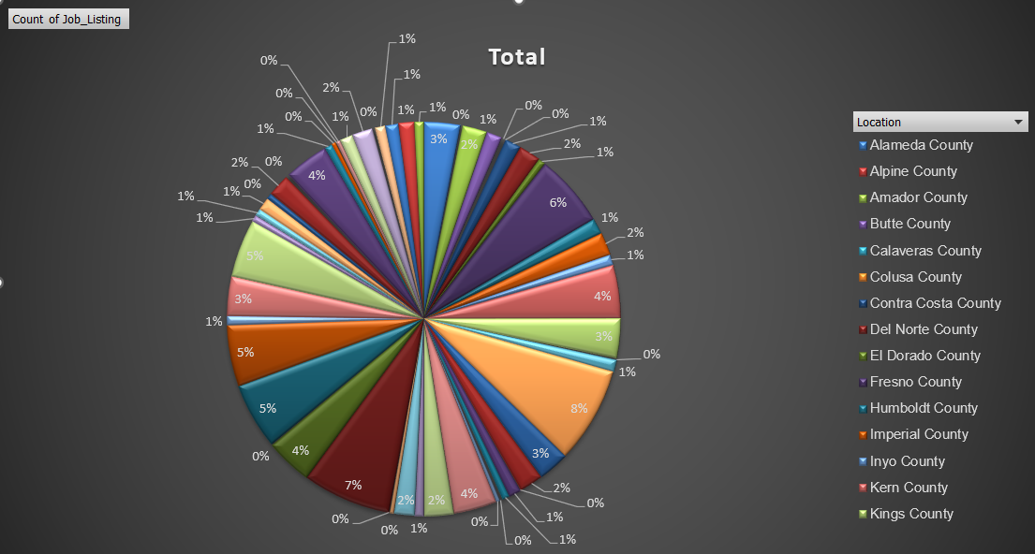

Nhóm các công việc được tuyển dụng trải đều ở tất cả các khu vực.

### Cụm 2:

|  |
| --- |
| ACCOUNTING ADMINISTRATOR I (SUPERVISOR), ACCOUNTING OFFICER (SPECIALIST), CHIEF PSYCHOLOGIST, CORRECTIONAL FACILITY, COMMUNICATIONS SUPERVISOR, COMMUNITY PROGRAM SPECIALIST III, CORRECTIONAL COUNSELOR II (SPECIALIST), CRIME ANALYST II, EMERGENCY MANAGEMENT COORDINATOR/INSTRUCTOR I, OFFICE OF EMERGENCY SERVICES, EMERGENCY MANAGEMENT COORDINATOR/INSTRUCTOR II, OFFICE OF EMERGENCY SERVICES, EMERGENCY SERVICES COORDINATOR, OFFICE OF EMERGENCY SERVICES, ENGINEER, WATER RESOURCES, ENVIRONMENTAL PROGRAM MANAGER I (SUPERVISORY), EXECUTIVE ASSISTANT, FINANCIAL ACCOUNTANT I, FISH AND WILDLIFE SEASONAL AID, HEALTH FACILITIES EVALUATOR II (SUPERVISOR), INFORMATION TECHNOLOGY SPECIALIST II, PROGRAM TECHNICIAN II, SENIOR ENGINEER WATER RESOURCES, SUPERVISING ENGINEER WATER RESOURCES, ACCOUNTANT TRAINEE, ASSOCIATE ACCOUNTING ANALYST, ASSOCIATE ENERGY SPECIALIST (TECHNOLOGY EVALUATION AND DEVELOPMENT), ASSOCIATE OPERATIONS SPECIALIST, FRANCHISE TAX BOARD, ATTORNEY, ASSISTANT CHIEF COUNSEL, CRIME ANALYST I, DISTRICT SALES REPRESENTATIVE, CA STATE LOTTERY, EDUCATION FISCAL SERVICES CONSULTANT, HEALTH FACILITIES EVALUATOR MANAGER I, INFORMATION OFFICER I (SPECIALIST), ASSOCIATE PROPERTY APPRAISER (BOARD OF EQUALIZATION), SENIOR ACCOUNTING OFFICER (SPECIALIST), ADMINISTRATOR III FRANCHISE TAX BOARD, ASSOCIATE BUSINESS MANAGEMENT ANALYST, ASSOCIATE MECHANICAL ENGINEER, ASSOCIATE TRANSPORTATION PLANNER, CUSTOMER SERVICE SUPERVISOR, FRANCHISE TAX BOARD, GRAPHIC DESIGNER III, HAZARDOUS SUBSTANCES ENGINEER, HEALTH PROGRAM MANAGER II, OFFICE ASSISTANT (GENERAL), ACCOUNTING ANALYST, ADMINISTRATOR II, FRANCHISE TAX BOARD, AIR POLLUTION SPECIALIST, ASSOCIATE INVESTMENT MANAGER,PUBLIC EMPLOYEES` RETIREMENT SYSTEM, BATTALION CHIEF, CHILD DEVELOPMENT CONSULTANT, CLAIM AUDITOR, CORPORATION EXAMINER, CORRECTIONAL CASE RECORDS ANALYST, EXECUTIVE SECRETARY I, JUNIOR ENGINEERING TECHNICIAN, TAX TECHNICIAN II, BOARD OF EQUALIZATION, CORRECTIONAL COUNSELOR III, LEGAL ANALYST, MATERIALS AND STORES SUPERVISOR I (CORRECTIONAL FACILITY), PROGRAM MANAGER, PUBLIC UTILITIES COMMISSION, RESEARCH DATA SUPERVISOR II, ACCOUNTING ADMINISTRATOR I (SPECIALIST), ACCOUNTING ADMINISTRATOR II, ASSOCIATE ADMINISTRATIVE ANALYST ACCOUNTING SYSTEMS, ASSOCIATE RIGHT OF WAY AGENT, BUSINESS TAXES ADMINISTRATOR I, BOARD OF EQUALIZATION, CORRECTIONAL HEALTH SERVICES ADMINISTRATOR I, CORRECTIONAL FACILITY, ELECTRICAL ENGINEER, ELECTRONICS TECHNICIAN, FINANCIAL ACCOUNTANT II, INFORMATION TECHNOLOGY TECHNICIAN, STAFF SERVICES MANAGEMENT AUDITOR, TAX TECHNICIAN I, BOARD OF EQUALIZATION, ASSOCIATE TELECOMMUNICATIONS ENGINEER, CORRECTIONAL ADMINISTRATOR, DEPARTMENT OF CORRECTIONS, CUSTODIAN SUPERVISOR II, DISASTER ASSISTANCE PROGRAM SPECIALIST I, SENIOR SPECIALIST PROPERTY APPRAISER (BOE), ADMINISTRATIVE ASSISTANT II, ADMINISTRATOR I, FRANCHISE TAX BOARD, ASSOCIATE BUDGET ANALYST, ASSOCIATE CONSTRUCTION ANALYST, BUSINESS TAXES SPECIALIST I, BOARD OF EQUALIZATION, ENERGY COMMISSION SPECIALIST II (TECH EVALUATION AND DEVELOPMENT), ENVIRONMENTAL PROGRAM MANAGER II, FORESTRY AIDE, INFORMATION TECHNOLOGY MANAGER II, STAFF MANAGEMENT AUDITOR (SPECIALIST) STATE CONTROLLER'S OFFICE, AGRICULTURAL TECHNICIAN II (SEASONAL), ASSISTANT BUREAU CHIEF, NON-PEACE OFFICER, ASSOCIATE HAZARDOUS MATERIALS SPECIALIST, ASSISTANT INDUSTRIAL HYGIENIST, ASSOCIATE OIL AND GAS ENGINEER, ATTORNEY V, AUDITOR I, CHIEF ENGINEER I, DIGITAL PRINT OPERATOR II, EDUCATION PROGRAMS CONSULTANT, FINANCIAL ACCOUNTANT III, GROUNDSKEEPER (CORRECTIONAL FACILITY), HOUSING AND COMMUNITY DEVELOPMENT REPRESENTATIVE I, LEGAL SUPPORT SUPERVISOR I, MECHANICAL ENGINEER, SENIOR PERSONNEL SPECIALIST, YOUTH AID, ELECTRICIAN III (CORRECTIONAL FACILITY), OFFICE SERVICES SUPERVISOR I (TYPING), ATTORNEY II, FIELD REPRESENTATIVE, DEPARTMENT OF JUSTICE, MANAGEMENT SERVICES TECHNICIAN, PAINTER I, STUDENT ASSISTANT -ENGINEERING AND ARCHITECTURAL SCIENCES-, AGRICULTURE PROGRAM SUPERVISOR I, ASSOCIATE INSURANCE COMPLIANCE OFFICER, DEPARTMENT OF INSURANCE, ASSOCIATE PARK AND RECREATION SPECIALIST, BUSINESS TAXES SPECIALIST III, BOARD OF EQUALIZATION, CRIME ANALYST SUPERVISOR, AIR RESOURCES SUPERVISOR I, CHIEF EXECUTIVE OFFICER, HEALTH CARE (SAFETY), Communications Editor, EDUCATION RESEARCH AND EVALUATION ADMINISTRATOR I, EDUCATION RESEARCH AND EVALUATION CONSULTANT, ELECTRIC GENERATION SYSTEM SPECIALIST III, ELECTRICIAN I, HEAVY EQUIPMENT MECHANIC, MAILING MACHINES OPERATOR I, SEASONAL CLERK, TRANSPORTATION SURVEYOR (CALTRANS), ADMINISTRATIVE OFFICER I, RESOURCES AGENCY, AIR QUALITY ENGINEER I, DEPARTMENT OF CONSUMER AFFAIRS, ASSOCIATE ENVIRONMENTAL PLANNER, BUSINESS SERVICE ASSISTANT (SPECIALIST), BUSINESS TAXES SPECIALIST II, BOARD OF EQUALIZATION, Assistant Secretary, Public and Employee Communications, FISH AND WILDLIFE INTERPRETER II, ACCOUNT CLERK II, SENIOR PAYROLL SPECIALIST, ASSOCIATE INDUSTRIAL HYGIENIST, BUILDING MAINTENANCE WORKER, Hydroelectric Plant Technician II, PROGRAM MANAGER II, CALIFORNIA BAY DELTA AUTHORITY, PROGRAM MANAGER I, OFFICE OF EMERGENCY SERVICES, ACCOUNTING TECHNICIAN, ASSISTANT TELECOMMUNICATIONS ENGINEER, CALTRANS HIGHWAY MECHANIC SUPERVISOR, COMMUNITY PROGRAM SPECIALIST II, DIRECT CONSTRUCTION SUPERVISOR II, ELECTRIC GENERATION SYSTEM SPECIALIST I, EMPLOYMENT PROGRAM MANAGER I, MANAGER I, DEPARTMENT OF MOTOR VEHICLES, ASSOCIATE PRINTING PLANT SUPERINTENDENT, ELECTRICIAN II, ENERGY ANALYST, HEALTH FACILITIES EVALUATOR MANAGER II, INFORMATION TECHNOLOGY SPECIALIST III, LEGAL ASSISTANT, CONTROL CASHIER II (VEHICLE REGISTRATION), DEPARTMENT OF MOTOR VEHICLES, HEALTH PROGRAM AUDIT MANAGER I, DEPARTMENT OF HEALTH SERVICES, OFFICE TECHNICIAN (GENERAL), SENIOR ENGINEERING GEOLOGIST, ASSISTANT PROPERTY AUDITOR APPRAISER (BOARD OF EQUALIZATION), ASSOCIATE ANALYST, ASSOCIATE PROGRAM AUDITOR, CalPERS, BUSINESS MANAGER I, ENERGY RESOURCES SPECIALIST III MANAGERIAL, ASSOCIATE PROPERTY AUDITOR APPRAISER (BOARD OF EQUALIZATION), ASSOCIATE SAFETY ENGINEER, HOUSING AND COMMUNITY DEVELOPMENT REPRESENTATIVE II, HOUSING AND COMMUNITY DEVELOPMENT SPECIALIST II, LICENSING REPRESENTATIVE II, ABC, NURSE EVALUATOR II, HEALTH SERVICES, PARK AIDE (SEASONAL), PERSONNEL PROGRAM ADVISOR, PROGRAM AND PROJECT SUPERVISOR, PUBLIC UTILITIES COMMISSION, PROGRAM MANAGER II, OFFICE OF EMERGENCY SERVICES, PROGRAM SPECIALIST III, FRANCHISE TAX BOARD, PROGRAM TECHNICIAN, RESEARCH DATA SUPERVISOR I, RESEARCH SCIENTIST II (EPIDEMIOLOGY/BIOSTATISTICS), RESEARCH SCIENTIST III (EPIDEMIOLOGY/BIOSTATISTICS), SENIOR ACCOUNTING OFFICER (SUPERVISOR), SENIOR COMPLIANCE REPRESENTATIVE, FRANCHISE TAX BOARD, SENIOR LEGAL ANALYST, SENIOR PARK AND RECREATION SPECIALIST, SENIOR TELECOMMUNICATIONS ENGINEER, STAFF PARK AND RECREATION SPECIALIST, STAFF SERVICES MANAGER II (MANAGERIAL), STAFF SERVICES MANAGER III, SUPERVISING MANAGEMENT AUDITOR, SUPERVISING PSYCHIATRIC SOCIAL WORKER I, CORRECTIONAL FACILTY, TAX TECHNICIAN, FRANCHISE TAX BOARD, UTILITIES ENGINEER, WAREHOUSE WORKER, ASSOCIATE HEALTH PROGRAM ADVISER, ASSOCIATE HYDROELECTRIC POWER UTILITY ENGINEER, COMPLIANCE REPRESENTATIVE, FRANCHISE TAX BOARD, NURSE CONSULTANT III (SUPERVISOR), OFFICE SERVICES SUPERVISOR II, PUBLIC UTILITIES REGULATORY ANALYST I, SENIOR BRIDGE ENGINEER, SENIOR UTILITIES ENGINEER (SPECIALIST), SENIOR WORKERS' COMPENSATION INSURANCE REPRESENTATIVE, SPECIAL AGENT, STAFF AIR POLLUTION SPECIALIST, STAFF MANAGEMENT AUDITOR, SUPERVISING PROGRAM TECHNICIAN II, SUPERVISING SPECIAL INVESTIGATOR I (NON-PEACE OFFICER), WORKERS' COMPENSATION CONSULTANT, ASSOCIATE CONTROL ENGINEER, CORRECTIONAL LIEUTENANT, CUSTOMER SERVICE SPECIALIST, FRANCHISE TAX BOARD, DEPUTY ATTORNEY GENERAL SUPERVISOR, DIGITAL COMPOSITION SPECIALIST II, FINANCIAL ACCOUNTANT IV, FINANCIAL AND PERFORMANCE EVALUATOR II, DEPT OF FINANCE, GENERAL AUDITOR III, HYDROELECTRIC PLANT TECHNICIAN I, INVESTMENT MANAGER, PUBLIC EMPLOYEES' RETIREMENT SYSTEM, MANAGER II, DEPARTMENT OF MOTOR VEHICLES, PERSONNEL SUPERVISOR II, PHYSICIAN AND SURGEON, CORRECTIONAL FACILITY, PUBLIC HEALTH MEDICAL ADMINISTRATOR I, PUBLIC UTILITIES REGULATORY ANALYST IV, RESEARCH DATA ANALYST II, RESEARCH DATA SPECIALIST III, RESEARCH SCIENTIST III (SOCIAL BEHAVIORAL SCIENCES), RESEARCH SCIENTIST SUPERVISOR II (EPIDEMIOLOGY/BIOSTATISTICS), SENIOR TRANSPORTATION PLANNER, SUPERVISING PROGRAM TECHNICIAN III, TAX PROGRAM SUPERVISOR, FRANCHISE TAX BOARD, TRAINING OFFICER I, MATERIALS AND RESEARCH ENGINEERING ASSOCIATE (SPECIALIST), PHARMACY SERVICES MANAGER, PROGRAM TECHNICIAN III, RESEARCH SCIENTIST I (EPIDEMIOLOGY/BIOSTATISTICS), SENIOR AUDITOR EVALUATOR I, SENIOR AUDITOR EVALUATOR II, SENIOR AUDITOR EVALUATOR III, SENIOR EMERGENCY SERVICES COORDINATOR, OFFICE OF EMERGENCY SERVICES, SENIOR MARKETING SPECIALIST, CALIFORNIA STATE LOTTERY, STATE PARK INTERPRETER II, SUPERVISING TRANSPORTATION ENGINEER, CALTRANS, TAX PROGRAM TECHNICIAN I, FRANCHISE TAX BOARD, TRANSPORTATION ENGINEER (ELECTRICAL), WATER RESOURCES ENGINEERING ASSOCIATE (SPECIALIST), WORKERS' COMPENSATION ASSISTANT, AIR RESOURCES TECHNICIAN II, CALTRANS MAINTENANCE MANAGER I, FINANCIAL AND PERFORMANCE EVALUATOR I, DEPARTMENT OF FINANCE, HEALTH PROGRAM MANAGER I, INFORMATION OFFICER II, INVESTIGATOR, LANDSCAPE ASSOCIATE, CALTRANS, OFFSET PRESS ASSISTANT, PUBLIC SAFETY OPERATOR, CALIFORNIA HIGHWAY PATROL, PUBLIC UTILITIES REGULATORY ANALYST II, RECEIVER'S MEDICAL EXECUTIVE (SAFETY), SENIOR WATER RESOURCE CONTROL ENGINEER, SUPERVISING REGISTERED NURSE III, CORRECTIONAL FACILITY, TAX ADMINISTRATOR II, EMPLOYMENT DEVELOPMENT DEPARTMENT, CONSTRUCTION SUPERVISOR III (CORRECTIONAL FACILITY), DENTIST, CORRECTIONAL FACILITY, ELECTRIC GENERATION SYSTEM PROGRAM SPECIALIST I, MAILING MACHINES SUPERVISOR II, SENIOR ENVIRONMENTAL PLANNER, CODES AND STANDARDS ADMINISTRATOR I (NON-PEACE OFFICER), ENVIRONMENTAL PLANNER, PSYCHOLOGIST (HEALTH FACILITY - CLINICAL), DEPARTMENTS OF MENTAL HEALTH AND DEVELOPMENTAL SERVICES, PUBLIC UTILITIES REGULATORY ANALYST III, RESEARCH DATA ANALYST I, RESEARCH DATA MANAGER, SENIOR HAZARDOUS SUBSTANCES ENGINEER, SENIOR LEGAL TYPIST, ASSISTANT HEALTH PHYSICIST, AVIATION OFFICER II (FLIGHT OPERATIONS), FISCAL ANALYST, PERSONNEL SUPERVISOR I, SENIOR CLINICAL LABORATORY TECHNOLOGIST, CORRECTIONAL FACILITY, SENIOR STRUCTURAL ENGINEER, SENIOR TAX COMPLIANCE REPRESENTATIVE (SPECIALIST), AIR RESOURCES SUPERVISOR II, AUTOMOTIVE POOL ATTENDANT I, COMMUNITY COLLEGE PROGRAM ASSISTANT , ENERGY COMMISSION SPECIALIST I (TECH EVALUATION AND DEVELOPMENT), GRADUATE LEGAL ASSISTANT, PRINTING TRADES SPECIALIST TRAINEE (GENERAL), SENIOR MECHANICAL ENGINEER, VETERINARIAN SPECIALIST (GENERAL), FISCAL SUPERVISOR, Supervising Analyst, SUPERVISING HAZARDOUS SUBSTANCES ENGINEER I, SUPERVISING PSYCHIATRIC SOCIAL WORKER I, SUPERVISING TRANSPORTATION PLANNER, SUPPORT SERVICES ASSISTANT (INTERPRETER), RESEARCH SCIENTIST SUPERVISOR I (EPIDEMIOLOGY/BIOSTATISTICS), SENIOR MANAGEMENT AUDITOR, TAX PROGRAM TECHNICIAN II, FRANCHISE TAX BOARD, AGRICULTURAL BIOLOGICAL TECHNICIAN, COMMUNITY COLLEGE ADMINISTRATOR I, PRINCIPAL TRANSPORTATION ENGINEER, CALTRANS, STATE FAIR WORKER, CASUAL EMPLOYMENT (VARIOUS), PRINCIPAL HYDROELECTRIC POWER UTILITY ENGINEER, ASSISTANT AGRICULTURAL ECONOMIST, RESEARCH SCIENTIST II (SOCIAL/BEHAVIORAL SCIENCES), RESEARCH SCIENTIST IV (EPIDEMIOLOGY/BIOSTATISTICS), STAFF PROGRAM AUDITOR, CALPERS, SUPERVISING VETERINARIAN (GENERAL), TELECOMMUNICATIONS SYSTEMS TECHNICIAN II, FIELD REPRESENTATIVE, BOARD OF CORRECTIONS, WELFARE FRAUD PREVENTION COORDINATOR, SENIOR STATE ARCHEOLOGIST, ASSOCIATE TOXICOLOGIST, AGRICULTURE PROGRAM SUPERVISOR IV, SUPERVISING PSYCHIATRIC SOCIAL WORKER II, CORRECTIONAL FACLTY, NURSE CONSULTANT III (SPECIALIST), INVESTMENT OFFICER II, PUBLIC EMPLOYEES' RETIREMENT SYSTEM, FOUNDATION DRILLER, PRIVATE POSTSECONDARY EDUCATION SPECIALIST, PROJECT MANAGER I, LITTLE HOOVER COMMISSION, VETERINARIAN (GENERAL) |

**Ý nghĩa cụm 2:**

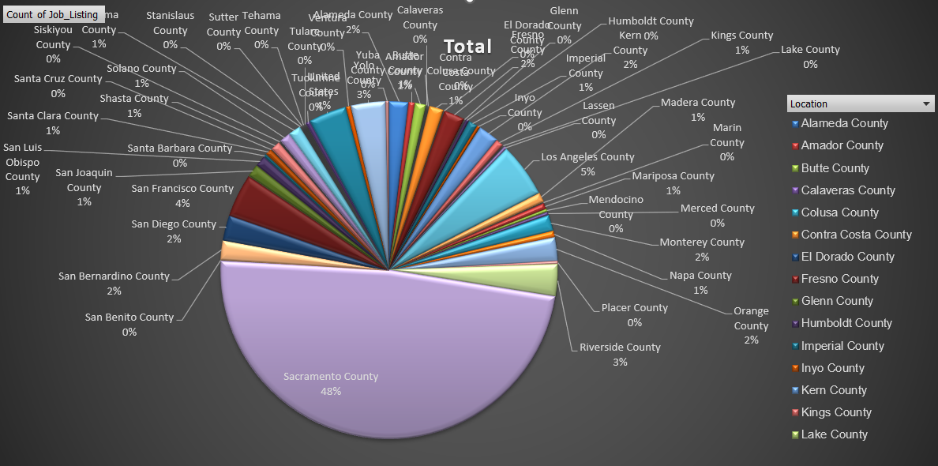

Nhóm các công việc được tuyển dụng chủ yếu tại khu vực *Sacramento County.*

### Cụm 3:

|  |
| --- |
| ASSOCIATE MANAGEMENT AUDITOR, ATTORNEY, ATTORNEY III, ATTORNEY IV, C. E. A., DEPUTY ATTORNEY GENERAL IV, DISABILITY INSURANCE PROGRAM REPRESENTATIVE, STAFF SERVICES MANAGER II (SUPERVISORY), DEPUTY ATTORNEY GENERAL, DEPUTY ATTORNEY GENERAL III, DISTRICT ADMINISTRATOR, ALCOHO, HEALTH PROGRAM SPECIALIST II, AIR RESOURCES ENGINEER (MAND), FINANCIAL INSTITUTIONS EXAMINER, TAX TECHNICIAN III, BOARD OF EQUALIZATION, BUSINESS TAXES REPRESENTATIVE, ENGINEER,CIVIL, RESEARCH DATA SPECIALIST I, BOOKBINDER IV, ENVIRONMENTAL PROGRAM MANAGER I (MANAGERIAL), INFORMATION TECHNOLOGY ASSOCIATE, INFORMATION TECHNOLOGY MANAGER I, FIRE CAPTAIN, FIRE FIGHTER II (PARAMEDIC), HEALTH EDUCATION CONSULTANT II, INFORMATION TECHNOLOGY SUPERVISOR II, ASSOCIATE ARCHITECT, ASSOCIATE STATE ARCHAEOLOGIST, ATTORNEY SUPERVISOR, SENIOR ENVIRONMENTAL SCIENTIST (SPECIALIST), ASSISTANT CHIEF, AGRICULTURAL AIDE (SEASONAL), COMMUNITY PROGRAM SPECIALIST IV, SENIOR WORKERS' COMPENSATION CLAIMS ADJUSTER, COASTAL PROGRAM ANALYST I, COASTAL PROGRAM ANALYST III, FAIR EMPLOYMENT AND HOUSING CONSULTANT III (SPECIALIST), ASSOCIATE SPACE PLANNER, RESEARCH DATA SPECIALIST II, ASSOCIATE SAFETY ENGINEER (PRESSURE VESSELS), CHILD NUTRITION CONSULTANT, MATE, FISH AND GAME VESSEL, SENIOR ENVIRONMENTAL SCIENTIST (SUPERVISORY), DEPUTY LABOR COMMISSIONER I, CONSULTING PSYCHOLOGIST, INSPECTOR, BOARD OF PHARMACY, LEGAL SECRETARY, FIRE CHIEF, ASSOCIATE REAL ESTATE OFFICER, HEAVY TRUCK DRIVER, PUBLIC UTILITIES REGULATORY ANALYST V, SENIOR ESTIMATOR OF BUILDING CONSTRUCTION, SUPERVISING INSPECTOR, BOARD OF PHARMACY, INVESTMENT OFFICER II, STATE TEACHERS' RETIREMENT SYSTEM, WORKERS' COMPENSATION INSURANCE TECHNICIAN, COASTAL PROGRAM MANAGER, DISABILITY INSURANCE PROGRAM MANAGER III, FIELD REPRESENTATIVE, BOARD OF FUNERAL DIRECTORS AND EMBALMERS, LAW ENFORCEMENT CONSULTANT I, COMMISSION ON PEACE OFFICER STANDARDS AND TRAINING, SENIOR PSYCHOLOGIST (HEALTH FACILITY) (SUPERVISOR), BUSINESS SERVICE OFFICER I (SPECIALIST), HEALTH EDUCATION CONSULTANT III (SPECIALIST), MINERAL RESOURCES INSPECTOR II, SHEETFED OFFSET PRESS OPERATOR II, DEPUTY INSPECTOR GENERAL, MANAGER I, STATE COMPENSATION INSURANCE FUND, MEDICAL CONSULTANT I, DEPARTMENT OF HEALTH SERVICES, ADMINISTRATOR IV FRANCHISE TAX BOARD, AUTOMOTIVE TECHNICIAN I, MOTOR VEHICLE REPRESENTATIVE, SPECIAL ASSISTANT INSPECTOR GENERAL, STAFF TOXICOLOGIST (SPECIALIST), BUSINESS SERVICE OFFICER II (SUPERVISOR), INVESTIGATIVE CERTIFIED PUBLIC ACCOUNTANT, SUPERVISING TAX AUDITOR II BOARD OF EQUALIZATION, ASSOCIATE TAX AUDITOR, BOARD OF EQUALIZATION, SUPERVISING FRAUD INVESTIGATOR I, DEPARTMENT OF INSURANCE, TAX AUDITOR, BOARD OF EQUALIZATION, WORKERS' COMPENSATION CLAIMS ADJUSTER, MEDICAL CONSULTANT II, DEPARTMENT OF HEALTH SERVICES, PROGRAM SPECIALIST II, FRANCHISE TAX BOARD, PUBLIC HEALTH MEDICAL OFFICER II, STRUCTURAL PEST CONTROL BOARD SPECIALIST, PROGRAM REPRESENTATIVE II (SPECIALIST), DEPARTMENT OF CONSUMER AFFAIRS, HOSPITAL POLICE OFFICER, CHILD NUTRITION SUPERVISOR I, SENIOR TOXICOLOGIST, AGENT, ALCOHOLIC BEVERAGE CONT, NUTRITION EDUCATION CONSULTANT |

**Ý nghĩa cụm 3:**

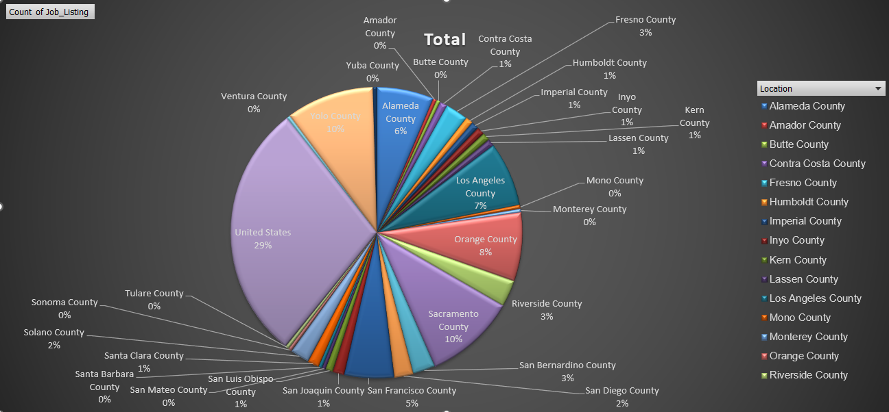

Nhóm các công việc được tuyển dụng chủ yếu tại khu vực *United States.*

### Cụm 4:

|  |
| --- |
| WATER RESOURCES TECHNICIAN I |

**Ý nghĩa cụm 4:**

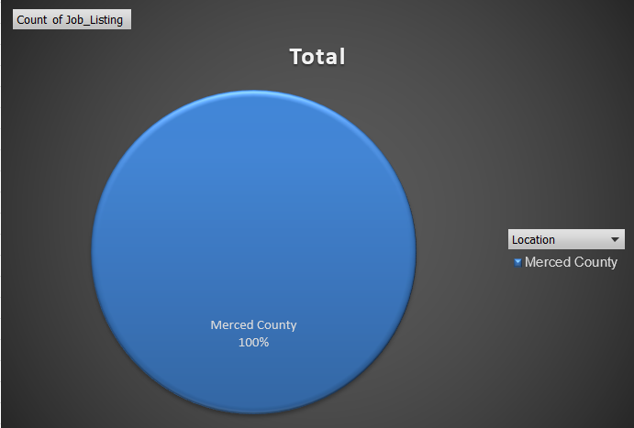

Nhóm các công việc được tuyển dụng tại khu vực *Merced County.*

## Thuật toán Agglomerative Clustering

Import thư viện[3]

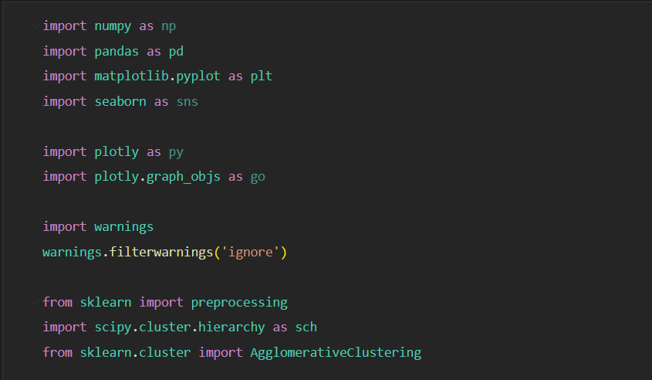

Mở đọc file csv lọc lấy 2 cột *Job_Listing*, *Location* và loại bỏ dòng null và trùng.

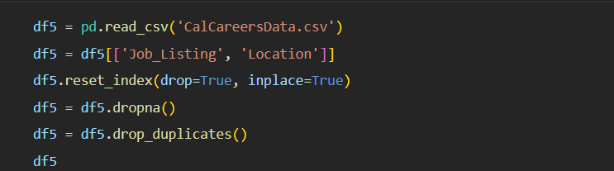

Mã hóa các giá trị của 2 cột từ dạng chuỗi (String) về dạng số (Int) và sau đó gán vào 2 cột mới tên là *Job_Listing_name* và *Location_name.*

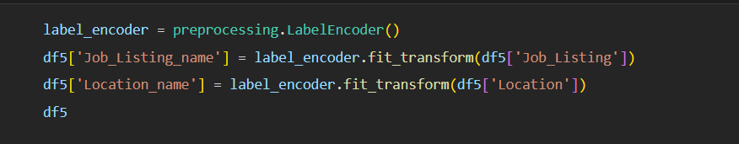

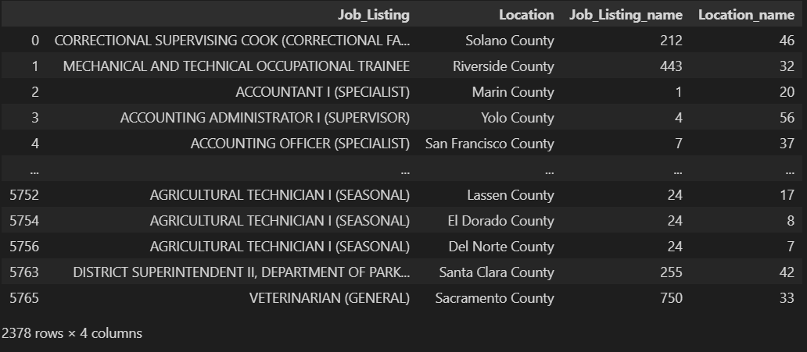

Vẽ dendrogram (biểu đồ cây) của các cụm dữ liệu dựa trên khoảng cách Euclidean giữa các điểm dữ liệu.

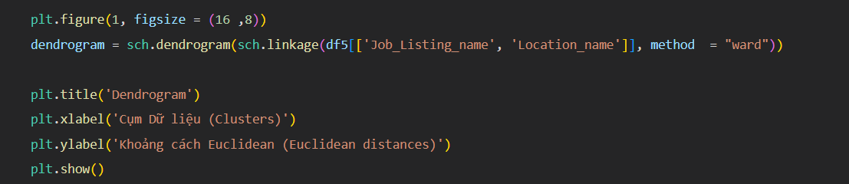

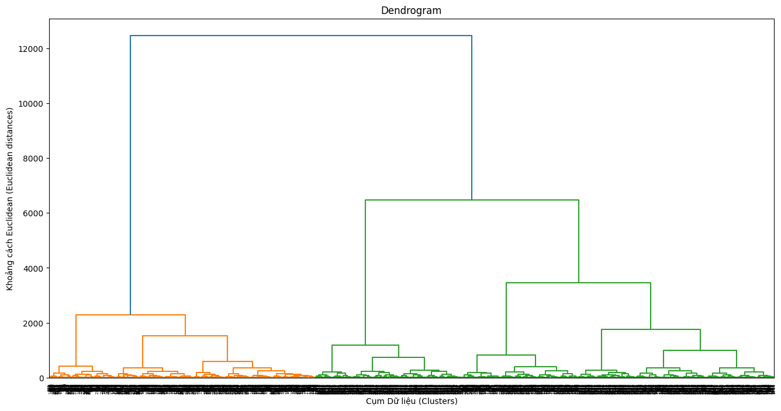

Sử dụng chỉ số silhouette (*silhouette_scores*) để thực hiện quá trình đánh giá hiệu suất của việc phân cụm dữ liệu với một loạt các số lượng cụm khác nhau (từ 2-7).

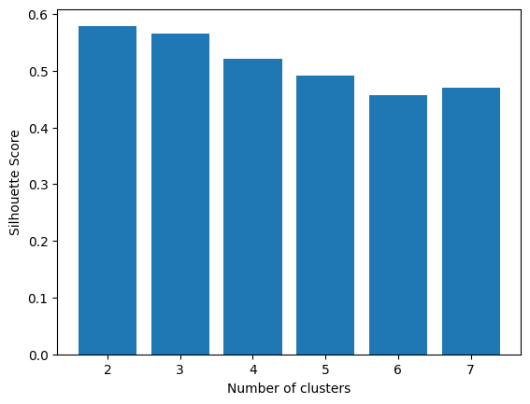  
Kết quả biểu đồ cột giúp xác định số lượng cụm tốt nhất dựa trên silhouette_score. Số lượng cụm có silhouette_score cao nhất thường được chọn làm số lượng cụm tối ưu. Ở đây cột 2 là cao nhất nên em sẽ chọn 2 để tạo ra 2 cụm tương ứng. Sau đó vẽ biểu đồ Scatterd Plot để xem sự phân bố giữa 2 cụm.

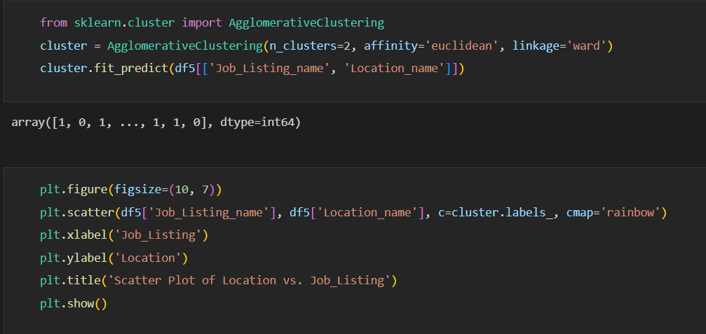

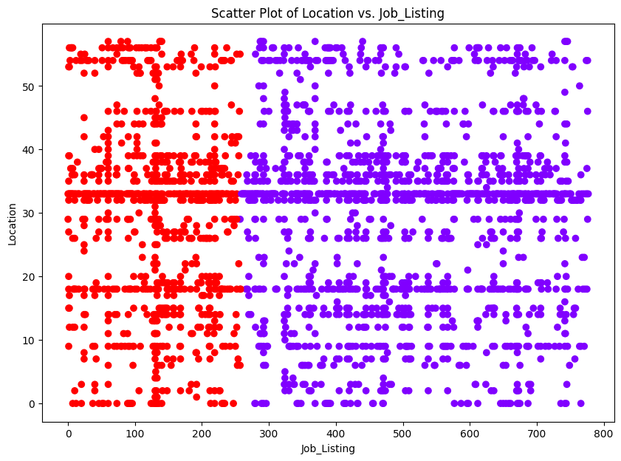

### Cụm 1:

|  |
| --- |
| MECHANICAL AND TECHNICAL OCCUPATIONAL TRAINEE, EMERGENCY MANAGEMENT COORDINATOR/INSTRUCTOR I, OFFICE OF EMERGENCY SERVICES, EMERGENCY MANAGEMENT COORDINATOR/INSTRUCTOR II, OFFICE OF EMERGENCY SERVICES, EMERGENCY SERVICES COORDINATOR, OFFICE OF EMERGENCY SERVICES, EMPLOYMENT PROGRAM REPRESENTATIVE, ENGINEER, WATER RESOURCES, ENVIRONMENTAL PROGRAM MANAGER I (SUPERVISORY), ENVIRONMENTAL SCIENTIST, EXECUTIVE ASSISTANT, FINANCIAL ACCOUNTANT I, FISH AND WILDLIFE SEASONAL AID, FORESTRY TECHNICIAN, GROUNDSKEEPER, HEALTH FACILITIES EVALUATOR II (SUPERVISOR), HEALTH PROGRAM MANAGER III, HEALTH RECORD TECHNICIAN I, HEALTH SERVICES SPECIALIST (SAFETY), HEAVY EQUIPMENT MECHANIC (CORRECTIONAL FACILITY), HEAVY EQUIPMENT MECHANIC APPRENTICE, CALTRANS, INFORMATION TECHNOLOGY SPECIALIST I, INFORMATION TECHNOLOGY SPECIALIST II, PROGRAM TECHNICIAN II, REGISTERED NURSE (SAFETY), SENIOR ENGINEER WATER RESOURCES, STAFF SERVICES ANALYST, STAFF SERVICES MANAGER I, STAFF SERVICES MANAGER II (SUPERVISORY), SUPERVISING ENGINEER WATER RESOURCES, EDUCATION FISCAL SERVICES CONSULTANT, FOOD ADMINISTRATOR I (CORRECTIONAL FACILITY), HEALTH FACILITIES EVALUATOR MANAGER I, HEALTH PROGRAM SPECIALIST I, HEALTH PROGRAM SPECIALIST II, INDUSTRIAL SUPERVISOR, PRISON INDUSTRIES (MAINTENANCE AND REPAIR), INFORMATION OFFICER I (SPECIALIST), JEWISH CHAPLAIN, OFFICE TECHNICIAN (TYPING), SENIOR ACCOUNTING OFFICER (SPECIALIST), FINANCIAL INSTITUTIONS EXAMINER, FISH AND WILDLIFE SCIENTIFIC AID, FISH AND WILDLIFE TECHNICIAN, FOOD SERVICE TECHNICIAN I, FORESTRY LOGISTICS OFFICER I, GRAPHIC DESIGNER III, HAZARDOUS SUBSTANCES ENGINEER, HEALTH PROGRAM MANAGER II, HYDROELECTRIC PLANT MECHANICAL SUPERVISOR, NATIVE AMERICAN SPIRITUAL LEADER, OFFICE ASSISTANT (GENERAL), SENIOR PSYCHIATRIST (SPECIALIST), STUDENT ASSISTANT, TAX TECHNICIAN III, BOARD OF EQUALIZATION, ENGINEERING GEOLOGIST, ENVIRONMENTAL SERVICES INTERN, EXECUTIVE SECRETARY I, JUNIOR ENGINEERING TECHNICIAN, SUPERVISING REGISTERED NURSE (SAFETY), TAX TECHNICIAN II, BOARD OF EQUALIZATION, WATER RESOURCES TECHNICIAN I, ELECTRICIAN II (CORRECTIONAL FACILITY), PAINTER II (CORRECTIONAL FACILITY), SUPERVISING CORRECTIONAL COOK DEPT OF CORRECTIONS, LEGAL ANALYST, MATERIALS AND STORES SUPERVISOR I (CORRECTIONAL FACILITY), PROGRAM MANAGER, PUBLIC UTILITIES COMMISSION, RESEARCH DATA SUPERVISOR II, ELECTRICAL ENGINEER, ELECTRONICS TECHNICIAN, ENGINEER,CIVIL, FINANCIAL ACCOUNTANT II, FIRE PREVENTION SPECIALIST I, FIRE PREVENTION SPECIALIST II, INFORMATION TECHNOLOGY TECHNICIAN, PLUMBER II (CORRECTIONAL FACILITY), RESEARCH DATA SPECIALIST I, STAFF SERVICES MANAGEMENT AUDITOR, TAX TECHNICIAN I, BOARD OF EQUALIZATION, DRIVER SAFETY HEARING OFFICER, ENVIRONMENTAL PROGRAM MANAGER I (MANAGERIAL), SENIOR SPECIALIST PROPERTY APPRAISER (BOE), ENERGY COMMISSION SPECIALIST II (TECH EVALUATION AND DEVELOPMENT), ENVIRONMENTAL PROGRAM MANAGER II, FISH HABITAT ASSISTANT, FORESTRY AIDE, HEAVY FIRE EQUIPMENT OPERATOR, HOSPITAL POLICE LIEUTENANT, INFORMATION TECHNOLOGY ASSOCIATE, INFORMATION TECHNOLOGY MANAGER I, INFORMATION TECHNOLOGY MANAGER II, STAFF MANAGEMENT AUDITOR (SPECIALIST) STATE CONTROLLER'S OFFICE, PSYCHIATRIC TECHNICIAN (SAFETY), EDUCATION PROGRAMS CONSULTANT, ELECTRONICS TECHNICIAN (CORRECTIONAL FACILITY), FINANCIAL ACCOUNTANT III, FIRE CAPTAIN, FIRE FIGHTER II (PARAMEDIC), FORESTRY AND FIRE PROTECTION A, GROUNDSKEEPER (CORRECTIONAL FACILITY), HEALTH EDUCATION CONSULTANT II, HEARING REPORTER, HOUSING AND COMMUNITY DEVELOPMENT REPRESENTATIVE I, INDUSTRIAL SUPERVISOR, PRISON INDUSTRIES (LAUNDRY), INFORMATION TECHNOLOGY SUPERVISOR II, LEGAL SUPPORT SUPERVISOR I, LICENSED VOCATIONAL NURSE, CALIFORNIA DEPARTMENT OF CORRECTIONS AND REHABILITATION, MECHANICAL ENGINEER, SENIOR PERSONNEL SPECIALIST, YOUTH AID, STATIONARY ENGINEER (CORRECTIONAL FACILITY), ELECTRICIAN III (CORRECTIONAL FACILITY), OFFICE SERVICES SUPERVISOR I (TYPING), ELECTRICAL ENGINEERING TECHNICIAN I, FIELD REPRESENTATIVE, DEPARTMENT OF JUSTICE, FORESTER II (SUPERVISORY), HEALTH FACILITIES EVALUATOR NURSE, MANAGEMENT SERVICES TECHNICIAN, MEDICAL ASSISTANT, PAINTER I, SENIOR ENVIRONMENTAL SCIENTIST (SPECIALIST), STUDENT ASSISTANT -ENGINEERING AND ARCHITECTURAL SCIENCES-, TELEVISION SPECIALIST, MUSLIM CHAPLAIN, SENIOR WORKERS' COMPENSATION CLAIMS ADJUSTER, EDUCATION RESEARCH AND EVALUATION ADMINISTRATOR I, EDUCATION RESEARCH AND EVALUATION CONSULTANT, ELECTRIC GENERATION SYSTEM SPECIALIST III, ELECTRICIAN I, HEAVY EQUIPMENT MECHANIC, MAILING MACHINES OPERATOR I, OFFICE ASSISTANT (TYPING), PARK MAINTENANCE WORKER I, RECREATION THERAPIST, CORRECTIONAL FACILITY, SEASONAL CLERK, STAFF PSYCHIATRIST (SAFETY), TEACHER (HIGH SCHOOL-GENERAL EDUCATION) (CORRECTIONAL FACILITY), TRANSPORTATION SURVEYOR (CALTRANS), SENIOR VOCATIONAL REHABILITATION COUNSELOR, QUALIFIED REHABILITIATION PROFESSIONAL, TRANSPORTATION ENGINEER (CIVIL), FAIR EMPLOYMENT AND HOUSING CONSULTANT III (SPECIALIST), FIRE AND LIFE SAFETY OFFICER II (HEALTH FACILITIES CONSTRUCTION), FISH AND WILDLIFE INTERPRETER II, SENIOR PAYROLL SPECIALIST, GRADUATE STUDENT ASSISTANT, Hydroelectric Plant Technician II, PROGRAM MANAGER II, CALIFORNIA BAY DELTA AUTHORITY, PROGRAM DIRECTOR (MENTAL DISABILITIES-SAFETY), PROGRAM MANAGER I, OFFICE OF EMERGENCY SERVICES, RESEARCH DATA SPECIALIST II, ELECTRIC GENERATION SYSTEM SPECIALIST I, EMPLOYMENT PROGRAM MANAGER I, EXAMINER II LABORATORY FIELD SERVICES, MANAGER I, DEPARTMENT OF MOTOR VEHICLES, MATE, FISH AND GAME VESSEL, REGISTERED NURSE, CORRECTIONAL FACILITY, SENIOR ENVIRONMENTAL SCIENTIST (SUPERVISORY), TEACHING ASSISTANT (CORRECTIONAL FACILITY), HEALTH PROGRAM AUDITOR IV, DEPARTMENT OF HEALTH SERVICES, SPECIAL AGENT-IN-CHARGE, ELECTRICIAN II, ENERGY ANALYST, FORESTRY ASSISTANT II, HEALTH FACILITIES EVALUATOR MANAGER II, INFORMATION TECHNOLOGY SPECIALIST III, INSPECTOR, BOARD OF PHARMACY, LABORER, LEGAL ASSISTANT, LEGAL SECRETARY, LICENSED VOCATIONAL NURSE (MAND), GUIDE II, HISTORICAL MONUMENT (SPECIALIST), HEALTH PROGRAM AUDIT MANAGER I, DEPARTMENT OF HEALTH SERVICES, OFFICE TECHNICIAN (GENERAL), PHARMACY TECHNICIAN, SENIOR ENGINEERING GEOLOGIST, SENIOR MOTOR VEHICLE TECHNICIAN, ENERGY RESOURCES SPECIALIST III MANAGERIAL, FIRE CHIEF, FOOD SERVICE SUPERVISOR II, LICENSING-REGISTRATION EXAMINER, DEPARTMENT OF MOTOR VEHICLES, FIRE CAPTAIN CORRECTION INSTITUTION, HOUSING AND COMMUNITY DEVELOPMENT REPRESENTATIVE II, HOUSING AND COMMUNITY DEVELOPMENT SPECIALIST II, LABORATORY ASSISTANT, CORRECTIONAL FACILITY, LIBRARIAN (CORRECTIONAL FACILITY), LIBRARY TECHNICAL ASSISTANT (SAFETY), LICENSING REPRESENTATIVE II, ABC, MAINTENANCE MECHANIC, MAINTENANCE MECHANIC (CORRECTIONAL FACILITY), MAINTENANCE WORKER, DEPARTMENT OF THE CALIF. HIGHWAY PATROL, NURSE EVALUATOR II, HEALTH SERVICES, OIL SPILL PREVENTION SPECIALIST, OPTOMETRIST, CORRECTIONAL FACILITY, PARK AIDE (SEASONAL), PAROLE AGENT II, ADULT PAROLE SUPERVISOR, PERSONNEL PROGRAM ADVISOR, PERSONNEL SPECIALIST, PHYSICAL THERAPIST I, CORRECTIONAL FACILITY, PROGRAM AND PROJECT SUPERVISOR, PUBLIC UTILITIES COMMISSION, PROGRAM ASSISTANT (MENTAL DISABILITIES-SAFETY), PROGRAM MANAGER II, OFFICE OF EMERGENCY SERVICES, PROGRAM SPECIALIST III, FRANCHISE TAX BOARD, PROGRAM TECHNICIAN, RADIOLOGIC TECHNOLOGIST, CORRECTIONAL FACILITY, REGISTERED NURSE (MAND), RESEARCH DATA SUPERVISOR I, RESEARCH SCIENTIST II (EPIDEMIOLOGY/BIOSTATISTICS), RESEARCH SCIENTIST III (EPIDEMIOLOGY/BIOSTATISTICS), RESPIRATORY CARE SUPERVISOR, CORRECTIONAL FACILITY, ROUTE SALES REPRESENTATIVE, SENIOR ACCOUNTING OFFICER (SUPERVISOR), SENIOR COMPLIANCE REPRESENTATIVE, FRANCHISE TAX BOARD, SENIOR LEGAL ANALYST, SENIOR PARK AIDE (SEASONAL), SENIOR PARK AND RECREATION SPECIALIST, SENIOR PSYCHIATRIST (SUPERVISOR), CORRECTIONAL AND REHABILITATIVE SERVICES (SAFETY), SENIOR TELECOMMUNICATIONS ENGINEER, SPECIAL INVESTIGATOR, STAFF PARK AND RECREATION SPECIALIST, STAFF SERVICES MANAGER II (MANAGERIAL), STAFF SERVICES MANAGER III, STATE PARK PEACE OFFICER SUPERVISOR (RANGER), SUPERVISING CLINICAL LABORATORY TECHNOLOGIST, CORRECTIONAL FACILTY, SUPERVISING COOK I, SUPERVISING MANAGEMENT AUDITOR, SUPERVISING PSYCHIATRIC SOCIAL WORKER I, CORRECTIONAL FACILTY, SUPERVISING REGISTERED NURSE II, CORRECTIONAL FACILITY, TAX TECHNICIAN, FRANCHISE TAX BOARD, TEACHER (HIGH SCHOOL-PHYSICAL EDUCATION) (CORRECTIONAL FACILITY), TRANSPORTATION ENGINEERING TECHNICIAN, UNIT SUPERVISOR (SAFETY), UTILITIES ENGINEER, UTILITY CRAFTSWORKER, WATER RESOURCES, VOCATIONAL INSTRUCTOR (BUILDING MAINTENANCE) (CORRECTIONAL FACILITY), WAREHOUSE WORKER, HEALTH RECORD TECHNICIAN II (SUPERVISOR), HEAVY TRUCK DRIVER, HYDROELECTRIC PLANT ELECTRICIAN II, LICENSING PROGRAM ANALYST, LICENSING PROGRAM MANAGER II, NURSE CONSULTANT III (SUPERVISOR), OFFICE SERVICES SUPERVISOR II, PARK MAINTENANCE CHIEF I, PHARMACIST I (MAND), PROTESTANT CHAPLAIN, PUBLIC HEALTH MICROBIOLOGIST SPECIALIST, PUBLIC SAFETY DISPATCHER, CALIFORNIA HIGHWAY PATROL, PUBLIC UTILITIES REGULATORY ANALYST I, PUBLIC UTILITIES REGULATORY ANALYST V, REHABILITATION THERAPIST, STATE FACILITIES (RECREATION-SAFETY), SCIENTIFIC AID, SENIOR BRIDGE ENGINEER, SENIOR ESTIMATOR OF BUILDING CONSTRUCTION, SENIOR UTILITIES ENGINEER (SPECIALIST), SENIOR WORKERS' COMPENSATION INSURANCE REPRESENTATIVE, SPECIAL AGENT, STAFF AIR POLLUTION SPECIALIST, STAFF MANAGEMENT AUDITOR, STAFF PSYCHIATRIST (MAND), STATIONARY ENGINEER, STOCK CLERK, SUPERVISING INSPECTOR, BOARD OF PHARMACY, SUPERVISING PROGRAM TECHNICIAN II, SUPERVISING SPECIAL INVESTIGATOR I (NON-PEACE OFFICER) , TAX ADMINISTRATOR I, EMPLOYMENT DEVELOPMENT DEPARTMENT, TAX AUDITOR, EMPLOYMENT DEVELOPMENT DEPARTMENT, TRANSPORTATION SURVEYOR PARTY CHIEF (CALTRANS), VOCATIONAL INSTRUCTOR (CARPENTRY) (CORRECTIONAL FACILITY), VOCATIONAL INSTRUCTOR (WELDING) (CORRECTIONAL FACILITY), VOCATIONAL INSTRUCTOR, AUTO MECHANICS (CORRECTIONAL FACILITY), WILDLIFE HABITAT ASSISTANT, WORKERS' COMPENSATION CONSULTANT, FINANCIAL ACCOUNTANT IV, FINANCIAL AND PERFORMANCE EVALUATOR II, DEPT OF FINANCE, GENERAL AUDITOR III, HYDROELECTRIC PLANT TECHNICIAN I, INDUSTRIAL WAREHOUSE AND DISTRIBUTION SUPERVISOR, PRISON INDUSTRY, INVESTMENT MANAGER, PUBLIC EMPLOYEES' RETIREMENT SYSTEM, INVESTMENT OFFICER II, STATE TEACHERS' RETIREMENT SYSTEM, MANAGER II, DEPARTMENT OF MOTOR VEHICLES, MOTOR CARRIER SPECIALIST I, CALIFORNIA HIGHWAY PATROL, NURSE PRACTITIONER (SAFETY), PARK LANDSCAPE MAINTENANCE TECHNICIAN, PARK MAINTENANCE ASSISTANT, PERSONNEL SUPERVISOR II, PHYSICIAN AND SURGEON, CORRECTIONAL FACILITY, PRISON INDUSTRIES SUPERINTENDENT II (MATTRESS AND BEDDING), PSYCHIATRIC TECHNICIAN ASSISTANT (SAFETY), PSYCHOLOGIST - CLINICAL, CORRECTIONAL FACILITY, PUBLIC HEALTH MEDICAL ADMINISTRATOR I, PUBLIC HEALTH MEDICAL OFFICER III (EPIDEMIOLOGY), PUBLIC HEALTH NURSE II, CORRECTIONAL FACILITY, PUBLIC SAFETY DISPATCH SUPERVISOR I CALIFORNIA HIGHWAY PATROL, PUBLIC UTILITIES REGULATORY ANALYST IV, RESEARCH DATA ANALYST II, RESEARCH DATA SPECIALIST III, RESEARCH SCIENTIST III (SOCIAL BEHAVIORAL SCIENCES), RESEARCH SCIENTIST SUPERVISOR II (EPIDEMIOLOGY/BIOSTATISTICS), SENIOR PSYCHOLOGIST, CORRECTIONAL FACILITY (SPECIALIST), SENIOR PSYCHOLOGIST, CORRECTIONAL FACILITY (SUPERVISOR), SENIOR TRANSPORTATION ENGINEER, CALTRANS, SENIOR TRANSPORTATION PLANNER, SENIOR TRANSPORTATION SURVEYOR (CALTRANS), SUPERVISING PROGRAM TECHNICIAN III, SUPERVISOR OF BUILDING TRADES (CORRECTIONAL FACILITY), TAX PROGRAM SUPERVISOR, FRANCHISE TAX BOARD, TEACHING ASSISTANT, SCHOOL FOR THE BLIND, TRAINING OFFICER I, WAREHOUSE MANAGER II, WORKERS' COMPENSATION INSURANCE TECHNICIAN, FIELD REPRESENTATIVE, BOARD OF FUNERAL DIRECTORS AND EMBALMERS, LABOR RELATIONS ANALYST, LAW ENFORCEMENT CONSULTANT I, COMMISSION ON PEACE OFFICER STANDARDS AND TRAINING, LOCKSMITH I (CORRECTIONAL FACILITY), MAINTENANCE WORKER, TUNNELS AND TUBES, MATERIALS AND RESEARCH ENGINEERING ASSOCIATE (SPECIALIST), MATERIALS AND STORES SUPERVISOR II (CORRECTIONAL FACILITY), MEDICAL RECORD DIRECTOR, PARK MAINTENANCE SUPERVISOR, PHARMACIST II, PHARMACY SERVICES MANAGER, PRE-LICENSED PSYCHIATRIC TECHNICIAN, PROGRAM TECHNICIAN III, REGIONAL DENTAL DIRECTOR, CEA, REGISTERED DIETITIAN, CORRECTIONAL FACILITY, RESEARCH SCIENTIST I (EPIDEMIOLOGY/BIOSTATISTICS), RESPIRATORY CARE PRACTITIONER, CORRECTIONAL FACILITY, SENIOR AUDITOR EVALUATOR I, SENIOR AUDITOR EVALUATOR II, SENIOR AUDITOR EVALUATOR III, SENIOR EMERGENCY SERVICES COORDINATOR, OFFICE OF EMERGENCY SERVICES, SENIOR MARKETING SPECIALIST, CALIFORNIA STATE LOTTERY, SENIOR PSYCHOLOGIST (HEALTH FACILITY) (SUPERVISOR), SENIOR RADIOLOGIC TECHNOLOGIST, CORRECTIONAL FACILITY (SPECIALIST), STATE PARK INTERPRETER II, SUPERVISING TRANSPORTATION ENGINEER, CALTRANS, TAX PROGRAM TECHNICIAN I, FRANCHISE TAX BOARD, TRANSPORTATION ENGINEER (ELECTRICAL), WATER RESOURCES ENGINEERING ASSOCIATE (SPECIALIST), WATER SERVICES SUPERVISOR, WORKERS' COMPENSATION ASSISTANT, FINANCIAL AND PERFORMANCE EVALUATOR I, DEPARTMENT OF FINANCE, FISH HATCHERY MANAGER I, FORESTER I (NONSUPERVISORY), HEALTH EDUCATION CONSULTANT III (SPECIALIST), HEALTH PROGRAM MANAGER I, INFORMATION OFFICER II, INVESTIGATOR, LANDSCAPE ASSOCIATE, CALTRANS, LICENSED VOCATIONAL NURSE, DEPARTMENTS OF MENTAL HEALTH AND DEVELOPMENTAL SERVICES, MATERIALS AND STORES SPECIALIST, MINERAL RESOURCES INSPECTOR II, NURSE PRACTITIONER, CORRECTIONAL FACILITY, OCCUPATIONAL THERAPIST, DEPARTMENTS OF MENTAL HEALTH AND DEVELOPMENTAL SERVICES, OFFSET PRESS ASSISTANT, PAROLE SERVICE ASSOCIATE, PSYCHIATRIC TECHNICIAN ASSISTANT, PUBLIC SAFETY OPERATOR, CALIFORNIA HIGHWAY PATROL, PUBLIC UTILITIES REGULATORY ANALYST II, RECEIVER'S MEDICAL EXECUTIVE (SAFETY), REGISTERED DIETITIAN (SAFETY), REGISTERED DIETITIAN, SENIOR HYDROELECTRIC PLANT OPERATOR, SENIOR PSYCHOLOGIST (HEALTH FACILITY) (SPECIALIST), SENIOR WATER RESOURCE CONTROL ENGINEER, SERVICE ASSISTANT (MAINTENANCE), CALTRANS, SHEETFED OFFSET PRESS OPERATOR II, SPECIAL AGENT, DEPARTMENT OF JUSTICE, STATE PARK INTERPRETER I, SUPERVISING CASE RECORDS TECHNICIAN, SUPERVISING REGISTERED NURSE III, CORRECTIONAL FACILITY, TAX ADMINISTRATOR II, EMPLOYMENT DEVELOPMENT DEPARTMENT, WATER AND SEWAGE PLANT OPERATOR, DEPARTMENT FORESTRY AND FIRE PROTECTION (SAFETY), ELECTRIC GENERATION SYSTEM PROGRAM SPECIALIST I, INVESTIGATIVE AUDITOR III, DEPARTMENT OF JUSTICE, MAILING MACHINES SUPERVISOR II, MAINTENANCE AIDE (SEASONAL), NURSE INSTRUCTOR, PROPERTY CONTROLLER II (CORRECTIONAL FACILITY), PSYCHIATRIC TECHNICIAN INSTRUCTOR, SECURITY GUARD, SENIOR ENVIRONMENTAL PLANNER, SENIOR PSYCHIATRIC TECHNICIAN (SAFETY), SUPERVISING REHABILITATION THERAPIST, WATER RESOURCE CONTROL ENGINEER, ENVIRONMENTAL PLANNER, EXECUTIVE OFFICER, SAN JOAQUIN RIVER CONSERVANCY, HEAVY TRUCK DRIVER (CORRECTIONAL FACILITY), LICENSED VOCATIONAL NURSE (SAFETY), MANAGER I, STATE COMPENSATION INSURANCE FUND, MEDICAL CONSULTANT I, DEPARTMENT OF HEALTH SERVICES, PARK MAINTENANCE WORKER II, PHARMACEUTICAL CONSULTANT II, DEPARTMENT OF HEALTH SERVICES (SUPERVISORY), PRE-LICENSED PSYCHIATRIC TECHNICIAN (SAFETY), PSYCHOLOGIST (HEALTH FACILITY - CLINICAL), DEPARTMENTS OF MENTAL HEALTH AND DEVELOPMENTAL SERVICES, PUBLIC UTILITIES REGULATORY ANALYST III, RESEARCH DATA ANALYST I, RESEARCH DATA MANAGER, RESPIRATORY CARE PRACTITIONER (MAND), SENIOR HAZARDOUS SUBSTANCES ENGINEER, SENIOR LEGAL TYPIST, STATE PARK EQUIPMENT OPERATOR, TEACHER, STATE HOSPITALS(LRNG HANDICAPPED, MENTALLY DISABLED), EMPLOYMENT DEVELOPMENT ADMINISTRATOR, EMPLOYMENT PROGRAM MANAGER II, FISCAL ANALYST, GUIDE TRAINEE HISTORICAL MONUMENT, MOTOR VEHICLE REPRESENTATIVE, PAROLE AGENT III, ADULT PAROLE, PEACE OFFICER I, DEVELOPMENTAL CENTER, PERSONNEL SUPERVISOR I, PEST CONTROL TECHNICIAN (CORRECTIONAL FACILITY), RESIDENT CARE SPECIALIST, SENIOR CLINICAL LABORATORY TECHNOLOGIST, CORRECTIONAL FACILITY, SENIOR STRUCTURAL ENGINEER, SENIOR TAX COMPLIANCE REPRESENTATIVE (SPECIALIST), SPECIAL ASSISTANT INSPECTOR GENERAL, STAFF PSYCHIATRIST, CORRECTIONAL AND REHAB SERVICES (SAFETY), STAFF TOXICOLOGIST (SPECIALIST), SUPERVISING GROUNDSKEEPER II (CORRECTIONAL FACILITY), SUPPORT SERVICES ASSISTANT (GENERAL), VOCATIONAL INSTRUCTOR (ELECTRICAL WORK) (CORRECTIONAL FACILITY), VOCATIONAL INSTRUCTOR (REFRIGERATION AND AIR CONDITIONING REPAIR) (CORRECTIONAL FACILITY), ENERGY COMMISSION SPECIALIST I (TECH EVALUATION AND DEVELOPMENT), FINANCIAL INSTITUTIONS MANAGER, FOOD SERVICE TECHNICIAN II, GRADUATE LEGAL ASSISTANT, INVESTIGATIVE CERTIFIED PUBLIC ACCOUNTANT, NIGHT ATTENDANT, SCHOOL FOR THE DEAF, PERSONNEL TECHNICIAN II (SPECIALIST), PEST PREVENTION ASSISTANT I (VARIOUS PROJECTS), PRINTING TRADES SPECIALIST TRAINEE (GENERAL), SENIOR MECHANICAL ENGINEER, SENIOR TRANSPORTATION ELECTRICAL ENGINEER (SUPERVISOR), SUPERVISING TAX AUDITOR II BOARD OF EQUALIZATION, TEACHER, STATE HOSPITALS (SEVERELY HANDICAPPED, DEVELOPMENTALLY DISABLED), TELECOMMUNICATIONS FACILITIES TECHNICIAN II, CHP, VETERINARIAN SPECIALIST (GENERAL), VOCATIONAL INSTRUCTOR (COMPUTER AND RELATED TECHNOLOGIES) (CORRECTIONAL FACILITY), FIRE FIGHTER, FISCAL SUPERVISOR, LEAD GROUNDSKEEPER I (CORRECTIONAL FACILITY), NURSE INSTRUCTOR, CORRECTIONAL FACILITY, PEST PREVENTION ASSISTANT II (VARIOUS PROJECTS), PETROLEUM DRILLING ENGINEER, RIGHT OF WAY AGENT, SENIOR LANDSCAPE ARCHITECT, CALTRANS, Supervising Analyst, SUPERVISING FRAUD INVESTIGATOR I, DEPARTMENT OF INSURANCE, SUPERVISING HAZARDOUS SUBSTANCES ENGINEER I, SUPERVISING PSYCHIATRIC SOCIAL WORKER I, SUPERVISING TRANSPORTATION PLANNER, SUPPORT SERVICES ASSISTANT (INTERPRETER), TAX AUDITOR, BOARD OF EQUALIZATION, VOCATIONAL INSTRUCTOR (OFFICE SERVICES AND RELATED TECHNICAL) (CORRECTIONAL FACILITY), WORKERS' COMPENSATION CLAIMS ADJUSTER, PODIATRIST, DEPARTMENTS OF MENTAL HEALTH AND DEVELOPMENTAL SERVICES, MEDICAL CONSULTANT II, DEPARTMENT OF HEALTH SERVICES, PHYSICAL THERAPY ASSISTANT, PHYSICIAN AND SURGEON, CORRECTIONAL FACILITY (INTERNAL MED/FAMILY PRACTICE), PHYSICIAN ASSISTANT, CORRECTIONAL FACILITY, PROGRAM SPECIALIST II, FRANCHISE TAX BOARD, RESEARCH SCIENTIST SUPERVISOR I (EPIDEMIOLOGY/BIOSTATISTICS), SENIOR MANAGEMENT AUDITOR, TAX PROGRAM TECHNICIAN II, FRANCHISE TAX BOARD, WORKERS COMPENSATION COMPLIANCE OFFICER, PHARMACIST I, DEPARTMENTS OF MENTAL HEALTH AND DEVELOPMENTAL SERVICES, PHYSICAL THERAPIST I, DEPARTMENTS OF MENTAL HEALTH AND DEVELOPMENTAL SERVICES, PRINCIPAL TRANSPORTATION ENGINEER, CALTRANS, PUBLIC HEALTH MEDICAL OFFICER II, SUPERVISING REGISTERED NURSE, SENIOR RIGHT OF WAY AGENT, STATE FAIR WORKER, CASUAL EMPLOYMENT (VARIOUS), PARK INTERPRETIVE SPECIALIST (SEASONAL), PRINCIPAL HYDROELECTRIC POWER UTILITY ENGINEER, STRUCTURAL PEST CONTROL BOARD SPECIALIST, PSYCHOLOGIST (HEALTH FACILITY - CLINICAL - SAFETY), MEDICAL CONSULTANT (ENFORCEMENT), MEDICAL BOARD OF CALIFORNIA, WATER AND SEWAGE PLANT SUPERVISOR (CORRECTIONAL FACILITY), REHABILITATION THERAPIST, STATE FACILITIES (ART-SAFETY), REHABILITATION THERAPIST, STATE FACILITIES (MUSIC-SAFETY), REHABILITATION THERAPIST, STATE FACILITIES (OCCUPATIONAL-SAFETY), RESEARCH SCIENTIST II (SOCIAL/BEHAVIORAL SCIENCES), RESEARCH SCIENTIST IV (EPIDEMIOLOGY/BIOSTATISTICS), SOCIAL WORK ASSOCIATE (SAFETY), STAFF PROGRAM AUDITOR, CALPERS, VOCATIONAL INSTRUCTOR (AUTO BODY AND FENDER REPAIR) (CORRECTIONAL FACILITY), VOCATIONAL INSTRUCTOR, PLUMBING (CORRECTIONAL FACILITY), FERRYBOAT MASTER, PROGRAM REPRESENTATIVE II (SPECIALIST), DEPARTMENT OF CONSUMER AFFAIRS, SENIOR PSYCHIATRIC TECHNICIAN, SUPERVISING VETERINARIAN (GENERAL), PHYSICIAN AND SURGEON (SAFETY), REHABILITATION THERAPIST, STATE FACILITIES (RECREATION), SENIOR MAINTENANCE AIDE (SEASONAL), TELECOMMUNICATIONS SYSTEMS TECHNICIAN II, TRACTOR OPERATOR-LABORER, FIELD REPRESENTATIVE, BOARD OF CORRECTIONS, HOSPITAL POLICE OFFICER, WELFARE FRAUD PREVENTION COORDINATOR, EQUIPMENT MATERIEL MANAGER I, LEAD GROUNDSKEEPER, SENIOR STATE ARCHEOLOGIST, SPEECH PATHOLOGIST I, DEPARTMENTS OF MENTAL HEALTH AND DEVELOPMENTAL SERVICES, SENIOR TOXICOLOGIST, LABORATORY TECHNICIAN CHEMICAL ANALYSIS, PLANT QUARANTINE INSPECTOR, SUPERVISING PSYCHIATRIC SOCIAL WORKER II, CORRECTIONAL FACLTY, SUPERVISING SPECIAL INVESTIGATOR I, SUPERVISING SPECIAL INVESTIGATOR II, NIGHT ATTENDANT, SCHOOL FOR THE BLIND, RESEARCH SCIENTIST MANAGER (CHEMICAL SCIENCES), NURSE CONSULTANT III (SPECIALIST), INVESTMENT OFFICER II, PUBLIC EMPLOYEES' RETIREMENT SYSTEM, LABORATORY ASSISTANT, FOUNDATION DRILLER, PRIVATE POSTSECONDARY EDUCATION SPECIALIST, SENIOR DELINEATOR, NUTRITION EDUCATION CONSULTANT, PROGRAM REPRESENTATIVE I, DEPARTMENT OF CONSUMER AFFAIRS, PROJECT MANAGER I, LITTLE HOOVER COMMISSION, VETERINARIAN (GENERAL) |

**Ý nghĩa cụm 1:**

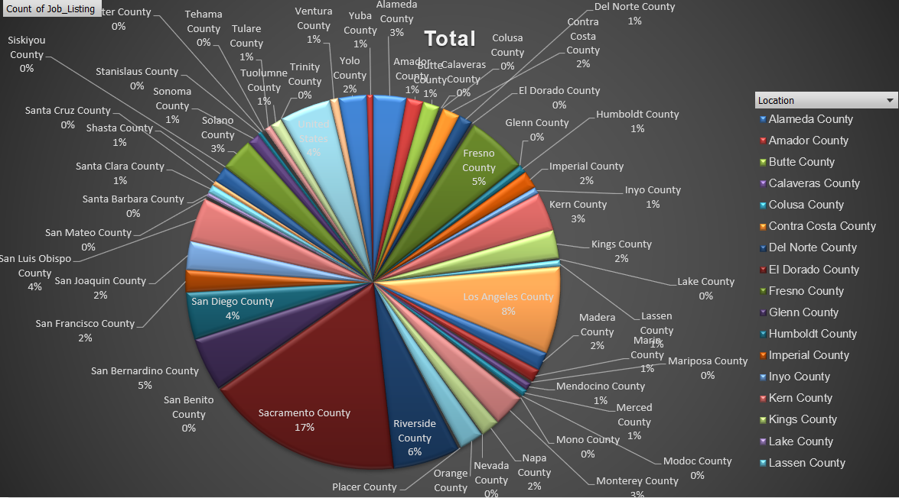

Nhóm các công việc được tuyển dụng phân bố khả rải rác nhưng có thể thấy nhóm công việc được tuyển dụng nhiều tại khu vực *Sacramento County.*

### Cụm 2:

|  |
| --- |
| CORRECTIONAL SUPERVISING COOK (CORRECTIONAL FACILITY), ACCOUNTANT I (SPECIALIST), ACCOUNTING ADMINISTRATOR I (SUPERVISOR), ACCOUNTING OFFICER (SPECIALIST), ADOPTIONS SPECIALIST, ASSOCIATE GOVERNMENTAL PROGRAM ANALYST, ASSOCIATE MANAGEMENT AUDITOR, ASSOCIATE PERSONNEL ANALYST, ATTORNEY, ATTORNEY III, ATTORNEY IV, AUTOMOBILE MECHANIC (CORRECTIONAL FACILITIES), BUSINESS SERVICE OFFICER I (SUPERVISOR), C. E. A., CALTRANS EQUIPMENT OPERATOR II, CALTRANS HIGHWAY MAINTENANCE LEADWORKER, CALTRANS HIGHWAY MAINTENANCE WORKER, CALTRANS LANDSCAPE MAINTENANCE LEADWORKER, CAPTAIN, ADULT INSTITUTION, CERTIFIED NURSING ASSISTANT, CHIEF PHYSICIAN AND SURGEON, CORRECTIONAL FACILITY, CHIEF PSYCHOLOGIST, CORRECTIONAL FACILITY, COMMUNICATIONS SUPERVISOR, COMMUNITY PROGRAM SPECIALIST III, CONSERVATIONIST I, COOK SPECIALIST I, CORRECTIONAL COUNSELOR II (SPECIALIST), CRIME ANALYST II, CUSTODIAN I, CUSTODIAN II, DENTAL ASSISTANT, CORRECTIONAL FACILITY, DEPUTY ATTORNEY GENERAL IV, DIRECT CONSTRUCTION SUPERVISOR I, DISABILITY INSURANCE PROGRAM REPRESENTATIVE, ACCOUNTANT TRAINEE, AGRICULTURAL TECHNICIAN I (SEASONAL), ASSOCIATE ACCOUNTING ANALYST, ASSOCIATE ENERGY SPECIALIST (TECHNOLOGY EVALUATION AND DEVELOPMENT), ASSOCIATE OPERATIONS SPECIALIST, FRANCHISE TAX BOARD, ATTORNEY, ASSISTANT CHIEF COUNSEL, AUTOMOTIVE TECHNICIAN II, CALTRANS ELECTRICIAN I, CALTRANS EQUIPMENT OPERATOR I, CALTRANS LANDSCAPE SPECIALIST, CALTRANS MAINTENANCE SUPERVISOR, CARPENTER I, CARPENTER II (CORRECTIONAL FACILITY), CASE RECORDS TECHNICIAN, COMMERCIAL VEHICLE INSPECTION SPECIALIST, CORRECTIONAL OFFICER, CORRECTIONAL SERGEANT, CRIME ANALYST I, DEPUTY ATTORNEY GENERAL, DEPUTY ATTORNEY GENERAL III, DISPATCH-CLERK SUPERVISOR, CALTRANS, DISTRICT ADMINISTRATOR, ALCOHO, DISTRICT SALES REPRESENTATIVE, CA STATE LOTTERY, ASSOCIATE PROPERTY APPRAISER (BOARD OF EQUALIZATION), ADMINISTRATIVE ASSISTANT I, ADMINISTRATOR III FRANCHISE TAX BOARD, AIR RESOURCES ENGINEER (MAND), ASSISTANT COORDINATOR OF NURSING SERVICES, ASSOCIATE BUSINESS MANAGEMENT ANALYST, ASSOCIATE MECHANICAL ENGINEER, ASSOCIATE TAX AUDITOR , EMPLOYMENT DEVELOPMENT DEPARTMENT, ASSOCIATE TRANSPORTATION PLANNER, AUTOMOTIVE EQUIPMENT OPERATOR I (MAND), BEHAVIOR SPECIALIST II, CALTRANS HEAVY EQUIPMENT MECHANIC, CALTRANS LANDSCAPE MAINTENANCE WORKER, CHIEF, FIREFIGHTER/SECURITY OFFICER, CORRECTIONAL PLANT SUPERVISOR, DEPT OF CORRECTIONS, CUSTOMER SERVICE SUPERVISOR, FRANCHISE TAX BOARD, ACCOUNTING ANALYST, ADMINISTRATOR II, FRANCHISE TAX BOARD, AIR POLLUTION SPECIALIST, AREA ADMINISTRATOR, DIVISION OF APPRENTICESHIP STANDARDS, ASSOCIATE INVESTMENT MANAGER,PUBLIC EMPLOYEES` RETIREMENT SYSTEM, BATTALION CHIEF, BUSINESS TAXES REPRESENTATIVE, CHIEF PSYCHIATRIST, CORRECTIONAL AND REHAB SERVICES (SAFETY), CHILD DEVELOPMENT CONSULTANT, CLAIM AUDITOR, CLINICAL SOCIAL WORKER (HEALTH/CORRECTIONAL FACILITY) - SAFETY, CORPORATION EXAMINER, CORRECTIONAL CASE RECORDS ANALYST, CORRECTIONAL CASE RECORDS MANAGER, CORRECTIONAL CASE RECORDS SUPERVISOR, CORRECTIONAL COUNSELOR I, CORRECTIONAL COUNSELOR III, ACCOUNTING ADMINISTRATOR I (SPECIALIST), ACCOUNTING ADMINISTRATOR II, ASSOCIATE ADMINISTRATIVE ANALYST ACCOUNTING SYSTEMS, ASSOCIATE RIGHT OF WAY AGENT, BUSINESS TAXES ADMINISTRATOR I, BOARD OF EQUALIZATION, CHIEF ENGINEER II, CLINICAL SOCIAL WORKER (HEALTH FACILITY), COMMUNITY RESOURCES MANAGER, DEPARTMENT OF CORRECTIONS, COOK SPECIALIST II, CORRECTIONAL HEALTH SERVICES ADMINISTRATOR I, CORRECTIONAL FACILITY, CRIMINALIST SUPERVISOR, DENTIST, DEPARTMENTS OF MENTAL HEALTH AND DEVELOPMENTAL SERVICES, ADMINISTRATIVE LAW JUDGE, ASSOCIATE TELECOMMUNICATIONS ENGINEER, BOOKBINDER IV, BUSINESS TAXES COMPLIANCE SPECIALIST, CALTRANS ELECTRICAL SUPERVISOR, CALTRANS ELECTRICIAN II, CARPENTER III (CORRECTIONAL FACILITY), CONSERVATIONIST SUPERVISOR, CORRECTIONAL ADMINISTRATOR, DEPARTMENT OF CORRECTIONS, CORRECTIONAL PLANT MANAGER II, DEPT OF CORRECTIONS, CUSTODIAN SUPERVISOR I, CUSTODIAN SUPERVISOR II, DISASTER ASSISTANCE PROGRAM SPECIALIST I, DRIVER SAFETY MANAGER I, ADMINISTRATIVE ASSISTANT II, ADMINISTRATOR I, FRANCHISE TAX BOARD, ASSOCIATE BUDGET ANALYST, ASSOCIATE CONSTRUCTION ANALYST, BUSINESS TAXES SPECIALIST I, BOARD OF EQUALIZATION, CLINICAL LABORATORY TECHNOLOGIST, CORRECTIONAL FACILITY, COMMUNICATIONS OPERATOR, AGRICULTURAL TECHNICIAN II (SEASONAL), ASSISTANT BUREAU CHIEF, NON-PEACE OFFICER, ASSOCIATE HAZARDOUS MATERIALS SPECIALIST, CHIEF DEPUTY ADMINISTRATOR, CORRECTIONAL PROGRAM, CEA, CONSERVATIONIST II, ASSISTANT INDUSTRIAL HYGIENIST, ASSOCIATE OIL AND GAS ENGINEER, ATTORNEY V, AUDITOR I, CHIEF ENGINEER I, CORRECTIONAL COUNSELOR II (SUPERVISOR), DIGITAL PRINT OPERATOR II, ACTIVITY COORDINATOR, VETERANS HOME AND MEDICAL CENTER, ASSOCIATE ARCHITECT, ASSOCIATE STATE ARCHAEOLOGIST, ATTORNEY II, ATTORNEY SUPERVISOR, CONSERVANCY PROJECT DEVELOPMENT ANALYST II, ADMINISTRATOR, VETERANS HOME OF CALIFORNIA, VENTURA, AGRICULTURE PROGRAM SUPERVISOR I, ASSISTANT CHIEF, ASSOCIATE INSURANCE COMPLIANCE OFFICER, DEPARTMENT OF INSURANCE, ASSOCIATE PARK AND RECREATION SPECIALIST, BOAT OPERATOR, CONTROL CASHIER I (MOTOR VEHICLE SERVICES), DEPARTMENT OF MOTOR VEHICLES, AGRICULTURAL AIDE (SEASONAL), APPRENTICESHIP CONSULTANT, BUSINESS TAXES SPECIALIST III, BOARD OF EQUALIZATION, CALTRANS MAINTENANCE AREA SUPERINTENDENT, COMMUNITY PROGRAM SPECIALIST IV, CRIME ANALYST SUPERVISOR, AIR RESOURCES SUPERVISOR I, ASSISTANT CORRECTIONAL FOOD MANAGER (DEPT OF CORRECTIONS), ASSISTANT SAFETY ENGINEER, CHIEF EXECUTIVE OFFICER, HEALTH CARE (SAFETY), Communications Editor, DISPATCHER-CLERK, CALTRANS, DRIVER SAFETY HEARING OFFICER, ADMINISTRATIVE OFFICER I, RESOURCES AGENCY, AIR QUALITY ENGINEER I, DEPARTMENT OF CONSUMER AFFAIRS, ASSOCIATE ENVIRONMENTAL PLANNER, BUSINESS SERVICE ASSISTANT (SPECIALIST), BUSINESS TAXES SPECIALIST II, BOARD OF EQUALIZATION, CORRECTIONAL BUSINESS MANAGER I, DEPARTMENT OF CORRECTIONS, Assistant Secretary, Public and Employee Communications, CHIEF ENGINEER I (CORRECTIONAL FACILITY), COASTAL PROGRAM ANALYST I, COASTAL PROGRAM ANALYST III, ACCOUNT CLERK II, ASSOCIATE INDUSTRIAL HYGIENIST, ASSOCIATE SPACE PLANNER, BUILDING MAINTENANCE WORKER, DISABILITY INSURANCE SPECIALIST I, ACCOUNTING TECHNICIAN, ASSISTANT TELECOMMUNICATIONS ENGINEER, ASSOCIATE SAFETY ENGINEER (PRESSURE VESSELS), CALTRANS HIGHWAY MECHANIC SUPERVISOR, CHIEF HYDROELECTRIC PLANT OPERATOR, CHILD NUTRITION CONSULTANT, COMMUNITY PROGRAM SPECIALIST II, CORRECTIONAL FOOD MANAGER I DEPT OF CORRECTIONS, DIRECT CONSTRUCTION SUPERVISOR II, CALTRANS BRIDGE MAINTENANCE SUPERVISOR, CHIEF OF PLANT OPERATION I, DEPUTY LABOR COMMISSIONER I, DISABILITY INSURANCE PROGRAM MANAGER II, ASSOCIATE PRINTING PLANT SUPERINTENDENT, CONSULTING PSYCHOLOGIST, CORRECTIONAL HEALTH SERVICES ADMINISTRATOR II, CORRECTIONAL FACILITY, CONTROL CASHIER II (VEHICLE REGISTRATION), DEPARTMENT OF MOTOR VEHICLES, ASSISTANT PROPERTY AUDITOR APPRAISER (BOARD OF EQUALIZATION), ASSOCIATE ANALYST, ASSOCIATE PROGRAM AUDITOR, CalPERS, BUSINESS MANAGER I, DISTRICT REPRESENTATIVE II, DIV CDS& STNDS (NON-PEACE OFFICER), DISTRICT SALES SUPERVISOR, CALIFORNIA STATE LOTTERY, ARCHEOLOGICAL PROJECT LEADER (SEASONAL), ARCHEOLOGICAL SPECIALIST (SEASONAL), ASSOCIATE MENTAL HEALTH SPECIALIST, ASSOCIATE PROPERTY AUDITOR APPRAISER (BOARD OF EQUALIZATION), ASSOCIATE SAFETY ENGINEER, ASSOCIATE HEALTH PROGRAM ADVISER, ASSOCIATE HYDROELECTRIC POWER UTILITY ENGINEER, ASSOCIATE REAL ESTATE OFFICER, COMPLIANCE REPRESENTATIVE, FRANCHISE TAX BOARD, COUNSELOR, SCHOOL FOR THE DEAF, ASSOCIATE CONTROL ENGINEER, CORRECTIONAL LIEUTENANT, CUSTOMER SERVICE SPECIALIST, FRANCHISE TAX BOARD, DEPUTY ATTORNEY GENERAL SUPERVISOR, DIGITAL COMPOSITION SPECIALIST II, BEHAVIOR SPECIALIST I, COASTAL PROGRAM MANAGER, DISABILITY INSURANCE PROGRAM MANAGER III, DISTRICT SUPERINTENDENT II, DEPARTMENT OF PARKS AND RECREATION SERIES, AIR RESOURCES TECHNICIAN II, BUSINESS SERVICE OFFICER I (SPECIALIST), CALTRANS MAINTENANCE MANAGER I, DISABILITY INSURANCE PROGRAM MANAGER I, ASSOCIATE STEEL INSPECTOR, CONSTRUCTION SUPERVISOR III (CORRECTIONAL FACILITY), DENTIST, CORRECTIONAL FACILITY, DISABILITY EVALUATION SERVICES ADMINISTRATOR I, CODES AND STANDARDS ADMINISTRATOR I (NON-PEACE OFFICER), DEPUTY INSPECTOR GENERAL, ADMINISTRATOR IV FRANCHISE TAX BOARD, ASSISTANT HEALTH PHYSICIST, AUTOMOTIVE EQUIPMENT OPERATOR I, DEPARTMENT OF MENTAL HEALTH AND DEVELOPMENTAL SERVICES, AUTOMOTIVE TECHNICIAN I, AVIATION OFFICER II (FLIGHT OPERATIONS), AIR RESOURCES SUPERVISOR II, AUTOMOTIVE POOL ATTENDANT I, BUSINESS SERVICE OFFICER II (SUPERVISOR), COMMUNITY COLLEGE PROGRAM ASSISTANT, CORRECTIONAL FOOD MANAGER II DEPT OF CORRECTIONS, ASSOCIATE TAX AUDITOR, BOARD OF EQUALIZATION, CRIME ANALYST III, DIETETICS ASSISTANT DIRECTOR, ASSOCIATE ENVIRONMENTAL PLANNER (ARCHEOLOGY), ASSOCIATE ENVIRONMENTAL PLANNER (ARCHITECTURAL HISTORY), CATHOLIC CHAPLAIN, AGRICULTURAL BIOLOGICAL TECHNICIAN, COMMUNITY COLLEGE ADMINISTRATOR I, DISTRICT SUPERINTENDENT I, DEPARTMENT OF PARKS AND RECREATION SERIES, ASSISTANT AGRICULTURAL ECONOMIST, CHIEF PHYSICIAN AND SURGEON, CHIEF, RESTORATIVE CARE SERVICE, DRAWBRIDGE OPERATOR, BRAND INSPECTOR, ASSOCIATE TOXICOLOGIST, CHILD NUTRITION SUPERVISOR I, DISTRICT MANAGER, DIVISION OF OCCUPATIONAL SAFETY AND HEALTH, ADMINISTRATIVE OFFICER II, RESOURCES AGENCY, AGRICULTURE PROGRAM SUPERVISOR IV, AGENT, ALCOHOLIC BEVERAGE CONT, CARPENTER II |

**Ý nghĩa cụm 2:**

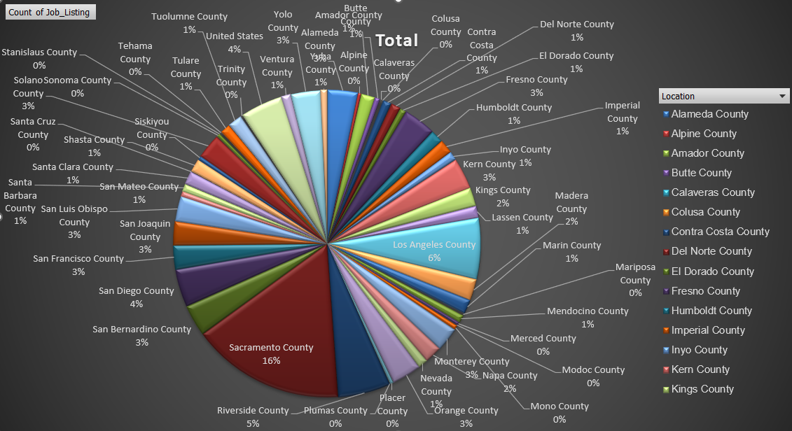

Nhóm các công việc được tuyển dụng phân bố khả rải rác nhưng có thể thấy nhóm công việc được tuyển dụng nhiều tại khu vực *Sacramento County.*

## Thuật toán Spectral Clustering

Import thư viện, mở đọc file csv lọc lấy 2 cột *Job_Listing*, *Location,* mã hóa các giá trị của 2 cột từ dạng chuỗi (String) về dạng số (Int).[4]

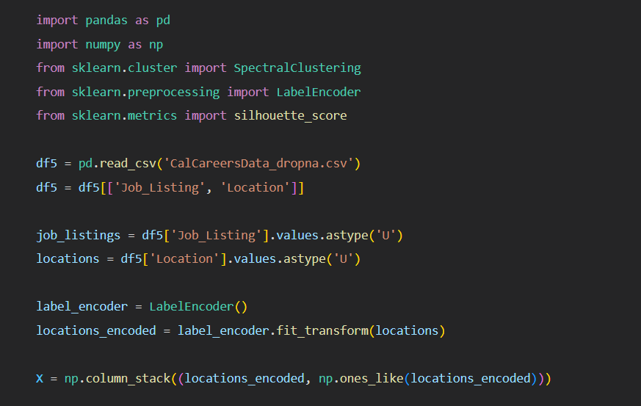

Sử dụng chỉ số silhouette (*silhouette_scores*) để thực hiện quá trình đánh giá hiệu suất của việc phân cụm dữ liệu với một loạt các số lượng cụm khác nhau (từ 2-7).

Vẽ dendrogram (biểu đồ cây) của các cụm dữ liệu dựa trên khoảng cách Euclidean giữa các điểm dữ liệu.

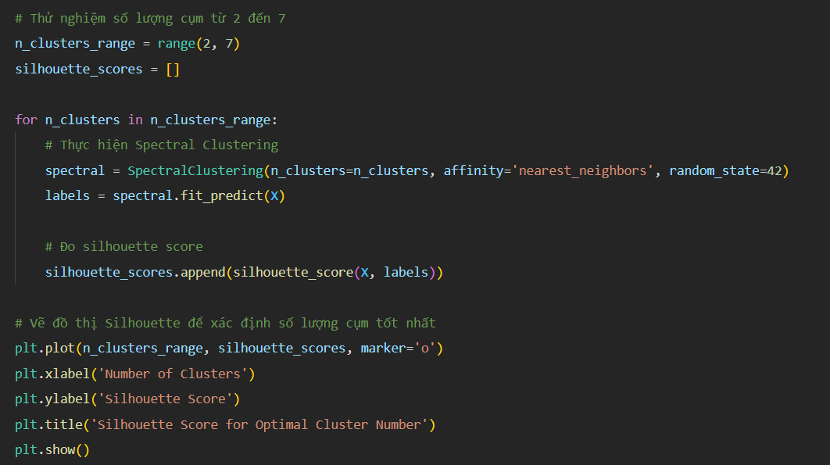  
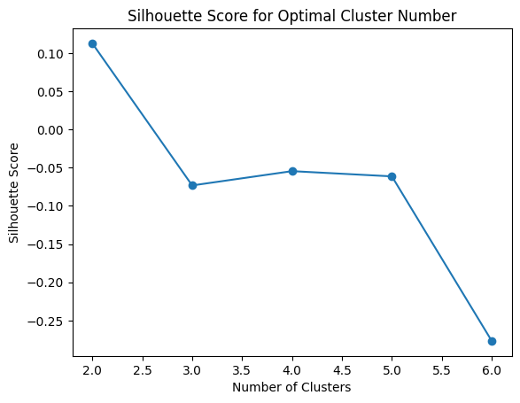

Kết quả biểu đồ cột giúp xác định số lượng cụm tốt nhất dựa trên silhouette_score. Số lượng cụm có silhouette_score cao nhất thường được chọn làm số lượng cụm tối ưu. Ở đây em sẽ chọn cột 4 thay vì 2 để so sánh kết quả phân cụm với thuật toán Louvain.

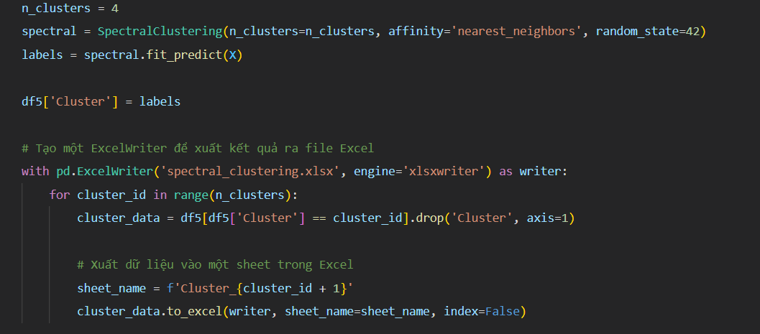

### Cụm 1:

|  |
| --- |
| CORRECTIONAL SUPERVISING COOK (CORRECTIONAL FACILITY), ACCOUNTING ADMINISTRATOR I (SUPERVISOR), ACCOUNTING OFFICER (SPECIALIST), ASSOCIATE GOVERNMENTAL PROGRAM ANALYST, CALTRANS EQUIPMENT OPERATOR II, CALTRANS HIGHWAY MAINTENANCE LEADWORKER, CAPTAIN, ADULT INSTITUTION, CRIME ANALYST II, CUSTODIAN I, CUSTODIAN II, FORESTRY TECHNICIAN, GROUNDSKEEPER, HEALTH PROGRAM MANAGER III, HEAVY EQUIPMENT MECHANIC (CORRECTIONAL FACILITY), INFORMATION TECHNOLOGY SPECIALIST II, AUTOMOTIVE TECHNICIAN II, BUSINESS SERVICE OFFICER I (SUPERVISOR), CARPENTER II (CORRECTIONAL FACILITY), CASE RECORDS TECHNICIAN, ENVIRONMENTAL SCIENTIST, EXECUTIVE ASSISTANT, HEALTH PROGRAM SPECIALIST I, INDUSTRIAL SUPERVISOR, PRISON INDUSTRIES (MAINTENANCE AND REPAIR), ACCOUNTANT TRAINEE, ADMINISTRATIVE ASSISTANT I, ATTORNEY IV, CALTRANS HIGHWAY MAINTENANCE WORKER, CORRECTIONAL PLANT SUPERVISOR, DEPT OF CORRECTIONS, FINANCIAL INSTITUTIONS EXAMINER, FISH AND WILDLIFE SCIENTIFIC AID, FISH AND WILDLIFE TECHNICIAN, AREA ADMINISTRATOR, DIVISION OF APPRENTICESHIP STANDARDS, CHIEF PHYSICIAN AND SURGEON, CORRECTIONAL FACILITY, CHIEF PSYCHIATRIST, CORRECTIONAL AND REHAB SERVICES (SAFETY), CORRECTIONAL COUNSELOR I, DEPUTY ATTORNEY GENERAL III, ENVIRONMENTAL SERVICES INTERN, ASSOCIATE ADMINISTRATIVE ANALYST ACCOUNTING SYSTEMS, CRIMINALIST SUPERVISOR, ENGINEER,CIVIL, TAX TECHNICIAN I, BOARD OF EQUALIZATION, ATTORNEY, BOOKBINDER IV, CALTRANS ELECTRICAL SUPERVISOR, CHIEF ENGINEER II, CONSERVATIONIST SUPERVISOR, COOK SPECIALIST I, ACCOUNTING ADMINISTRATOR II, CALTRANS HEAVY EQUIPMENT MECHANIC, ENGINEERING GEOLOGIST, INFORMATION TECHNOLOGY ASSOCIATE, SUPERVISING ENGINEER WATER RESOURCES, ASSOCIATE PERSONNEL ANALYST, CERTIFIED NURSING ASSISTANT, CONSERVATIONIST II, TAX TECHNICIAN III, BOARD OF EQUALIZATION, CORRECTIONAL COUNSELOR II (SUPERVISOR), FINANCIAL ACCOUNTANT II, FORESTRY AIDE, HEARING REPORTER, HEAVY FIRE EQUIPMENT OPERATOR, INFORMATION TECHNOLOGY SPECIALIST I, INFORMATION TECHNOLOGY SUPERVISOR II, LEGAL SUPPORT SUPERVISOR I, LICENSED VOCATIONAL NURSE, CALIFORNIA DEPARTMENT OF CORRECTIONS AND REHABILITATION, ASSOCIATE ARCHITECT, ASSOCIATE STATE ARCHAEOLOGIST, ATTORNEY II, CARPENTER III (CORRECTIONAL FACILITY), CORRECTIONAL SERGEANT, CRIME ANALYST I, ELECTRICAL ENGINEERING TECHNICIAN I, EMPLOYMENT PROGRAM REPRESENTATIVE, HEALTH FACILITIES EVALUATOR NURSE, MEDICAL ASSISTANT, SENIOR ENVIRONMENTAL SCIENTIST (SPECIALIST), ADMINISTRATOR, VETERANS HOME OF CALIFORNIA, VENTURA, ATTORNEY III, CALTRANS EQUIPMENT OPERATOR I, CONTROL CASHIER I (MOTOR VEHICLE SERVICES), DEPARTMENT OF MOTOR VEHICLES, OFFICE TECHNICIAN (TYPING), APPRENTICESHIP CONSULTANT, BUSINESS TAXES ADMINISTRATOR I, BOARD OF EQUALIZATION, ACCOUNTANT I (SPECIALIST), ASSISTANT SAFETY ENGINEER, BATTALION CHIEF, C. E. A., Communications Editor, RECREATION THERAPIST, CORRECTIONAL FACILITY, TEACHER (HIGH SCHOOL-GENERAL EDUCATION) (CORRECTIONAL FACILITY), COOK SPECIALIST II, CORRECTIONAL BUSINESS MANAGER I, DEPARTMENT OF CORRECTIONS, CORRECTIONAL OFFICER, JUNIOR ENGINEERING TECHNICIAN, STAFF SERVICES ANALYST, TRANSPORTATION ENGINEER (CIVIL), AUTOMOBILE MECHANIC (CORRECTIONAL FACILITIES), CHIEF ENGINEER I (CORRECTIONAL FACILITY), COASTAL PROGRAM ANALYST I, ASSOCIATE SPACE PLANNER, CALTRANS MAINTENANCE SUPERVISOR, CLINICAL SOCIAL WORKER (HEALTH/CORRECTIONAL FACILITY) - SAFETY, CONSERVATIONIST I, DISABILITY INSURANCE SPECIALIST I, TAX TECHNICIAN II, BOARD OF EQUALIZATION, BUSINESS SERVICE ASSISTANT (SPECIALIST), MATE, FISH AND GAME VESSEL, REGISTERED NURSE, CORRECTIONAL FACILITY, SENIOR ENVIRONMENTAL SCIENTIST (SUPERVISORY), ASSOCIATE TRANSPORTATION PLANNER, CORRECTIONAL CASE RECORDS ANALYST, DENTAL ASSISTANT, CORRECTIONAL FACILITY, DISPATCHER-CLERK, CALTRANS, FORESTER II (SUPERVISORY), FORESTRY ASSISTANT II, LABORER, SENIOR ENGINEERING GEOLOGIST, ASSOCIATE ANALYST, ASSOCIATE BUSINESS MANAGEMENT ANALYST, DEPUTY ATTORNEY GENERAL, DEPUTY ATTORNEY GENERAL IV, CORRECTIONAL CASE RECORDS SUPERVISOR, HEALTH RECORD TECHNICIAN I, ACCOUNTING ANALYST, ARCHEOLOGICAL PROJECT LEADER (SEASONAL), ARCHEOLOGICAL SPECIALIST (SEASONAL), FOOD ADMINISTRATOR I (CORRECTIONAL FACILITY), NURSE EVALUATOR II, HEALTH SERVICES, OFFICE ASSISTANT (TYPING), PROGRAM AND PROJECT SUPERVISOR, PUBLIC UTILITIES COMMISSION, PROGRAM TECHNICIAN II, RADIOLOGIC TECHNOLOGIST, CORRECTIONAL FACILITY, RESPIRATORY CARE SUPERVISOR, CORRECTIONAL FACILITY, ROUTE SALES REPRESENTATIVE, SENIOR ACCOUNTING OFFICER (SPECIALIST), SENIOR TELECOMMUNICATIONS ENGINEER, STAFF SERVICES MANAGER I, STAFF SERVICES MANAGER II (SUPERVISORY), SUPERVISING CLINICAL LABORATORY TECHNOLOGIST, CORRECTIONAL FACILTY, SUPERVISING PSYCHIATRIC SOCIAL WORKER I, CORRECTIONAL FACILTY, VOCATIONAL INSTRUCTOR (BUILDING MAINTENANCE) (CORRECTIONAL FACILITY), ASSOCIATE PARK AND RECREATION SPECIALIST, ASSOCIATE REAL ESTATE OFFICER, CALTRANS MAINTENANCE AREA SUPERINTENDENT, COMPLIANCE REPRESENTATIVE, FRANCHISE TAX BOARD, DISTRICT SALES REPRESENTATIVE, CA STATE LOTTERY, ENVIRONMENTAL PROGRAM MANAGER I (MANAGERIAL), FOOD SERVICE TECHNICIAN I, GRADUATE STUDENT ASSISTANT, GROUNDSKEEPER (CORRECTIONAL FACILITY), INFORMATION TECHNOLOGY MANAGER I, LEGAL SECRETARY, LICENSING PROGRAM ANALYST, LICENSING PROGRAM MANAGER II, PHYSICAL THERAPIST I, CORRECTIONAL FACILITY, PROTESTANT CHAPLAIN, PUBLIC SAFETY DISPATCHER, CALIFORNIA HIGHWAY PATROL, PUBLIC UTILITIES REGULATORY ANALYST I, PUBLIC UTILITIES REGULATORY ANALYST V, REGISTERED NURSE (MAND), RESEARCH DATA SPECIALIST I, SENIOR ESTIMATOR OF BUILDING CONSTRUCTION, SENIOR UTILITIES ENGINEER (SPECIALIST), SENIOR WORKERS' COMPENSATION INSURANCE REPRESENTATIVE, STUDENT ASSISTANT, TAX ADMINISTRATOR I, EMPLOYMENT DEVELOPMENT DEPARTMENT, TAX AUDITOR, EMPLOYMENT DEVELOPMENT DEPARTMENT, CORRECTIONAL HEALTH SERVICES ADMINISTRATOR II, CORRECTIONAL FACILITY, FINANCIAL ACCOUNTANT IV, INVESTMENT OFFICER II, STATE TEACHERS' RETIREMENT SYSTEM, JEWISH CHAPLAIN, LIBRARY TECHNICAL ASSISTANT (SAFETY), MAINTENANCE WORKER, DEPARTMENT OF THE CALIF. HIGHWAY PATROL, MOTOR CARRIER SPECIALIST I, CALIFORNIA HIGHWAY PATROL, NATIVE AMERICAN SPIRITUAL LEADER, OPTOMETRIST, CORRECTIONAL FACILITY, PARK MAINTENANCE ASSISTANT, PLUMBER II (CORRECTIONAL FACILITY), PSYCHIATRIC TECHNICIAN (SAFETY), PSYCHOLOGIST - CLINICAL, CORRECTIONAL FACILITY, PUBLIC HEALTH NURSE II, CORRECTIONAL FACILITY, PUBLIC SAFETY DISPATCH SUPERVISOR I CALIFORNIA HIGHWAY PATROL, PUBLIC UTILITIES REGULATORY ANALYST IV, RESEARCH DATA ANALYST II, SENIOR PSYCHOLOGIST, CORRECTIONAL FACILITY (SPECIALIST), WORKERS' COMPENSATION INSURANCE TECHNICIAN, ASSOCIATE MANAGEMENT AUDITOR, CHIEF PSYCHOLOGIST, CORRECTIONAL FACILITY, DRIVER SAFETY HEARING OFFICER, LAW ENFORCEMENT CONSULTANT I, COMMISSION ON PEACE OFFICER STANDARDS AND TRAINING, LEGAL ANALYST, PERSONNEL SPECIALIST, REGISTERED DIETITIAN, CORRECTIONAL FACILITY, SENIOR PSYCHOLOGIST, CORRECTIONAL FACILITY (SUPERVISOR), SUPERVISING REGISTERED NURSE II, CORRECTIONAL FACILITY, TRANSPORTATION ENGINEER (ELECTRICAL), WORKERS' COMPENSATION CONSULTANT, ASSOCIATE ACCOUNTING ANALYST, BUSINESS SERVICE OFFICER I (SPECIALIST), COMMERCIAL VEHICLE INSPECTION SPECIALIST, CORRECTIONAL ADMINISTRATOR, DEPARTMENT OF CORRECTIONS, PUBLIC SAFETY OPERATOR, CALIFORNIA HIGHWAY PATROL, PUBLIC UTILITIES REGULATORY ANALYST II, RESEARCH DATA SPECIALIST II, SERVICE ASSISTANT (MAINTENANCE), CALTRANS, SHEETFED OFFSET PRESS OPERATOR II, SPECIAL AGENT, DEPARTMENT OF JUSTICE, SUPERVISING REGISTERED NURSE III, CORRECTIONAL FACILITY, ASSOCIATE STEEL INSPECTOR, DISABILITY EVALUATION SERVICES ADMINISTRATOR I, INFORMATION TECHNOLOGY SPECIALIST III, INVESTIGATIVE AUDITOR III, DEPARTMENT OF JUSTICE, INVESTIGATOR, LABORATORY ASSISTANT, CORRECTIONAL FACILITY, MANAGER II, DEPARTMENT OF MOTOR VEHICLES, OFFICE TECHNICIAN (GENERAL), SENIOR ENVIRONMENTAL PLANNER, SENIOR PERSONNEL SPECIALIST, SUPERVISING CASE RECORDS TECHNICIAN, SUPERVISING REHABILITATION THERAPIST, DIGITAL PRINT OPERATOR II, MANAGEMENT SERVICES TECHNICIAN, MATERIALS AND STORES SUPERVISOR I (CORRECTIONAL FACILITY), PHARMACIST I (MAND), PUBLIC UTILITIES REGULATORY ANALYST III, SEASONAL CLERK, SENIOR RADIOLOGIC TECHNOLOGIST, CORRECTIONAL FACILITY (SPECIALIST), SENIOR TRANSPORTATION ENGINEER, CALTRANS, STATE PARK INTERPRETER II, AUTOMOTIVE TECHNICIAN I, EMPLOYMENT PROGRAM MANAGER II, FISCAL ANALYST, HEALTH PROGRAM SPECIALIST II, PARK MAINTENANCE SUPERVISOR, PEST CONTROL TECHNICIAN (CORRECTIONAL FACILITY), STAFF PSYCHIATRIST, CORRECTIONAL AND REHAB SERVICES (SAFETY), STATIONARY ENGINEER, STATIONARY ENGINEER (CORRECTIONAL FACILITY), SUPERVISING GROUNDSKEEPER II (CORRECTIONAL FACILITY), VOCATIONAL INSTRUCTOR (ELECTRICAL WORK) (CORRECTIONAL FACILITY), VOCATIONAL INSTRUCTOR (REFRIGERATION AND AIR CONDITIONING REPAIR) (CORRECTIONAL FACILITY), AUTOMOTIVE EQUIPMENT OPERATOR I (MAND), BUSINESS SERVICE OFFICER II (SUPERVISOR), NURSE INSTRUCTOR, OFFICE SERVICES SUPERVISOR II, PEST PREVENTION ASSISTANT I (VARIOUS PROJECTS), PSYCHIATRIC TECHNICIAN INSTRUCTOR, SENIOR TRANSPORTATION ELECTRICAL ENGINEER (SUPERVISOR), SUPERVISING TAX AUDITOR II BOARD OF EQUALIZATION, WATER RESOURCE CONTROL ENGINEER, CALTRANS LANDSCAPE MAINTENANCE WORKER, CORRECTIONAL LIEUTENANT, FINANCIAL ACCOUNTANT III, FISCAL SUPERVISOR, INFORMATION OFFICER I (SPECIALIST), MOTOR VEHICLE REPRESENTATIVE, PHARMACY TECHNICIAN, SENIOR VOCATIONAL REHABILITATION COUNSELOR, QUALIFIED REHABILITIATION PROFESSIONAL, Supervising Analyst, DEPUTY LABOR COMMISSIONER I, INFORMATION TECHNOLOGY MANAGER II, NURSE PRACTITIONER, CORRECTIONAL FACILITY, PHYSICIAN AND SURGEON, CORRECTIONAL FACILITY (INTERNAL MED/FAMILY PRACTICE), BUSINESS TAXES COMPLIANCE SPECIALIST, MECHANICAL AND TECHNICAL OCCUPATIONAL TRAINEE, RESEARCH DATA MANAGER, SENIOR PSYCHIATRIST (SUPERVISOR), CORRECTIONAL AND REHABILITATIVE SERVICES (SAFETY), SUPERVISING TRANSPORTATION ENGINEER, CALTRANS, LEAD GROUNDSKEEPER I (CORRECTIONAL FACILITY), NURSE INSTRUCTOR, CORRECTIONAL FACILITY, DISTRICT SUPERINTENDENT I, DEPARTMENT OF PARKS AND RECREATION SERIES, SENIOR PARK AIDE (SEASONAL), MEDICAL CONSULTANT (ENFORCEMENT), MEDICAL BOARD OF CALIFORNIA, FERRYBOAT MASTER, SENIOR LEGAL TYPIST, SUPERVISING PROGRAM TECHNICIAN II, VOCATIONAL INSTRUCTOR (CARPENTRY) (CORRECTIONAL FACILITY), DRAWBRIDGE OPERATOR, EQUIPMENT MATERIEL MANAGER I, LIBRARIAN (CORRECTIONAL FACILITY), TEACHING ASSISTANT (CORRECTIONAL FACILITY), STAFF SERVICES MANAGER II (MANAGERIAL), AGRICULTURAL TECHNICIAN I (SEASONAL), PHARMACIST II, SECURITY GUARD, LICENSED VOCATIONAL NURSE (MAND), PHYSICIAN ASSISTANT, CORRECTIONAL FACILITY, SENIOR MAINTENANCE AIDE (SEASONAL), SENIOR DELINEATOR, AGRICULTURAL TECHNICIAN II (SEASONAL), CALTRANS ELECTRICIAN II, SENIOR LEGAL ANALYST, DISTRICT SUPERINTENDENT II, DEPARTMENT OF PARKS AND RECREATION SERIES |

**Ý nghĩa cụm 1:**

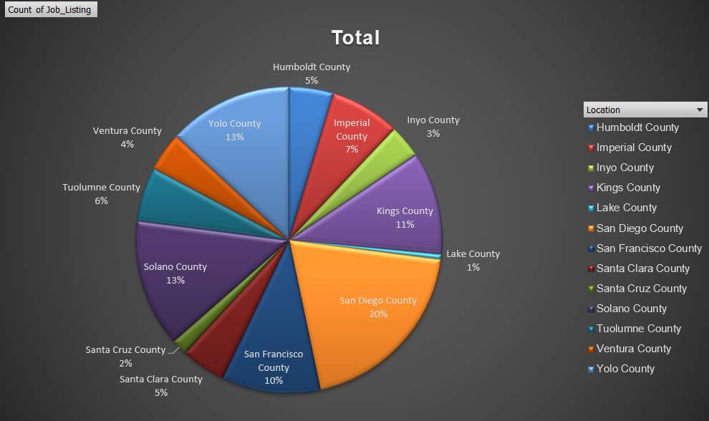

Nhóm các công việc được tuyển dụng phân bố khả rải rác nhưng có thể thấy nhóm công việc được tuyển dụng nhiều tại khu vực *Sandiego County.*

### Cụm 2:

|  |
| --- |
| ASSOCIATE GOVERNMENTAL PROGRAM ANALYST, CALTRANS EQUIPMENT OPERATOR II, CONSERVATIONIST I, FISH AND WILDLIFE SEASONAL AID, HEALTH FACILITIES EVALUATOR II (SUPERVISOR), SENIOR ENGINEER WATER RESOURCES, CALTRANS MAINTENANCE SUPERVISOR, HEALTH PROGRAM SPECIALIST I, FORESTRY LOGISTICS OFFICER I, FORESTRY TECHNICIAN, HEALTH PROGRAM MANAGER II, HYDROELECTRIC PLANT MECHANICAL SUPERVISOR, BATTALION CHIEF, CUSTODIAN I, AUTOMOTIVE EQUIPMENT OPERATOR I (MAND), HEAVY FIRE EQUIPMENT OPERATOR, ASSOCIATE PERSONNEL ANALYST, AUDITOR I, ENVIRONMENTAL SCIENTIST, FORESTRY AND FIRE PROTECTION A, HEALTH EDUCATION CONSULTANT II, HEALTH FACILITIES EVALUATOR NURSE, MANAGEMENT SERVICES TECHNICIAN, CALTRANS ELECTRICIAN II, DRIVER SAFETY HEARING OFFICER, PARK MAINTENANCE WORKER I, CALTRANS HEAVY EQUIPMENT MECHANIC, Hydroelectric Plant Technician II, CHIEF HYDROELECTRIC PLANT OPERATOR, EXAMINER II LABORATORY FIELD SERVICES, CALTRANS HIGHWAY MAINTENANCE WORKER, CALTRANS MAINTENANCE AREA SUPERINTENDENT, DISTRICT SALES SUPERVISOR, CALIFORNIA STATE LOTTERY, ASSISTANT CHIEF, FOOD SERVICE TECHNICIAN I, REGISTERED NURSE (MAND), RESEARCH SCIENTIST III (EPIDEMIOLOGY/BIOSTATISTICS), SUPERVISING COOK I, UTILITY CRAFTSWORKER, WATER RESOURCES, HYDROELECTRIC PLANT ELECTRICIAN II, LICENSED VOCATIONAL NURSE (MAND), PARK MAINTENANCE CHIEF I, PUBLIC HEALTH MICROBIOLOGIST SPECIALIST, PUBLIC HEALTH MEDICAL OFFICER III (EPIDEMIOLOGY), ROUTE SALES REPRESENTATIVE, STAFF SERVICES ANALYST, LICENSING PROGRAM ANALYST, MATERIALS AND RESEARCH ENGINEERING ASSOCIATE (SPECIALIST), TRANSPORTATION ENGINEER (CIVIL), TRANSPORTATION SURVEYOR (CALTRANS), ASSOCIATE SAFETY ENGINEER, FISH HATCHERY MANAGER I, OFFICE TECHNICIAN (TYPING), PROGRAM TECHNICIAN, SENIOR EMERGENCY SERVICES COORDINATOR, OFFICE OF EMERGENCY SERVICES, FISH AND WILDLIFE SCIENTIFIC AID, MAINTENANCE AIDE (SEASONAL), OFFICE ASSISTANT (TYPING), PROGRAM TECHNICIAN II, SECURITY GUARD, STUDENT ASSISTANT -ENGINEERING AND ARCHITECTURAL SCIENCES-, ADOPTIONS SPECIALIST, PARK MAINTENANCE ASSISTANT, RESPIRATORY CARE PRACTITIONER (MAND), CALTRANS LANDSCAPE MAINTENANCE WORKER, FORESTRY ASSISTANT II, RESIDENT CARE SPECIALIST, SERVICE ASSISTANT (MAINTENANCE), CALTRANS, SENIOR MOTOR VEHICLE TECHNICIAN, ENGINEERING GEOLOGIST, SENIOR VOCATIONAL REHABILITATION COUNSELOR, QUALIFIED REHABILITIATION PROFESSIONAL, SUPERVISING REGISTERED NURSE, BUILDING MAINTENANCE WORKER, STAFF SERVICES MANAGER II (SUPERVISORY), RESEARCH SCIENTIST IV (EPIDEMIOLOGY/BIOSTATISTICS), COOK SPECIALIST II, MAINTENANCE MECHANIC, COOK SPECIALIST I, GRADUATE STUDENT ASSISTANT, INVESTIGATOR, AGRICULTURAL TECHNICIAN I (SEASONAL) |

**Ý nghĩa cụm 2:**

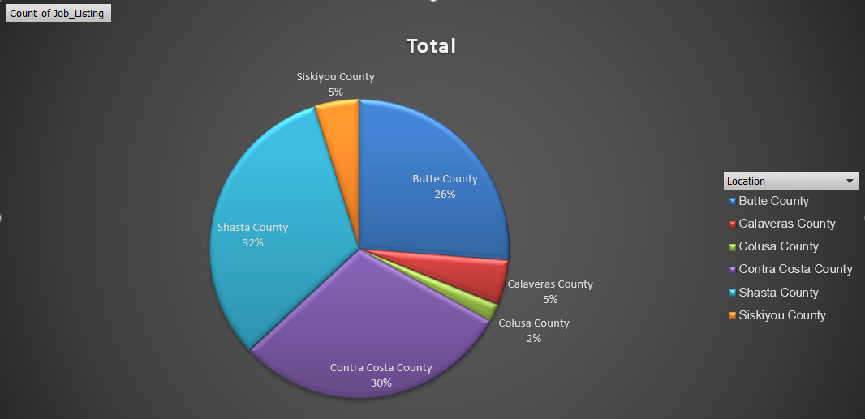

Nhóm các công việc được tuyển dụng chủ yếu tại 3 khu vực *Contra Costa County, Shasta County và Butte County.*

### Cụm 3:

|  |
| --- |
| MECHANICAL AND TECHNICAL OCCUPATIONAL TRAINEE, ACCOUNTANT I (SPECIALIST), ACCOUNTING OFFICER (SPECIALIST), ADOPTIONS SPECIALIST, ASSOCIATE GOVERNMENTAL PROGRAM ANALYST, ASSOCIATE MANAGEMENT AUDITOR, ASSOCIATE PERSONNEL ANALYST, ATTORNEY, ATTORNEY III, ATTORNEY IV, AUTOMOBILE MECHANIC (CORRECTIONAL FACILITIES), C. E. A., CALTRANS EQUIPMENT OPERATOR II, CALTRANS HIGHWAY MAINTENANCE WORKER, CERTIFIED NURSING ASSISTANT, CHIEF PHYSICIAN AND SURGEON, CORRECTIONAL FACILITY, CHIEF PSYCHOLOGIST, CORRECTIONAL FACILITY, COMMUNICATIONS SUPERVISOR, COMMUNITY PROGRAM SPECIALIST III, COOK SPECIALIST I, CORRECTIONAL COUNSELOR II (SPECIALIST), CORRECTIONAL SUPERVISING COOK (CORRECTIONAL FACILITY), DENTAL ASSISTANT, CORRECTIONAL FACILITY, DEPUTY ATTORNEY GENERAL IV, DIRECT CONSTRUCTION SUPERVISOR I, DISABILITY INSURANCE PROGRAM REPRESENTATIVE, EMERGENCY MANAGEMENT COORDINATOR/INSTRUCTOR I, OFFICE OF EMERGENCY SERVICES, EMERGENCY MANAGEMENT COORDINATOR/INSTRUCTOR II, OFFICE OF EMERGENCY SERVICES, EMERGENCY SERVICES COORDINATOR, OFFICE OF EMERGENCY SERVICES, ENVIRONMENTAL PROGRAM MANAGER I (SUPERVISORY), ENVIRONMENTAL SCIENTIST, EXECUTIVE ASSISTANT, FINANCIAL ACCOUNTANT I, FISH AND WILDLIFE SEASONAL AID, HEALTH PROGRAM MANAGER III, HEALTH RECORD TECHNICIAN I, HEALTH SERVICES SPECIALIST (SAFETY), HEAVY EQUIPMENT MECHANIC APPRENTICE, CALTRANS, INFORMATION TECHNOLOGY SPECIALIST I, PROGRAM TECHNICIAN II, REGISTERED NURSE (SAFETY), STAFF SERVICES ANALYST, STAFF SERVICES MANAGER I, STAFF SERVICES MANAGER II (SUPERVISORY), SUPERVISING ENGINEER WATER RESOURCES, ACCOUNTANT TRAINEE, AGRICULTURAL TECHNICIAN I (SEASONAL), ASSOCIATE ACCOUNTING ANALYST, ASSOCIATE ENERGY SPECIALIST (TECHNOLOGY EVALUATION AND DEVELOPMENT), ASSOCIATE OPERATIONS SPECIALIST, FRANCHISE TAX BOARD, ATTORNEY, ASSISTANT CHIEF COUNSEL, CALTRANS ELECTRICIAN I, CALTRANS EQUIPMENT OPERATOR I, CALTRANS HIGHWAY MAINTENANCE LEADWORKER, CALTRANS LANDSCAPE SPECIALIST, CARPENTER I, COMMERCIAL VEHICLE INSPECTION SPECIALIST, CORRECTIONAL OFFICER, CORRECTIONAL SERGEANT, CRIME ANALYST I, DEPUTY ATTORNEY GENERAL, DEPUTY ATTORNEY GENERAL III, DISPATCH-CLERK SUPERVISOR, CALTRANS, DISTRICT ADMINISTRATOR, ALCOHO, DISTRICT SALES REPRESENTATIVE, CA STATE LOTTERY, EDUCATION FISCAL SERVICES CONSULTANT, HEALTH PROGRAM SPECIALIST I, HEALTH PROGRAM SPECIALIST II, INFORMATION OFFICER I (SPECIALIST), ASSOCIATE PROPERTY APPRAISER (BOARD OF EQUALIZATION), JEWISH CHAPLAIN, OFFICE TECHNICIAN (TYPING), SENIOR ACCOUNTING OFFICER (SPECIALIST), ADMINISTRATIVE ASSISTANT I, ADMINISTRATOR III FRANCHISE TAX BOARD, AIR RESOURCES ENGINEER (MAND), ASSOCIATE BUSINESS MANAGEMENT ANALYST, ASSOCIATE MECHANICAL ENGINEER, ASSOCIATE TAX AUDITOR , EMPLOYMENT DEVELOPMENT DEPARTMENT, ASSOCIATE TRANSPORTATION PLANNER, AUTOMOTIVE EQUIPMENT OPERATOR I (MAND), AUTOMOTIVE TECHNICIAN II, BEHAVIOR SPECIALIST II, CALTRANS LANDSCAPE MAINTENANCE WORKER, CHIEF, FIREFIGHTER/SECURITY OFFICER, CONSERVATIONIST I, CUSTOMER SERVICE SUPERVISOR, FRANCHISE TAX BOARD, ENGINEER, WATER RESOURCES, FISH AND WILDLIFE SCIENTIFIC AID, FOOD ADMINISTRATOR I (CORRECTIONAL FACILITY), GRAPHIC DESIGNER III, GROUNDSKEEPER, HAZARDOUS SUBSTANCES ENGINEER, HEALTH FACILITIES EVALUATOR MANAGER I, HEALTH PROGRAM MANAGER II, NATIVE AMERICAN SPIRITUAL LEADER, OFFICE ASSISTANT (GENERAL), SENIOR PSYCHIATRIST (SPECIALIST), STUDENT ASSISTANT, ACCOUNTING ANALYST, ADMINISTRATOR II, FRANCHISE TAX BOARD, AIR POLLUTION SPECIALIST, AREA ADMINISTRATOR, DIVISION OF APPRENTICESHIP STANDARDS, ASSOCIATE INVESTMENT MANAGER,PUBLIC EMPLOYEES` RETIREMENT SYSTEM, BUSINESS TAXES REPRESENTATIVE, CALTRANS LANDSCAPE MAINTENANCE LEADWORKER, CAPTAIN, ADULT INSTITUTION, CHILD DEVELOPMENT CONSULTANT, CLAIM AUDITOR, CORPORATION EXAMINER, CORRECTIONAL CASE RECORDS ANALYST, CORRECTIONAL CASE RECORDS MANAGER, CORRECTIONAL CASE RECORDS SUPERVISOR, CORRECTIONAL PLANT SUPERVISOR, DEPT OF CORRECTIONS, CUSTODIAN I, EMPLOYMENT PROGRAM REPRESENTATIVE, ENGINEERING GEOLOGIST, EXECUTIVE SECRETARY I, JUNIOR ENGINEERING TECHNICIAN, SUPERVISING REGISTERED NURSE (SAFETY), TAX TECHNICIAN II, BOARD OF EQUALIZATION, WATER RESOURCES TECHNICIAN I, ELECTRICIAN II (CORRECTIONAL FACILITY), PAINTER II (CORRECTIONAL FACILITY), SUPERVISING CORRECTIONAL COOK DEPT OF CORRECTIONS, CORRECTIONAL COUNSELOR III, LEGAL ANALYST, MATERIALS AND STORES SUPERVISOR I (CORRECTIONAL FACILITY), PROGRAM MANAGER, PUBLIC UTILITIES COMMISSION, RESEARCH DATA SUPERVISOR II, ACCOUNTING ADMINISTRATOR I (SPECIALIST), ACCOUNTING ADMINISTRATOR II, ASSOCIATE ADMINISTRATIVE ANALYST ACCOUNTING SYSTEMS, ASSOCIATE RIGHT OF WAY AGENT, BUSINESS SERVICE OFFICER I (SUPERVISOR), BUSINESS TAXES ADMINISTRATOR I, BOARD OF EQUALIZATION, CHIEF PSYCHIATRIST, CORRECTIONAL AND REHAB SERVICES (SAFETY), CLINICAL SOCIAL WORKER (HEALTH FACILITY), COMMUNITY RESOURCES MANAGER, DEPARTMENT OF CORRECTIONS, CORRECTIONAL HEALTH SERVICES ADMINISTRATOR I, CORRECTIONAL FACILITY, ELECTRONICS TECHNICIAN, FINANCIAL ACCOUNTANT II, FINANCIAL INSTITUTIONS EXAMINER, FIRE PREVENTION SPECIALIST I, FIRE PREVENTION SPECIALIST II, INFORMATION TECHNOLOGY TECHNICIAN, PLUMBER II (CORRECTIONAL FACILITY), RESEARCH DATA SPECIALIST I, STAFF SERVICES MANAGEMENT AUDITOR, ASSOCIATE TELECOMMUNICATIONS ENGINEER, BATTALION CHIEF, BUSINESS TAXES COMPLIANCE SPECIALIST, CALTRANS ELECTRICIAN II, CALTRANS HEAVY EQUIPMENT MECHANIC, CARPENTER III (CORRECTIONAL FACILITY), CORRECTIONAL ADMINISTRATOR, DEPARTMENT OF CORRECTIONS, CORRECTIONAL PLANT MANAGER II, DEPT OF CORRECTIONS, CUSTODIAN SUPERVISOR I, CUSTODIAN SUPERVISOR II, DISASTER ASSISTANCE PROGRAM SPECIALIST I, DRIVER SAFETY HEARING OFFICER, ENVIRONMENTAL PROGRAM MANAGER I (MANAGERIAL), SENIOR ENGINEER WATER RESOURCES, SENIOR SPECIALIST PROPERTY APPRAISER (BOE), ACCOUNTING ADMINISTRATOR I (SUPERVISOR), ADMINISTRATIVE ASSISTANT II, ADMINISTRATOR I, FRANCHISE TAX BOARD, ASSOCIATE BUDGET ANALYST, ASSOCIATE CONSTRUCTION ANALYST, BUSINESS TAXES SPECIALIST I, BOARD OF EQUALIZATION, CLINICAL LABORATORY TECHNOLOGIST, CORRECTIONAL FACILITY, COMMUNICATIONS OPERATOR, CUSTODIAN II, ENERGY COMMISSION SPECIALIST II (TECH EVALUATION AND DEVELOPMENT), ENVIRONMENTAL PROGRAM MANAGER II, FISH HABITAT ASSISTANT, FORESTRY AIDE, HOSPITAL POLICE LIEUTENANT, INFORMATION TECHNOLOGY ASSOCIATE, INFORMATION TECHNOLOGY MANAGER I, INFORMATION TECHNOLOGY MANAGER II, STAFF MANAGEMENT AUDITOR (SPECIALIST) STATE CONTROLLER'S OFFICE, AGRICULTURAL TECHNICIAN II (SEASONAL), ASSISTANT BUREAU CHIEF, NON-PEACE OFFICER, ASSOCIATE HAZARDOUS MATERIALS SPECIALIST, CALTRANS MAINTENANCE SUPERVISOR, CHIEF DEPUTY ADMINISTRATOR, CORRECTIONAL PROGRAM, CEA, PSYCHIATRIC TECHNICIAN (SAFETY), TAX TECHNICIAN III, BOARD OF EQUALIZATION, ASSISTANT INDUSTRIAL HYGIENIST, ATTORNEY V, CHIEF ENGINEER I, DIGITAL PRINT OPERATOR II, EDUCATION PROGRAMS CONSULTANT, ELECTRICAL ENGINEER, ELECTRONICS TECHNICIAN (CORRECTIONAL FACILITY), FINANCIAL ACCOUNTANT III, FIRE CAPTAIN, FIRE FIGHTER II (PARAMEDIC), FORESTRY TECHNICIAN, GROUNDSKEEPER (CORRECTIONAL FACILITY), HEAVY FIRE EQUIPMENT OPERATOR, HOUSING AND COMMUNITY DEVELOPMENT REPRESENTATIVE I, INDUSTRIAL SUPERVISOR, PRISON INDUSTRIES (LAUNDRY), INFORMATION TECHNOLOGY SPECIALIST II, INFORMATION TECHNOLOGY SUPERVISOR II, LICENSED VOCATIONAL NURSE, CALIFORNIA DEPARTMENT OF CORRECTIONS AND REHABILITATION, MECHANICAL ENGINEER, SENIOR PERSONNEL SPECIALIST, YOUTH AID, HEAVY EQUIPMENT MECHANIC (CORRECTIONAL FACILITY), STATIONARY ENGINEER (CORRECTIONAL FACILITY), ELECTRICIAN III (CORRECTIONAL FACILITY), OFFICE SERVICES SUPERVISOR I (TYPING), ATTORNEY II, ATTORNEY SUPERVISOR, AUDITOR I, CORRECTIONAL COUNSELOR I, CRIME ANALYST II, FIELD REPRESENTATIVE, DEPARTMENT OF JUSTICE, FORESTER II (SUPERVISORY), HEALTH FACILITIES EVALUATOR NURSE, PAINTER I, STUDENT ASSISTANT -ENGINEERING AND ARCHITECTURAL SCIENCES-, AGRICULTURE PROGRAM SUPERVISOR I, ASSISTANT CHIEF, ASSOCIATE INSURANCE COMPLIANCE OFFICER, DEPARTMENT OF INSURANCE, ASSOCIATE OIL AND GAS ENGINEER, ASSOCIATE PARK AND RECREATION SPECIALIST, BOAT OPERATOR, COOK SPECIALIST II, CORRECTIONAL COUNSELOR II (SUPERVISOR), TELEVISION SPECIALIST, AGRICULTURAL AIDE (SEASONAL), BUSINESS TAXES SPECIALIST III, BOARD OF EQUALIZATION, CALTRANS MAINTENANCE AREA SUPERINTENDENT, CARPENTER II (CORRECTIONAL FACILITY), CASE RECORDS TECHNICIAN, COMMUNITY PROGRAM SPECIALIST IV, CRIME ANALYST SUPERVISOR, MUSLIM CHAPLAIN, SENIOR WORKERS' COMPENSATION CLAIMS ADJUSTER, AIR RESOURCES SUPERVISOR I, ASSISTANT CORRECTIONAL FOOD MANAGER (DEPT OF CORRECTIONS), ASSISTANT SAFETY ENGINEER, CHIEF EXECUTIVE OFFICER, HEALTH CARE (SAFETY), Communications Editor, EDUCATION RESEARCH AND EVALUATION ADMINISTRATOR I, EDUCATION RESEARCH AND EVALUATION CONSULTANT, ELECTRIC GENERATION SYSTEM SPECIALIST III, ELECTRICIAN I, HEAVY EQUIPMENT MECHANIC, MAILING MACHINES OPERATOR I, MEDICAL ASSISTANT, OFFICE ASSISTANT (TYPING), SEASONAL CLERK, STAFF PSYCHIATRIST (SAFETY), TRANSPORTATION SURVEYOR (CALTRANS), ADMINISTRATIVE OFFICER I, RESOURCES AGENCY, AIR QUALITY ENGINEER I, DEPARTMENT OF CONSUMER AFFAIRS, ASSOCIATE ENVIRONMENTAL PLANNER, BUSINESS SERVICE ASSISTANT (SPECIALIST), BUSINESS TAXES SPECIALIST II, BOARD OF EQUALIZATION, SENIOR VOCATIONAL REHABILITATION COUNSELOR, QUALIFIED REHABILITIATION PROFESSIONAL, TRANSPORTATION ENGINEER (CIVIL), ADMINISTRATIVE LAW JUDGE, Assistant Secretary, Public and Employee Communications, CLINICAL SOCIAL WORKER (HEALTH/CORRECTIONAL FACILITY) - SAFETY, COASTAL PROGRAM ANALYST III, FAIR EMPLOYMENT AND HOUSING CONSULTANT III (SPECIALIST), FISH AND WILDLIFE INTERPRETER II, ACCOUNT CLERK II, SENIOR PAYROLL SPECIALIST, ASSOCIATE ARCHITECT, ASSOCIATE INDUSTRIAL HYGIENIST, BUILDING MAINTENANCE WORKER, GRADUATE STUDENT ASSISTANT, PROGRAM MANAGER II, CALIFORNIA BAY DELTA AUTHORITY, PROGRAM DIRECTOR (MENTAL DISABILITIES-SAFETY), PROGRAM MANAGER I, OFFICE OF EMERGENCY SERVICES, RESEARCH DATA SPECIALIST II, ACCOUNTING TECHNICIAN, ASSISTANT TELECOMMUNICATIONS ENGINEER, ASSOCIATE SAFETY ENGINEER (PRESSURE VESSELS), CALTRANS HIGHWAY MECHANIC SUPERVISOR, CHILD NUTRITION CONSULTANT, COMMUNITY PROGRAM SPECIALIST II, CORRECTIONAL FOOD MANAGER I DEPT OF CORRECTIONS, DIRECT CONSTRUCTION SUPERVISOR II, ELECTRIC GENERATION SYSTEM SPECIALIST I, EMPLOYMENT PROGRAM MANAGER I, MANAGER I, DEPARTMENT OF MOTOR VEHICLES, TEACHING ASSISTANT (CORRECTIONAL FACILITY), CALTRANS BRIDGE MAINTENANCE SUPERVISOR, DEPUTY LABOR COMMISSIONER I, DISABILITY INSURANCE PROGRAM MANAGER II, SPECIAL AGENT-IN-CHARGE, ASSOCIATE PRINTING PLANT SUPERINTENDENT, CONSERVATIONIST II, CONSULTING PSYCHOLOGIST, CORRECTIONAL BUSINESS MANAGER I, DEPARTMENT OF CORRECTIONS, CORRECTIONAL HEALTH SERVICES ADMINISTRATOR II, CORRECTIONAL FACILITY, ELECTRICIAN II, ENERGY ANALYST, HEALTH FACILITIES EVALUATOR MANAGER II, INFORMATION TECHNOLOGY SPECIALIST III, INSPECTOR, BOARD OF PHARMACY, LEGAL ASSISTANT, LEGAL SECRETARY, LICENSED VOCATIONAL NURSE (MAND), CONTROL CASHIER II (VEHICLE REGISTRATION), DEPARTMENT OF MOTOR VEHICLES, GUIDE II, HISTORICAL MONUMENT (SPECIALIST), HEALTH PROGRAM AUDIT MANAGER I, DEPARTMENT OF HEALTH SERVICES, OFFICE TECHNICIAN (GENERAL), PHARMACY TECHNICIAN, SENIOR MOTOR VEHICLE TECHNICIAN, ASSISTANT PROPERTY AUDITOR APPRAISER (BOARD OF EQUALIZATION), ASSOCIATE ANALYST, ASSOCIATE PROGRAM AUDITOR, CalPERS, BUSINESS MANAGER I, CHIEF ENGINEER I (CORRECTIONAL FACILITY), DISTRICT REPRESENTATIVE II, DIV CDS& STNDS (NON-PEACE OFFICER), ENERGY RESOURCES SPECIALIST III MANAGERIAL, FIRE CHIEF, FOOD SERVICE SUPERVISOR II, FOOD SERVICE TECHNICIAN I, ASSOCIATE MENTAL HEALTH SPECIALIST, ASSOCIATE PROPERTY AUDITOR APPRAISER (BOARD OF EQUALIZATION), ASSOCIATE SAFETY ENGINEER, ENVIRONMENTAL SERVICES INTERN, FIRE CAPTAIN CORRECTION INSTITUTION, HOUSING AND COMMUNITY DEVELOPMENT REPRESENTATIVE II, HOUSING AND COMMUNITY DEVELOPMENT SPECIALIST II, LABORATORY ASSISTANT, CORRECTIONAL FACILITY, LIBRARIAN (CORRECTIONAL FACILITY), LIBRARY TECHNICAL ASSISTANT (SAFETY), LICENSING REPRESENTATIVE II, ABC, MAINTENANCE MECHANIC, MAINTENANCE MECHANIC (CORRECTIONAL FACILITY), MAINTENANCE WORKER, DEPARTMENT OF THE CALIF. HIGHWAY PATROL, OIL SPILL PREVENTION SPECIALIST, OPTOMETRIST, CORRECTIONAL FACILITY, PARK AIDE (SEASONAL), PERSONNEL PROGRAM ADVISOR, PERSONNEL SPECIALIST, PHYSICAL THERAPIST I, CORRECTIONAL FACILITY, PROGRAM AND PROJECT SUPERVISOR, PUBLIC UTILITIES COMMISSION, PROGRAM ASSISTANT (MENTAL DISABILITIES-SAFETY), PROGRAM MANAGER II, OFFICE OF EMERGENCY SERVICES, PROGRAM SPECIALIST III, FRANCHISE TAX BOARD, PROGRAM TECHNICIAN, RADIOLOGIC TECHNOLOGIST, CORRECTIONAL FACILITY, REGISTERED NURSE, CORRECTIONAL FACILITY, RESEARCH DATA SUPERVISOR I, RESEARCH SCIENTIST II (EPIDEMIOLOGY/BIOSTATISTICS), SENIOR ACCOUNTING OFFICER (SUPERVISOR), SENIOR COMPLIANCE REPRESENTATIVE, FRANCHISE TAX BOARD, SENIOR ENVIRONMENTAL SCIENTIST (SPECIALIST), SENIOR LEGAL ANALYST, SENIOR PARK AIDE (SEASONAL), SENIOR PARK AND RECREATION SPECIALIST, SENIOR PSYCHIATRIST (SUPERVISOR), CORRECTIONAL AND REHABILITATIVE SERVICES (SAFETY), SENIOR TELECOMMUNICATIONS ENGINEER, SPECIAL INVESTIGATOR, STAFF PARK AND RECREATION SPECIALIST, STAFF SERVICES MANAGER II (MANAGERIAL), STAFF SERVICES MANAGER III, STATE PARK PEACE OFFICER SUPERVISOR (RANGER), SUPERVISING MANAGEMENT AUDITOR, SUPERVISING PSYCHIATRIC SOCIAL WORKER I, CORRECTIONAL FACILTY, SUPERVISING REGISTERED NURSE II, CORRECTIONAL FACILITY, TAX TECHNICIAN, FRANCHISE TAX BOARD, TEACHER (HIGH SCHOOL-GENERAL EDUCATION) (CORRECTIONAL FACILITY), TEACHER (HIGH SCHOOL-PHYSICAL EDUCATION) (CORRECTIONAL FACILITY), TRANSPORTATION ENGINEERING TECHNICIAN, UNIT SUPERVISOR (SAFETY), UTILITIES ENGINEER, WAREHOUSE WORKER, ASSOCIATE HEALTH PROGRAM ADVISER, ASSOCIATE HYDROELECTRIC POWER UTILITY ENGINEER, COUNSELOR, SCHOOL FOR THE DEAF, HEALTH FACILITIES EVALUATOR II (SUPERVISOR), HEALTH RECORD TECHNICIAN II (SUPERVISOR), HEAVY TRUCK DRIVER, LEGAL SUPPORT SUPERVISOR I, LICENSING PROGRAM ANALYST, MANAGEMENT SERVICES TECHNICIAN, NURSE CONSULTANT III (SUPERVISOR), OFFICE SERVICES SUPERVISOR II, PHARMACIST I (MAND), PUBLIC SAFETY DISPATCHER, CALIFORNIA HIGHWAY PATROL, PUBLIC UTILITIES REGULATORY ANALYST I, PUBLIC UTILITIES REGULATORY ANALYST V, RECREATION THERAPIST, CORRECTIONAL FACILITY, REHABILITATION THERAPIST, STATE FACILITIES (RECREATION-SAFETY), SENIOR BRIDGE ENGINEER, SENIOR UTILITIES ENGINEER (SPECIALIST), SENIOR WORKERS' COMPENSATION INSURANCE REPRESENTATIVE, SPECIAL AGENT, STAFF AIR POLLUTION SPECIALIST, STAFF MANAGEMENT AUDITOR, STAFF PSYCHIATRIST (MAND), STATIONARY ENGINEER, STOCK CLERK, SUPERVISING INSPECTOR, BOARD OF PHARMACY, SUPERVISING PROGRAM TECHNICIAN II, SUPERVISING SPECIAL INVESTIGATOR I (NON-PEACE OFFICER), TAX TECHNICIAN I, BOARD OF EQUALIZATION, VOCATIONAL INSTRUCTOR (CARPENTRY) (CORRECTIONAL FACILITY), VOCATIONAL INSTRUCTOR (WELDING) (CORRECTIONAL FACILITY), VOCATIONAL INSTRUCTOR, AUTO MECHANICS (CORRECTIONAL FACILITY), WILDLIFE HABITAT ASSISTANT, WORKERS' COMPENSATION CONSULTANT, ASSOCIATE CONTROL ENGINEER, COMPLIANCE REPRESENTATIVE, FRANCHISE TAX BOARD, CORRECTIONAL LIEUTENANT, CUSTOMER SERVICE SPECIALIST, FRANCHISE TAX BOARD, DEPUTY ATTORNEY GENERAL SUPERVISOR, DIGITAL COMPOSITION SPECIALIST II, FINANCIAL AND PERFORMANCE EVALUATOR II, DEPT OF FINANCE, GENERAL AUDITOR III, HYDROELECTRIC PLANT TECHNICIAN I, Hydroelectric Plant Technician II, INDUSTRIAL WAREHOUSE AND DISTRIBUTION SUPERVISOR, PRISON INDUSTRY, INVESTMENT MANAGER, PUBLIC EMPLOYEES' RETIREMENT SYSTEM, MANAGER II, DEPARTMENT OF MOTOR VEHICLES, NURSE PRACTITIONER (SAFETY), PARK LANDSCAPE MAINTENANCE TECHNICIAN, PERSONNEL SUPERVISOR II, PHYSICIAN AND SURGEON, CORRECTIONAL FACILITY, PRISON INDUSTRIES SUPERINTENDENT II (MATTRESS AND BEDDING), PSYCHIATRIC TECHNICIAN ASSISTANT (SAFETY), PUBLIC HEALTH MEDICAL ADMINISTRATOR I, RESEARCH DATA SPECIALIST III , RESEARCH SCIENTIST III (SOCIAL BEHAVIORAL SCIENCES), RESEARCH SCIENTIST SUPERVISOR II (EPIDEMIOLOGY/BIOSTATISTICS), SENIOR PSYCHOLOGIST, CORRECTIONAL FACILITY (SUPERVISOR), SENIOR TRANSPORTATION ENGINEER, CALTRANS, SENIOR TRANSPORTATION PLANNER, SENIOR TRANSPORTATION SURVEYOR (CALTRANS), SUPERVISING CLINICAL LABORATORY TECHNOLOGIST, CORRECTIONAL FACILTY, SUPERVISING COOK I, SUPERVISING PROGRAM TECHNICIAN III, SUPERVISOR OF BUILDING TRADES (CORRECTIONAL FACILITY), TAX PROGRAM SUPERVISOR, FRANCHISE TAX BOARD, TEACHING ASSISTANT, SCHOOL FOR THE BLIND, TRAINING OFFICER I, WORKERS' COMPENSATION INSURANCE TECHNICIAN, ASSOCIATE STATE ARCHAEOLOGIST, BEHAVIOR SPECIALIST I, COASTAL PROGRAM MANAGER  DISABILITY INSURANCE PROGRAM MANAGER III, DISTRICT SUPERINTENDENT II, DEPARTMENT OF PARKS AND RECREATION SERIES, FIELD REPRESENTATIVE, BOARD OF FUNERAL DIRECTORS AND EMBALMERS, LABOR RELATIONS ANALYST, LOCKSMITH I (CORRECTIONAL FACILITY), MAINTENANCE WORKER, TUNNELS AND TUBES, MATERIALS AND STORES SUPERVISOR II (CORRECTIONAL FACILITY), MEDICAL RECORD DIRECTOR, NURSE EVALUATOR II, HEALTH SERVICES, PHARMACIST II, PHARMACY SERVICES MANAGER, PRE-LICENSED PSYCHIATRIC TECHNICIAN, PROGRAM TECHNICIAN III, REGIONAL DENTAL DIRECTOR, CEA, RESEARCH SCIENTIST I (EPIDEMIOLOGY/BIOSTATISTICS), RESPIRATORY CARE PRACTITIONER, CORRECTIONAL FACILITY, ROUTE SALES REPRESENTATIVE, SCIENTIFIC AID, SENIOR AUDITOR EVALUATOR I, SENIOR AUDITOR EVALUATOR II, SENIOR AUDITOR EVALUATOR III, SENIOR EMERGENCY SERVICES COORDINATOR, OFFICE OF EMERGENCY SERVICES, SENIOR ENVIRONMENTAL SCIENTIST (SUPERVISORY), SENIOR MARKETING SPECIALIST, CALIFORNIA STATE LOTTERY, SENIOR PSYCHOLOGIST (HEALTH FACILITY) (SUPERVISOR), SENIOR RADIOLOGIC TECHNOLOGIST, CORRECTIONAL FACILITY (SPECIALIST), STATE PARK INTERPRETER II, SUPERVISING TRANSPORTATION ENGINEER, CALTRANS, TAX PROGRAM TECHNICIAN I, FRANCHISE TAX BOARD, TRANSPORTATION ENGINEER (ELECTRICAL), WATER RESOURCES ENGINEERING ASSOCIATE (SPECIALIST), WORKERS' COMPENSATION ASSISTANT, AIR RESOURCES TECHNICIAN II, CALTRANS MAINTENANCE MANAGER I, FINANCIAL AND PERFORMANCE EVALUATOR I, DEPARTMENT OF FINANCE, FORESTER I (NONSUPERVISORY), FORESTRY ASSISTANT II, HEALTH EDUCATION CONSULTANT II, HEALTH EDUCATION CONSULTANT III (SPECIALIST), HEALTH PROGRAM MANAGER I, INDUSTRIAL SUPERVISOR, PRISON INDUSTRIES (MAINTENANCE AND REPAIR), INFORMATION OFFICER II, INVESTIGATOR, LANDSCAPE ASSOCIATE, CALTRANS, LICENSED VOCATIONAL NURSE, DEPARTMENTS OF MENTAL HEALTH AND DEVELOPMENTAL SERVICES, MATERIALS AND STORES SPECIALIST, MINERAL RESOURCES INSPECTOR II, NURSE PRACTITIONER, CORRECTIONAL FACILITY, OCCUPATIONAL THERAPIST, DEPARTMENTS OF MENTAL HEALTH AND DEVELOPMENTAL SERVICES, OFFSET PRESS ASSISTANT, PSYCHIATRIC TECHNICIAN ASSISTANT, PUBLIC HEALTH NURSE II, CORRECTIONAL FACILITY, PUBLIC UTILITIES REGULATORY ANALYST II, PUBLIC UTILITIES REGULATORY ANALYST IV, RECEIVER'S MEDICAL EXECUTIVE (SAFETY), REGISTERED DIETITIAN (SAFETY), RESEARCH DATA ANALYST II, RESEARCH SCIENTIST III (EPIDEMIOLOGY/BIOSTATISTICS), SENIOR WATER RESOURCE CONTROL ENGINEER, SERVICE ASSISTANT (MAINTENANCE), CALTRANS, SPECIAL AGENT, DEPARTMENT OF JUSTICE, STATE PARK INTERPRETER I, SUPERVISING CASE RECORDS TECHNICIAN, TAX ADMINISTRATOR II, EMPLOYMENT DEVELOPMENT DEPARTMENT, TRANSPORTATION SURVEYOR PARTY CHIEF (CALTRANS), WATER AND SEWAGE PLANT OPERATOR, DEPARTMENT FORESTRY AND FIRE PROTECTION (SAFETY), CONSTRUCTION SUPERVISOR III (CORRECTIONAL FACILITY), CONTROL CASHIER I (MOTOR VEHICLE SERVICES), DEPARTMENT OF MOTOR VEHICLES, DENTIST, CORRECTIONAL FACILITY, ELECTRIC GENERATION SYSTEM PROGRAM SPECIALIST I, MAILING MACHINES SUPERVISOR II, MAINTENANCE AIDE (SEASONAL), SECURITY GUARD, SENIOR ENGINEERING GEOLOGIST, SENIOR PSYCHIATRIC TECHNICIAN (SAFETY), SENIOR PSYCHOLOGIST, CORRECTIONAL FACILITY (SPECIALIST), WATER RESOURCE CONTROL ENGINEER, CODES AND STANDARDS ADMINISTRATOR I (NON-PEACE OFFICER), DEPUTY INSPECTOR GENERAL, ENVIRONMENTAL PLANNER, EXECUTIVE OFFICER, SAN JOAQUIN RIVER CONSERVANCY, HEARING REPORTER, HEAVY TRUCK DRIVER (CORRECTIONAL FACILITY), LICENSED VOCATIONAL NURSE (SAFETY), MANAGER I, STATE COMPENSATION INSURANCE FUND, MEDICAL CONSULTANT I, DEPARTMENT OF HEALTH SERVICES, PARK MAINTENANCE ASSISTANT, PARK MAINTENANCE WORKER II, PRE-LICENSED PSYCHIATRIC TECHNICIAN (SAFETY), PSYCHOLOGIST (HEALTH FACILITY - CLINICAL), DEPARTMENTS OF MENTAL HEALTH AND DEVELOPMENTAL SERVICES, PUBLIC UTILITIES REGULATORY ANALYST III, RESEARCH DATA ANALYST I, RESEARCH DATA MANAGER, SENIOR HAZARDOUS SUBSTANCES ENGINEER, SENIOR LEGAL TYPIST, STATE PARK EQUIPMENT OPERATOR, SUPERVISING REGISTERED NURSE III, CORRECTIONAL FACILITY, TEACHER, STATE HOSPITALS(LRNG HANDICAPPED, MENTALLY DISABLED), ADMINISTRATOR IV FRANCHISE TAX BOARD, ASSISTANT HEALTH PHYSICIST, AUTOMOTIVE EQUIPMENT OPERATOR I, DEPARTMENT OF MENTAL HEALTH AND DEVELOPMENTAL SERVICES, AVIATION OFFICER II (FLIGHT OPERATIONS), CONSERVATIONIST SUPERVISOR, EMPLOYMENT DEVELOPMENT ADMINISTRATOR, EMPLOYMENT PROGRAM MANAGER II, FISCAL ANALYST, GUIDE TRAINEE HISTORICAL MONUMENT, LICENSING-REGISTRATION EXAMINER, DEPARTMENT OF MOTOR VEHICLES, MATERIALS AND RESEARCH ENGINEERING ASSOCIATE (SPECIALIST), MOTOR VEHICLE REPRESENTATIVE, PEACE OFFICER I, DEVELOPMENTAL CENTER, PERSONNEL SUPERVISOR I, SENIOR CLINICAL LABORATORY TECHNOLOGIST, CORRECTIONAL FACILITY, SENIOR STRUCTURAL ENGINEER, SENIOR TAX COMPLIANCE REPRESENTATIVE (SPECIALIST), SPECIAL ASSISTANT INSPECTOR GENERAL, STAFF PSYCHIATRIST, CORRECTIONAL AND REHAB SERVICES (SAFETY), STAFF TOXICOLOGIST (SPECIALIST), AIR RESOURCES SUPERVISOR II, AUTOMOTIVE POOL ATTENDANT I, CHIEF ENGINEER II, COMMUNITY COLLEGE PROGRAM ASSISTANT, CORRECTIONAL FOOD MANAGER II DEPT OF CORRECTIONS, ENERGY COMMISSION SPECIALIST I (TECH EVALUATION AND DEVELOPMENT), FOOD SERVICE TECHNICIAN II, GRADUATE LEGAL ASSISTANT, INVESTIGATIVE CERTIFIED PUBLIC ACCOUNTANT, NIGHT ATTENDANT, SCHOOL FOR THE DEAF, PERSONNEL TECHNICIAN II (SPECIALIST), PRINTING TRADES SPECIALIST TRAINEE (GENERAL), PUBLIC SAFETY OPERATOR, CALIFORNIA HIGHWAY PATROL, REGISTERED DIETITIAN, CORRECTIONAL FACILITY, SENIOR MECHANICAL ENGINEER, SUPERVISING REHABILITATION THERAPIST, TEACHER, STATE HOSPITALS (SEVERELY HANDICAPPED, DEVELOPMENTALLY DISABLED), TELECOMMUNICATIONS FACILITIES TECHNICIAN II, CHP, VETERINARIAN SPECIALIST (GENERAL), VOCATIONAL INSTRUCTOR (COMPUTER AND RELATED TECHNOLOGIES) (CORRECTIONAL FACILITY), VOCATIONAL INSTRUCTOR (REFRIGERATION AND AIR CONDITIONING REPAIR) (CORRECTIONAL FACILITY), ASSOCIATE TAX AUDITOR, BOARD OF EQUALIZATION, CRIME ANALYST III, FIRE FIGHTER, FISCAL SUPERVISOR, FISH AND WILDLIFE TECHNICIAN, NURSE INSTRUCTOR, CORRECTIONAL FACILITY, PEST PREVENTION ASSISTANT II (VARIOUS PROJECTS), PUBLIC SAFETY DISPATCH SUPERVISOR I CALIFORNIA HIGHWAY PATROL, RIGHT OF WAY AGENT, Supervising Analyst, SUPERVISING FRAUD INVESTIGATOR I, DEPARTMENT OF INSURANCE, SUPERVISING HAZARDOUS SUBSTANCES ENGINEER I, SUPERVISING PSYCHIATRIC SOCIAL WORKER I, SUPERVISING TRANSPORTATION PLANNER, SUPPORT SERVICES ASSISTANT (INTERPRETER), TAX AUDITOR, BOARD OF EQUALIZATION, VOCATIONAL INSTRUCTOR (OFFICE SERVICES AND RELATED TECHNICAL) (CORRECTIONAL FACILITY), WORKERS' COMPENSATION CLAIMS ADJUSTER, DIETETICS ASSISTANT DIRECTOR, PODIATRIST, DEPARTMENTS OF MENTAL HEALTH AND DEVELOPMENTAL SERVICES, ASSOCIATE ENVIRONMENTAL PLANNER (ARCHEOLOGY), ASSOCIATE ENVIRONMENTAL PLANNER (ARCHITECTURAL HISTORY), CATHOLIC CHAPLAIN, MEDICAL CONSULTANT II, DEPARTMENT OF HEALTH SERVICES, PHYSICAL THERAPY ASSISTANT, PHYSICIAN AND SURGEON, CORRECTIONAL FACILITY (INTERNAL MED/FAMILY PRACTICE), PROGRAM SPECIALIST II, FRANCHISE TAX BOARD, REGISTERED DIETITIAN, REGISTERED NURSE (MAND), RESEARCH SCIENTIST SUPERVISOR I (EPIDEMIOLOGY/BIOSTATISTICS), SENIOR MANAGEMENT AUDITOR, TAX PROGRAM TECHNICIAN II, FRANCHISE TAX BOARD, AGRICULTURAL BIOLOGICAL TECHNICIAN, PHARMACIST I, DEPARTMENTS OF MENTAL HEALTH AND DEVELOPMENTAL SERVICES, SENIOR ENVIRONMENTAL PLANNER, COMMUNITY COLLEGE ADMINISTRATOR I, PHYSICAL THERAPIST I, DEPARTMENTS OF MENTAL HEALTH AND DEVELOPMENTAL SERVICES, PRINCIPAL TRANSPORTATION ENGINEER, CALTRANS, PUBLIC HEALTH MEDICAL OFFICER II, VOCATIONAL INSTRUCTOR (BUILDING MAINTENANCE) (CORRECTIONAL FACILITY), SENIOR RIGHT OF WAY AGENT, STATE FAIR WORKER, CASUAL EMPLOYMENT (VARIOUS), PARK INTERPRETIVE SPECIALIST (SEASONAL), PRINCIPAL HYDROELECTRIC POWER UTILITY ENGINEER, STRUCTURAL PEST CONTROL BOARD SPECIALIST, PSYCHOLOGIST (HEALTH FACILITY - CLINICAL - SAFETY), PSYCHOLOGIST - CLINICAL, CORRECTIONAL FACILITY, RESIDENT CARE SPECIALIST, WATER AND SEWAGE PLANT SUPERVISOR (CORRECTIONAL FACILITY), ASSISTANT AGRICULTURAL ECONOMIST, CHIEF PHYSICIAN AND SURGEON, FINANCIAL ACCOUNTANT IV, REHABILITATION THERAPIST, STATE FACILITIES (ART-SAFETY), REHABILITATION THERAPIST, STATE FACILITIES (MUSIC-SAFETY), REHABILITATION THERAPIST, STATE FACILITIES (OCCUPATIONAL-SAFETY), RESEARCH SCIENTIST II (SOCIAL/BEHAVIORAL SCIENCES), RESEARCH SCIENTIST IV (EPIDEMIOLOGY/BIOSTATISTICS), SOCIAL WORK ASSOCIATE (SAFETY), STAFF PROGRAM AUDITOR, CALPERS, VOCATIONAL INSTRUCTOR (AUTO BODY AND FENDER REPAIR) (CORRECTIONAL FACILITY), VOCATIONAL INSTRUCTOR (ELECTRICAL WORK) (CORRECTIONAL FACILITY), VOCATIONAL INSTRUCTOR, PLUMBING (CORRECTIONAL FACILITY), PROGRAM REPRESENTATIVE II (SPECIALIST), DEPARTMENT OF CONSUMER AFFAIRS, SENIOR PSYCHIATRIC TECHNICIAN, SUPERVISING VETERINARIAN (GENERAL), PHYSICIAN AND SURGEON (SAFETY), SENIOR MAINTENANCE AIDE (SEASONAL), TELECOMMUNICATIONS SYSTEMS TECHNICIAN II, TRACTOR OPERATOR-LABORER, BRAND INSPECTOR, FIELD REPRESENTATIVE, BOARD OF CORRECTIONS, HOSPITAL POLICE OFFICER, WELFARE FRAUD PREVENTION COORDINATOR, LEAD GROUNDSKEEPER, SENIOR STATE ARCHEOLOGIST, SPEECH PATHOLOGIST I, DEPARTMENTS OF MENTAL HEALTH AND DEVELOPMENTAL SERVICES, ASSOCIATE TOXICOLOGIST, CHILD NUTRITION SUPERVISOR I, DISTRICT MANAGER, DIVISION OF OCCUPATIONAL SAFETY AND HEALTH, SENIOR TOXICOLOGIST, ADMINISTRATIVE OFFICER II, RESOURCES AGENCY, AGRICULTURE PROGRAM SUPERVISOR IV, DISTRICT SUPERINTENDENT I, DEPARTMENT OF PARKS AND RECREATION SERIES, LABORATORY TECHNICIAN CHEMICAL ANALYSIS, PLANT QUARANTINE INSPECTOR, SUPERVISING PSYCHIATRIC SOCIAL WORKER II, CORRECTIONAL FACLTY, SUPERVISING SPECIAL INVESTIGATOR I, SUPERVISING SPECIAL INVESTIGATOR II, SENIOR PSYCHOLOGIST (HEALTH FACILITY) (SPECIALIST), AGENT, ALCOHOLIC BEVERAGE CONT, CARPENTER II, NIGHT ATTENDANT, SCHOOL FOR THE BLIND, RESEARCH SCIENTIST MANAGER (CHEMICAL SCIENCES), NURSE CONSULTANT III (SPECIALIST), PHYSICIAN ASSISTANT, CORRECTIONAL FACILITY, INVESTMENT OFFICER II, PUBLIC EMPLOYEES' RETIREMENT SYSTEM, FOUNDATION DRILLER, PRIVATE POSTSECONDARY EDUCATION SPECIALIST, NUTRITION EDUCATION CONSULTANT, PROJECT MANAGER I, LITTLE HOOVER COMMISSION, VETERINARIAN (GENERAL) |

**Ý nghĩa cụm 3:**

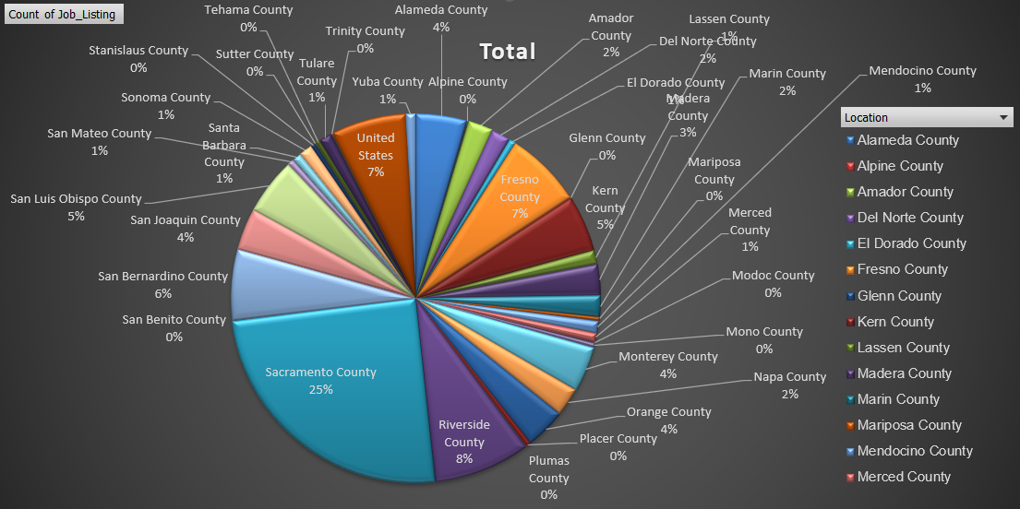

Nhóm các công việc được tuyển dụng chủ yếu tại khu vực *Sacramento County.*

### Cụm 4:

|  |
| --- |
| BUSINESS SERVICE OFFICER I (SUPERVISOR), CALTRANS LANDSCAPE MAINTENANCE LEADWORKER, EMPLOYMENT PROGRAM REPRESENTATIVE, ENGINEER, WATER RESOURCES, ASSOCIATE GOVERNMENTAL PROGRAM ANALYST, ENVIRONMENTAL SCIENTIST, FOOD ADMINISTRATOR I (CORRECTIONAL FACILITY), HEALTH FACILITIES EVALUATOR MANAGER I, ASSISTANT COORDINATOR OF NURSING SERVICES, CALTRANS HEAVY EQUIPMENT MECHANIC, FOOD SERVICE TECHNICIAN I, TAX TECHNICIAN III, BOARD OF EQUALIZATION, AREA ADMINISTRATOR, DIVISION OF APPRENTICESHIP STANDARDS, ATTORNEY, CLINICAL SOCIAL WORKER (HEALTH/CORRECTIONAL FACILITY) - SAFETY, DEPUTY ATTORNEY GENERAL III, CHIEF ENGINEER II, COOK SPECIALIST II, DENTIST, DEPARTMENTS OF MENTAL HEALTH AND DEVELOPMENTAL SERVICES, ELECTRICAL ENGINEER, ADMINISTRATIVE LAW JUDGE, ATTORNEY III, DRIVER SAFETY MANAGER I, CUSTODIAN I, ACCOUNTANT I (SPECIALIST), ASSOCIATE PERSONNEL ANALYST, CALTRANS EQUIPMENT OPERATOR II, ASSOCIATE OIL AND GAS ENGINEER, AUTOMOTIVE TECHNICIAN II, FINANCIAL INSTITUTIONS EXAMINER, ACTIVITY COORDINATOR, VETERANS HOME AND MEDICAL CENTER, CONSERVANCY PROJECT DEVELOPMENT ANALYST II, CORRECTIONAL SUPERVISING COOK (CORRECTIONAL FACILITY), ASSOCIATE TAX AUDITOR , EMPLOYMENT DEVELOPMENT DEPARTMENT, CLINICAL SOCIAL WORKER (HEALTH FACILITY), ADMINISTRATIVE ASSISTANT I, ASSISTANT SAFETY ENGINEER, CALTRANS MAINTENANCE AREA SUPERINTENDENT, COMMUNICATIONS OPERATOR, CORRECTIONAL SERGEANT, DISPATCHER-CLERK, CALTRANS, ELECTRICIAN I, ASSOCIATE CONSTRUCTION ANALYST, CUSTODIAN SUPERVISOR I, FIRE AND LIFE SAFETY OFFICER II (HEALTH FACILITIES CONSTRUCTION), ADMINISTRATOR II, FRANCHISE TAX BOARD, ASSOCIATE MANAGEMENT AUDITOR, CERTIFIED NURSING ASSISTANT, AGRICULTURAL TECHNICIAN I (SEASONAL), ATTORNEY IV, ATTORNEY SUPERVISOR, CHIEF OF PLANT OPERATION I, HEALTH PROGRAM AUDITOR IV, DEPARTMENT OF HEALTH SERVICES, GROUNDSKEEPER, DEPUTY ATTORNEY GENERAL IV, DISTRICT SALES REPRESENTATIVE, CA STATE LOTTERY, LICENSING-REGISTRATION EXAMINER, DEPARTMENT OF MOTOR VEHICLES, CHIEF ENGINEER I, LICENSED VOCATIONAL NURSE, CALIFORNIA DEPARTMENT OF CORRECTIONS AND REHABILITATION, OFFICE TECHNICIAN (TYPING), PAROLE AGENT II, ADULT PAROLE SUPERVISOR, PROGRAM AND PROJECT SUPERVISOR, PUBLIC UTILITIES COMMISSION, PSYCHIATRIC TECHNICIAN (SAFETY), SENIOR LEGAL ANALYST, SENIOR TELECOMMUNICATIONS ENGINEER, STAFF SERVICES MANAGER I, DRIVER SAFETY HEARING OFFICER, INFORMATION TECHNOLOGY SPECIALIST I, LEGAL SECRETARY, LICENSING PROGRAM ANALYST, MAINTENANCE MECHANIC, MAINTENANCE WORKER, DEPARTMENT OF THE CALIF. HIGHWAY PATROL, PROGRAM TECHNICIAN II, SCIENTIFIC AID, STAFF SERVICES ANALYST, STATIONARY ENGINEER (CORRECTIONAL FACILITY), TRANSPORTATION SURVEYOR PARTY CHIEF (CALTRANS), ACCOUNTING TECHNICIAN, BUSINESS TAXES SPECIALIST III, BOARD OF EQUALIZATION, CALTRANS HIGHWAY MAINTENANCE LEADWORKER, COMMERCIAL VEHICLE INSPECTION SPECIALIST, OFFICE TECHNICIAN (GENERAL), PUBLIC UTILITIES REGULATORY ANALYST IV, SENIOR PSYCHOLOGIST, CORRECTIONAL FACILITY (SUPERVISOR), WAREHOUSE MANAGER II, GRADUATE STUDENT ASSISTANT, INFORMATION TECHNOLOGY MANAGER I, PARK MAINTENANCE SUPERVISOR, SEASONAL CLERK, SENIOR UTILITIES ENGINEER (SPECIALIST), STAFF PARK AND RECREATION SPECIALIST, WATER SERVICES SUPERVISOR, DISABILITY INSURANCE PROGRAM MANAGER I, HEALTH PROGRAM SPECIALIST I, HYDROELECTRIC PLANT TECHNICIAN I, OFFICE ASSISTANT (TYPING), PAROLE SERVICE ASSOCIATE, PHARMACIST I (MAND), PROGRAM TECHNICIAN, PUBLIC UTILITIES REGULATORY ANALYST II, RECREATION THERAPIST, CORRECTIONAL FACILITY, REGISTERED DIETITIAN, RESEARCH DATA SPECIALIST II, SENIOR HYDROELECTRIC PLANT OPERATOR, SENIOR PSYCHOLOGIST (HEALTH FACILITY) (SPECIALIST), SENIOR TRANSPORTATION ENGINEER, CALTRANS, SPECIAL AGENT, DEPARTMENT OF JUSTICE, SPECIAL INVESTIGATOR, HEALTH FACILITIES EVALUATOR NURSE, LABORATORY ASSISTANT, CORRECTIONAL FACILITY, NURSE INSTRUCTOR, PERSONNEL SPECIALIST, PROPERTY CONTROLLER II (CORRECTIONAL FACILITY), PSYCHIATRIC TECHNICIAN INSTRUCTOR, PUBLIC UTILITIES REGULATORY ANALYST V, SECURITY GUARD, SENIOR ENVIRONMENTAL SCIENTIST (SPECIALIST), SENIOR VOCATIONAL REHABILITATION COUNSELOR, QUALIFIED REHABILITIATION PROFESSIONAL, TRANSPORTATION ENGINEER (CIVIL), WORKERS' COMPENSATION CONSULTANT, INVESTIGATOR, PHARMACEUTICAL CONSULTANT II, DEPARTMENT OF HEALTH SERVICES (SUPERVISORY), PHARMACY TECHNICIAN, PUBLIC SAFETY DISPATCHER, CALIFORNIA HIGHWAY PATROL, PUBLIC UTILITIES REGULATORY ANALYST III, SUPERVISING REGISTERED NURSE III, CORRECTIONAL FACILITY, TRANSPORTATION ENGINEER (ELECTRICAL), DISABILITY INSURANCE PROGRAM MANAGER III, EMPLOYMENT PROGRAM MANAGER II, MAINTENANCE AIDE (SEASONAL), PAROLE AGENT III, ADULT PAROLE, REGISTERED NURSE, CORRECTIONAL FACILITY, SENIOR PSYCHIATRIC TECHNICIAN (SAFETY), SENIOR STRUCTURAL ENGINEER, STAFF PSYCHIATRIST, CORRECTIONAL AND REHAB SERVICES (SAFETY), SUPPORT SERVICES ASSISTANT (GENERAL), DIRECT CONSTRUCTION SUPERVISOR I, FINANCIAL INSTITUTIONS MANAGER, MEDICAL ASSISTANT, LEAD GROUNDSKEEPER I (CORRECTIONAL FACILITY), PETROLEUM DRILLING ENGINEER, SENIOR LANDSCAPE ARCHITECT, CALTRANS, STUDENT ASSISTANT, NURSE PRACTITIONER, CORRECTIONAL FACILITY, PHYSICIAN AND SURGEON, CORRECTIONAL FACILITY (INTERNAL MED/FAMILY PRACTICE), PHYSICIAN ASSISTANT, CORRECTIONAL FACILITY, WORKERS COMPENSATION COMPLIANCE OFFICER, PHYSICAL THERAPIST I, CORRECTIONAL FACILITY, SENIOR LEGAL TYPIST, STAFF PSYCHIATRIST (SAFETY), AUTOMOTIVE EQUIPMENT OPERATOR I, DEPARTMENT OF MENTAL HEALTH AND DEVELOPMENTAL SERVICES, PSYCHOLOGIST (HEALTH FACILITY - CLINICAL - SAFETY), REGISTERED NURSE (SAFETY), STAFF SERVICES MANAGEMENT AUDITOR, BUILDING MAINTENANCE WORKER, HAZARDOUS SUBSTANCES ENGINEER, CHIEF, RESTORATIVE CARE SERVICE, DEPUTY ATTORNEY GENERAL, REHABILITATION THERAPIST, STATE FACILITIES (RECREATION), STOCK CLERK, DEPUTY LABOR COMMISSIONER I, FOOD SERVICE SUPERVISOR II, AGRICULTURAL TECHNICIAN II (SEASONAL), ENGINEERING GEOLOGIST, MEDICAL CONSULTANT (ENFORCEMENT), MEDICAL BOARD OF CALIFORNIA, HEARING REPORTER, LABORATORY ASSISTANT, INVESTIGATIVE AUDITOR III, DEPARTMENT OF JUSTICE, BUSINESS TAXES COMPLIANCE SPECIALIST, LEAD GROUNDSKEEPER, LABORER, PROGRAM REPRESENTATIVE I, DEPARTMENT OF CONSUMER AFFAIRS, STATIONARY ENGINEER |

**Ý nghĩa cụm 4:**

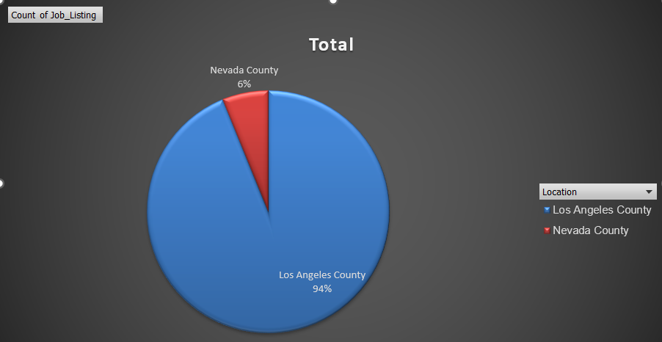

Nhóm các công việc được tuyển dụng chủ yếu tại khu vực *Los Angeles* *County.*

## Thuật toán Random Forest

Gán nhãn chia tập train test dữ liệu [5]

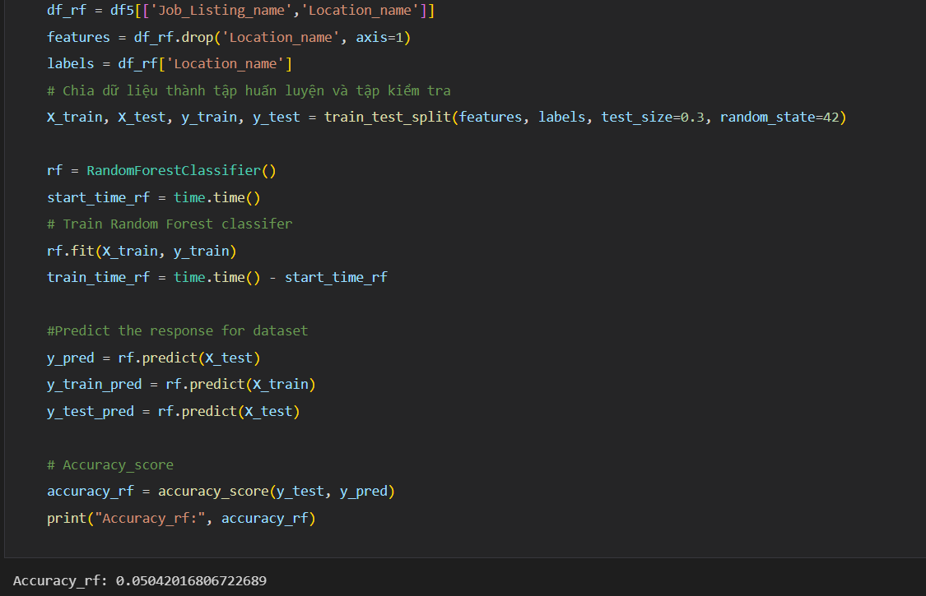

Xuất ra thời gian và độ chính xác thuật toán.

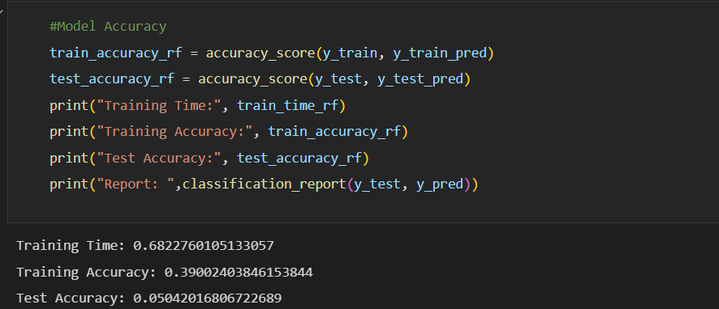

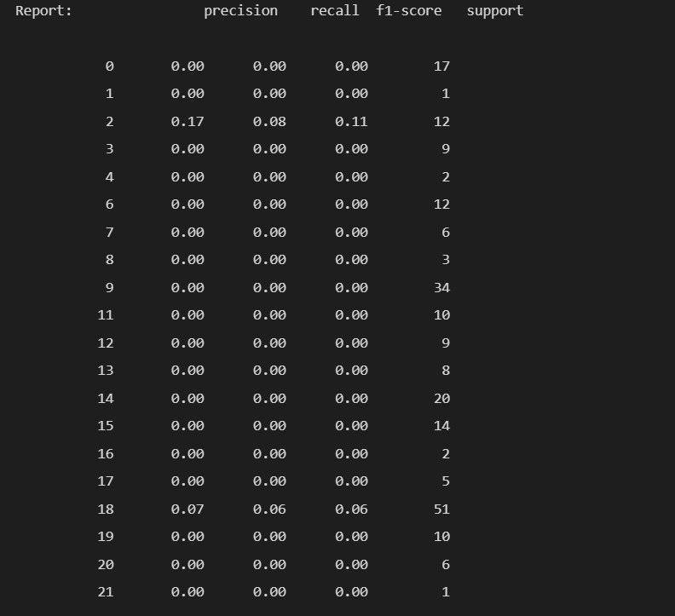

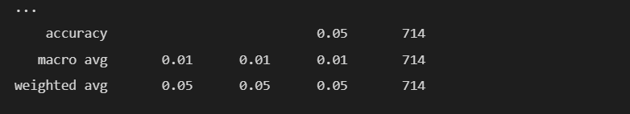

Vẽ biểu đồ plot xem sự phân chia các cụm.

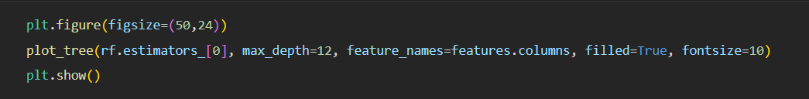

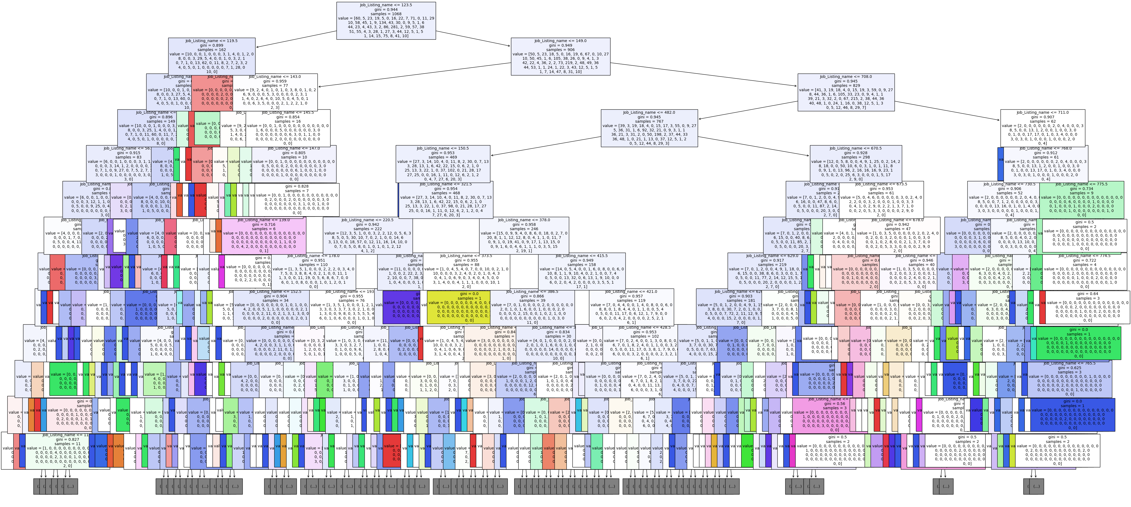

Kết quả sau khi phân cụm đối với thuật toán Random Forest phân được nhóm các công việc được tuyển vào tương tứng với từng khu vực chia thành 58 cụm ứng với 58 khu vực trong đó có những nhóm công việc được tuyển dụng phân cụm vào đúng khu vực với tỷ lệ 100% ở các cụm 4, 5 , 6, 11, 14, 15, 16, 17, 20, 22, 25, 29, 31, 32, 33, 34, 35, 36, 37, 38 ,40, 44, 49, 50, 52 và 56. Một số cụm tỷ lệ ra đúng công việc tuyển dụng thuộc về khu vực đó với tỷ lệ trên 90% ở các cụm 2 (94%), 3 (94%), 7 (93%), 10 (96%), 12 (92%), 13 (94%), 18 (98%), 19 (99%), 24 (91%), 30 (97%), 39 (95%), 47 (93%), 48 (94%), 54 (92%), 55 (95%), 57 (98%), 58 (93%). Còn các cụm còn lại đa số đều nhìn ra rõ được nhóm công việc được tuyển dụng thuộc về khu vực nào với tỷ lệ từ 67% trở lên.

Chi tiết xem thêm ở file excel “*RandomForest_results.xlsx”.*

Sau đây là minh chứng một số cụm.

**Cụm 3:**

|  |
| --- |
| CALTRANS EQUIPMENT OPERATOR II, FISH AND WILDLIFE SEASONAL AID, HEALTH RECORD TECHNICIAN I, CERTIFIED NURSING ASSISTANT, BATTALION CHIEF, ADMINISTRATIVE ASSISTANT I, CAPTAIN, ADULT INSTITUTION, CLINICAL SOCIAL WORKER (HEALTH/CORRECTIONAL FACILITY) - SAFETY, CALTRANS HIGHWAY MAINTENANCE LEADWORKER, CORRECTIONAL SUPERVISING COOK (CORRECTIONAL FACILITY), ASSISTANT CHIEF, CUSTODIAN I, FOOD SERVICE TECHNICIAN I, HEALTH PROGRAM SPECIALIST I, LICENSED VOCATIONAL NURSE, CALIFORNIA DEPARTMENT OF CORRECTIONS AND REHABILITATION, MEDICAL ASSISTANT, OFFICE ASSISTANT (TYPING), OFFICE SERVICES SUPERVISOR II, OFFICE TECHNICIAN (TYPING), STAFF SERVICES MANAGER I, SUPERVISING COOK I, STAFF SERVICES ANALYST, DENTIST, CORRECTIONAL FACILITY, HEALTH RECORD TECHNICIAN II (SUPERVISOR), OPTOMETRIST, CORRECTIONAL FACILITY, PHYSICAL THERAPIST I, CORRECTIONAL FACILITY, SENIOR PSYCHOLOGIST, CORRECTIONAL FACILITY (SUPERVISOR), STAFF PSYCHIATRIST, CORRECTIONAL AND REHAB SERVICES (SAFETY), COMMUNITY RESOURCES MANAGER, DEPARTMENT OF CORRECTIONS, LABORATORY ASSISTANT, CORRECTIONAL FACILITY, PHYSICIAN AND SURGEON, CORRECTIONAL FACILITY (INTERNAL MED/FAMILY PRACTICE), PSYCHIATRIC TECHNICIAN (SAFETY), DENTAL ASSISTANT, CORRECTIONAL FACILITY, REGISTERED NURSE, CORRECTIONAL FACILITY, SENIOR PSYCHIATRIST (SUPERVISOR), CORRECTIONAL AND REHABILITATIVE SERVICES (SAFETY) |

**Ý nghĩa cụm 3:**

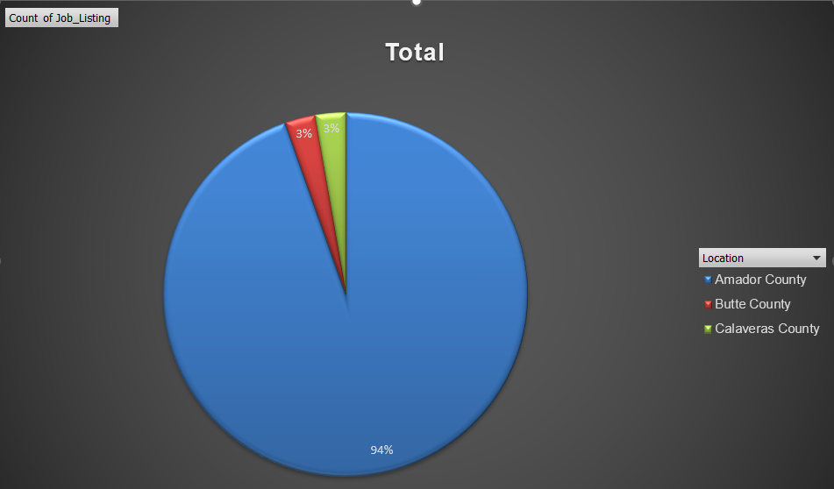

Nhóm các công việc được tuyển dụng chủ yếu tại khu vực *Amador County.*

**Cụm 49:**

|  |
| --- |
| ENVIRONMENTAL SCIENTIST, CALTRANS EQUIPMENT OPERATOR II, STATE PARK INTERPRETER I, STATE PARK INTERPRETER II, HEAVY FIRE EQUIPMENT OPERATOR |

**Ý nghĩa cụm 49:**

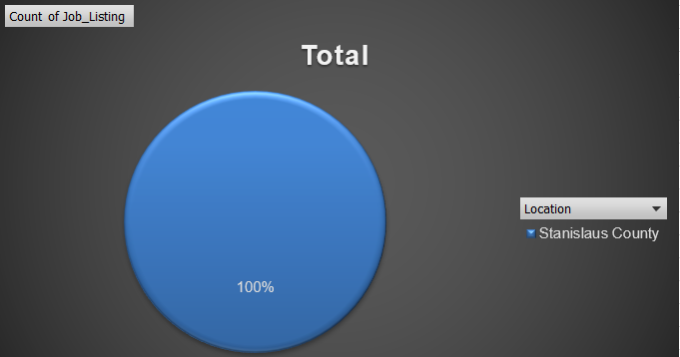

Nhóm các công việc được tuyển dụng tại khu vực *Stanislaus* *Country.*

**Cụm 51:**

|  |
| --- |
| CUSTODIAN II, CALTRANS LANDSCAPE MAINTENANCE WORKER, ENVIRONMENTAL SCIENTIST, CUSTODIAN I, ENGINEER, WATER RESOURCES, CALTRANS LANDSCAPE MAINTENANCE LEADWORKER, HEAVY FIRE EQUIPMENT OPERATOR, CALTRANS HIGHWAY MAINTENANCE WORKER, WATER AND SEWAGE PLANT OPERATOR, DEPARTMENT FORESTRY AND FIRE PROTECTION (SAFETY) |

**Ý nghĩa cụm 51:**

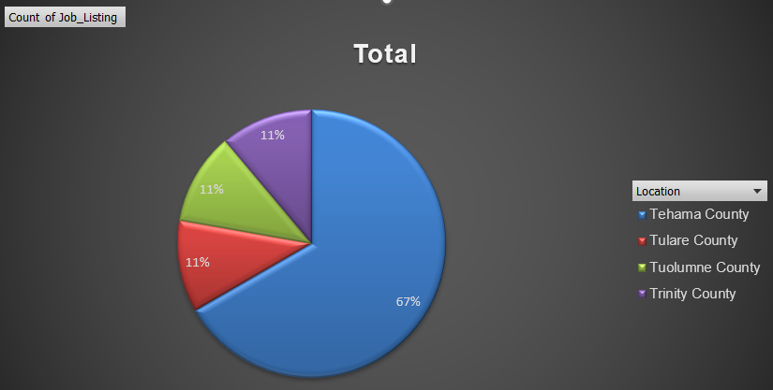

Nhóm các công việc được tuyển dụng chủ yếu tại khu vực *Tehama County.*

## Thuật toán Decision Tree

Gán nhãn chia tập train test dữ liệu và xuất ra thời gian và độ chính xác thuật toán[6]

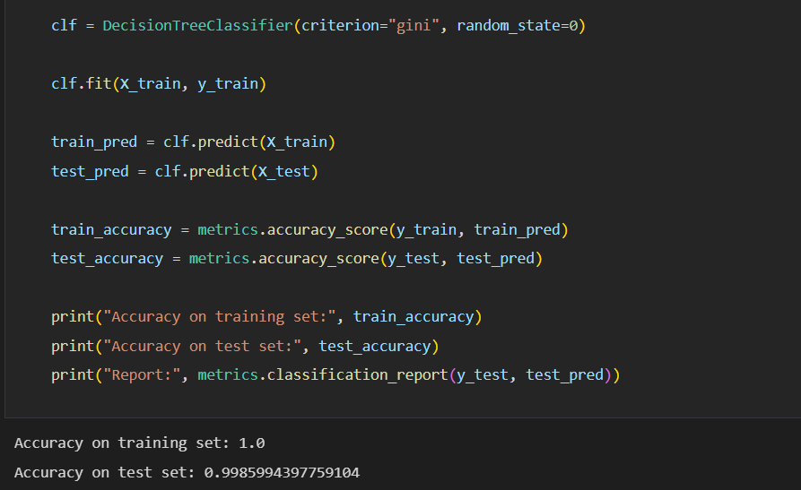

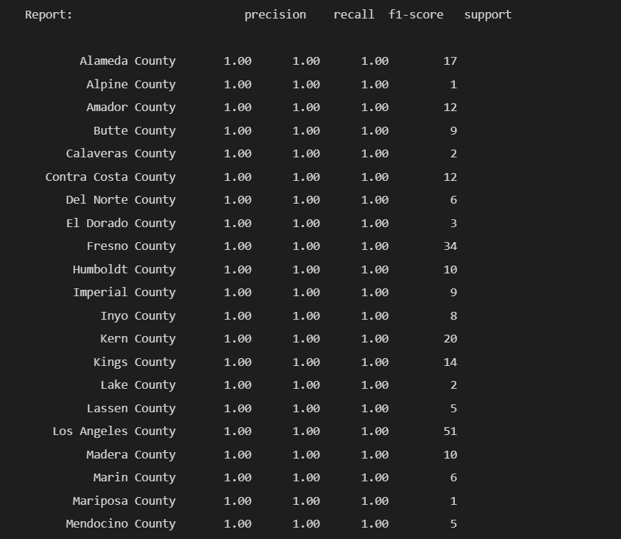





Vẽ biểu đồ plot xem sự phân chia các cụm.

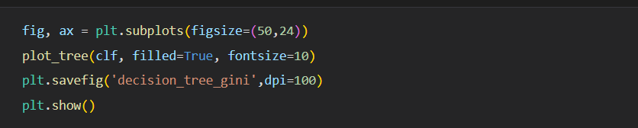

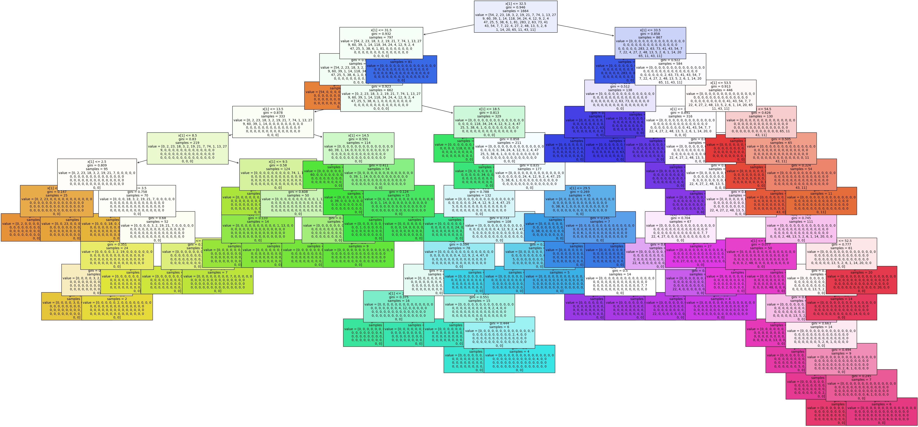

Kết quả sau khi phân cụm đối với thuật toán Decision Tree chia ra được 41 cụm trong đó có những nhóm công việc được tuyển dụng phân cụm vào đúng khu vực với tỷ lệ 100% ở các cụm 32, 33, 35, 36, 37, 38, 39. 40 và 41. Một số cụm tỷ lệ ra đúng công việc tuyển dụng thuộc về khu vực đó với tỷ lệ trên 70% ở các cụm 19 (83%), 29 (76%), 30 (78%), 31 (86%), 34 (78%). Còn các cụm còn lại đa số phân bố khá đồng đều không chênh lệch bao nhiêu có một vài cụm tỷ lệ các công việc tuyển dùng được phân bố đều cho các khu vực ở các cụm 5, 15, 27.

Chi tiết xem thêm ở file excel “*Decision_Tree.xlsx”.*

Sau đây là minh chứng một số cụm.

**Cụm 15:**

|  |
| --- |
| JUNIOR ENGINEERING TECHNICIAN |

**Ý nghĩa cụm 15:**

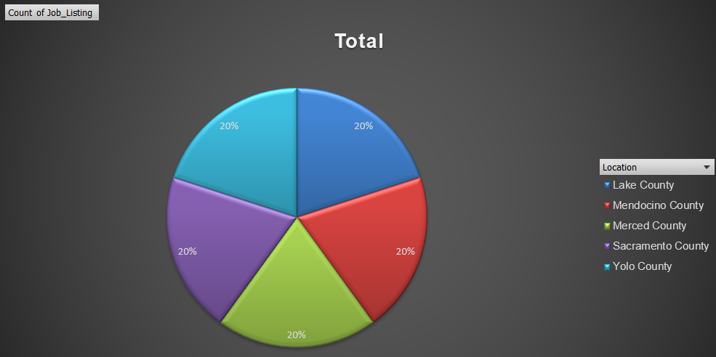

Nhóm công việc được tuyển dụng đồng đều tại 5 khu vực *Lake County, Mendocino County, Merced County, Sacramento County và Yolo County.*

**Cụm 17:**

|  |
| --- |
| ASSOCIATE MANAGEMENT AUDITOR, ATTORNEY IV, BUSINESS SERVICE OFFICER I (SUPERVISOR), CALTRANS LANDSCAPE MAINTENANCE LEADWORKER, DIRECT CONSTRUCTION SUPERVISOR I, AUTOMOTIVE TECHNICIAN II, DEPUTY ATTORNEY GENERAL, HEALTH FACILITIES EVALUATOR MANAGER I, ASSISTANT COORDINATOR OF NURSING SERVICES, FINANCIAL INSTITUTIONS EXAMINER, TAX TECHNICIAN III, BOARD OF EQUALIZATION, ADMINISTRATOR II, FRANCHISE TAX BOARD, CHIEF ENGINEER II, DENTIST, DEPARTMENTS OF MENTAL HEALTH AND DEVELOPMENTAL SERVICES, ELECTRICAL ENGINEER, STAFF SERVICES MANAGEMENT AUDITOR, BUSINESS TAXES COMPLIANCE SPECIALIST, CUSTODIAN SUPERVISOR I, DRIVER SAFETY MANAGER I, ASSOCIATE CONSTRUCTION ANALYST, COMMUNICATIONS OPERATOR, AGRICULTURAL TECHNICIAN II (SEASONAL), CHIEF ENGINEER I, HEARING REPORTER, ACTIVITY COORDINATOR, VETERANS HOME AND MEDICAL CENTER, CONSERVANCY PROJECT DEVELOPMENT ANALYST II, BUSINESS TAXES SPECIALIST III, BOARD OF EQUALIZATION, ELECTRICIAN I, SEASONAL CLERK, STAFF PSYCHIATRIST (SAFETY), FIRE AND LIFE SAFETY OFFICER II (HEALTH FACILITIES CONSTRUCTION), BUILDING MAINTENANCE WORKER, ACCOUNTING TECHNICIAN, CHIEF OF PLANT OPERATION I, HEALTH PROGRAM AUDITOR IV, DEPARTMENT OF HEALTH SERVICES, LABORER, FOOD SERVICE SUPERVISOR II, PAROLE AGENT II, ADULT PAROLE SUPERVISOR, PERSONNEL SPECIALIST, PROGRAM AND PROJECT SUPERVISOR, PUBLIC UTILITIES COMMISSION, PROGRAM TECHNICIAN, SENIOR LEGAL ANALYST, SENIOR TELECOMMUNICATIONS ENGINEER, STAFF PARK AND RECREATION SPECIALIST, PUBLIC SAFETY DISPATCHER, CALIFORNIA HIGHWAY PATROL, PUBLIC UTILITIES REGULATORY ANALYST V, SENIOR UTILITIES ENGINEER (SPECIALIST), STATIONARY ENGINEER, WORKERS' COMPENSATION CONSULTANT, HYDROELECTRIC PLANT TECHNICIAN I, PUBLIC UTILITIES REGULATORY ANALYST IV, WAREHOUSE MANAGER II, DISABILITY INSURANCE PROGRAM MANAGER III, WATER SERVICES SUPERVISOR, DISABILITY INSURANCE PROGRAM MANAGER I, PAROLE SERVICE ASSOCIATE, PUBLIC UTILITIES REGULATORY ANALYST II, SENIOR HYDROELECTRIC PLANT OPERATOR, SENIOR PSYCHOLOGIST (HEALTH FACILITY) (SPECIALIST), SUPERVISING REGISTERED NURSE III, CORRECTIONAL FACILITY, INVESTIGATIVE AUDITOR III, DEPARTMENT OF JUSTICE, NURSE INSTRUCTOR, PROPERTY CONTROLLER II (CORRECTIONAL FACILITY), PSYCHIATRIC TECHNICIAN INSTRUCTOR, SENIOR PSYCHIATRIC TECHNICIAN (SAFETY), PHARMACEUTICAL CONSULTANT II, DEPARTMENT OF HEALTH SERVICES (SUPERVISORY), PUBLIC UTILITIES REGULATORY ANALYST III, SENIOR LEGAL TYPIST, AUTOMOTIVE EQUIPMENT OPERATOR I, DEPARTMENT OF MENTAL HEALTH AND DEVELOPMENTAL SERVICES, PAROLE AGENT III, ADULT PAROLE, SENIOR STRUCTURAL ENGINEER, SUPPORT SERVICES ASSISTANT (GENERAL), FINANCIAL INSTITUTIONS MANAGER, LEAD GROUNDSKEEPER I (CORRECTIONAL FACILITY), PETROLEUM DRILLING ENGINEER, SENIOR LANDSCAPE ARCHITECT, CALTRANS, WORKERS COMPENSATION COMPLIANCE OFFICER, PSYCHOLOGIST (HEALTH FACILITY - CLINICAL - SAFETY), MEDICAL CONSULTANT (ENFORCEMENT), MEDICAL BOARD OF CALIFORNIA, CHIEF, RESTORATIVE CARE SERVICE, REHABILITATION THERAPIST, STATE FACILITIES (RECREATION), LEAD GROUNDSKEEPER, LABORATORY ASSISTANT, PROGRAM REPRESENTATIVE I, DEPARTMENT OF CONSUMER AFFAIRS |

**Ý nghĩa cụm 17:**

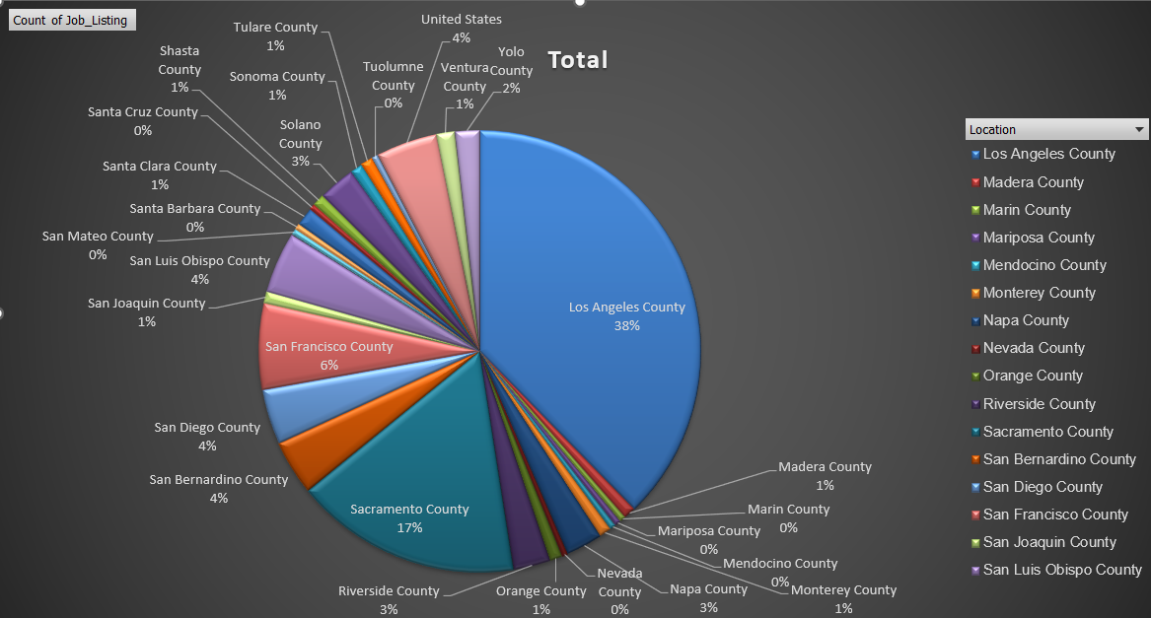

Nhóm công việc được tuyển dụng chủ yếu tại khu vực *Los Angeles County và Sacramento County.*

**Cụm 31:**

|  |
| --- |
| ELECTRICAL ENGINEERING TECHNICIAN I, APPRENTICESHIP CONSULTANT, ARCHEOLOGICAL PROJECT LEADER (SEASONAL), ARCHEOLOGICAL SPECIALIST (SEASONAL), SUPERVISING CLINICAL LABORATORY TECHNOLOGIST, CORRECTIONAL FACILTY, LICENSING PROGRAM MANAGER II, TAX ADMINISTRATOR I, EMPLOYMENT DEVELOPMENT DEPARTMENT, MOTOR CARRIER SPECIALIST I, CALIFORNIA HIGHWAY PATROL, DISABILITY EVALUATION SERVICES ADMINISTRATOR I, PEST PREVENTION ASSISTANT I (VARIOUS PROJECTS), SENIOR TRANSPORTATION ELECTRICAL ENGINEER (SUPERVISOR), SENIOR MAINTENANCE AIDE (SEASONAL) |

**Ý nghĩa cụm 31:**

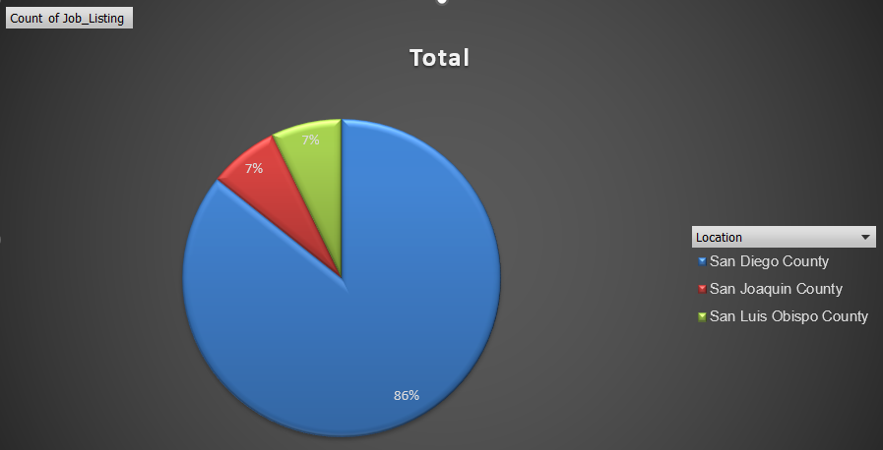

Nhóm các công việc được tuyển dụng chủ yếu tại khu vực *San Diego County.*

**Cụm 33:**

|  |
| --- |
| CLINICAL LABORATORY TECHNOLOGIST, CORRECTIONAL FACILITY, MEDICAL RECORD DIRECTOR, RESPIRATORY CARE PRACTITIONER, CORRECTIONAL FACILITY, ASSOCIATE ENVIRONMENTAL PLANNER (ARCHEOLOGY), ASSOCIATE ENVIRONMENTAL PLANNER (ARCHITECTURAL HISTORY), SENIOR RIGHT OF WAY AGENT, ADMINISTRATIVE OFFICER II, RESOURCES AGENCY |

**Ý nghĩa cụm 33:**

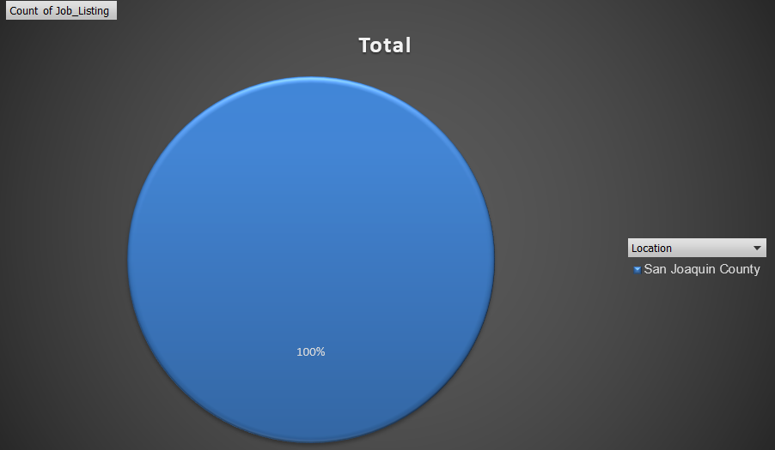

Nhóm công việc tuyển dụng tại khu vực *San Joaquin County.*

# BẢNG PHÂN CÔNG CÔNG VIỆC

|  |  |  |
| --- | --- | --- |
| **Tên công việc** | Bùi Đức Duy  20521228 | Bùi Duy Thiện  20520772 |
| Viết báo cáo | **🗸** | **🗸** |
| Vẽ đồ thị và tính các độ đo (lập trình python) | **🗸** |  |
| Thực hiện tính các độ đo với 10 đỉnh ngẫu nhiên. | **🗸** | **🗸** |
| Code thuật toán Louvain, Spinglass, Decision Tree và thực hiện pivot trên excel | **🗸** |  |
| Code và pivot thuật toán Agglomerative, Spectral, Random Forest và thực hiện pivot trên excel |  | **🗸** |
| Trực quan hóa bằng Gephi |  | **🗸** |

# THAM KHẢO

[1] “community API — Community detection for NetworkX 2 documentation.” Accessed: Dec. 18, 2023. [Online]. Available: https://python-louvain.readthedocs.io/en/latest/api.html

[2] “cdlib.algorithms.spinglass — CDlib - Community Discovery library.” Accessed: Dec. 18, 2023. [Online]. Available: https://cdlib.readthedocs.io/en/latest/reference/cd_algorithms/algs/cdlib.algorithms.spinglass.html

[3] “sklearn.cluster.AgglomerativeClustering,” scikit-learn. Accessed: Dec. 18, 2023. [Online]. Available: https://scikit-learn/stable/modules/generated/sklearn.cluster.AgglomerativeClustering.html

[4] “Spectral Clustering in Machine Learning,” GeeksforGeeks. Accessed: Dec. 18, 2023. [Online]. Available: https://www.geeksforgeeks.org/ml-spectral-clustering/

[5] “Machine Learning Random Forest Algorithm - Javatpoint,” www.javatpoint.com. Accessed: Dec. 18, 2023. [Online]. Available: https://www.javatpoint.com/machine-learning-random-forest-algorithm

[6] “1.10. Decision Trees,” scikit-learn. Accessed: Dec. 18, 2023. [Online]. Available: https://scikit-learn/stable/modules/tree.html

[7] GVHD. ThS. Nguyen Thi Kim Phung, “CodePython_Sample(update)_ChuaBoSungYNghiaCum”.